Security Overview
- This document aims to cover the Security Information associated with Next Predict/Next Response and the Vertiv Service Cloud (VSC) as well as the setup and network connectivity devices that hosts Next Predict/Next Response. This document will cover the following topics.
  - Network Connection Best Practice for LSG to CSP
    - Network Security Best Practices
    - Sample Network Diagram
  - Certificates
    - Public/Private Key TLS Handshake
      - Approved Cryptographic Algorithms
      - Outbound Connection Encryption
  - Predict & Response API connection to CSP
    - OAuth Flow Diagram
  - Security Q/A with link to VOC
  - Contacts
    - Security Concerns & Support Issues
    - Hardware + Software and Order Issues

Network Connection Best Practice for LSG to CSP
- Network Security Best Practices (LSG to Cloud Service Portal for Next Predict/Response Services)
  - VLAN Segmentation
    - Create Mac Address Network Objects
    - Group-like devices, SNMP Managers (LSG’s) with each other and SNMP Agents (Communication Cards) with each other.
    - Only allow routes and protocols in diagrams and follow VLAN segmentation inbound and outbound with rule of least privilege practiced in firewall configuration and policies.
  - Port 80 Implicit Deny (Only crl.sectigo.com allowed)
  - SNMP Unique Community Strings for managers and agents.
  - Set a complex password for Admin on LSG.
  - Disable TLS less than > TLS 1.2 and enable TLS 1.3 for future iterations and updates.

- Sample Network Connection (Client LSG/Communication Cards to Vertiv Service Cloud)

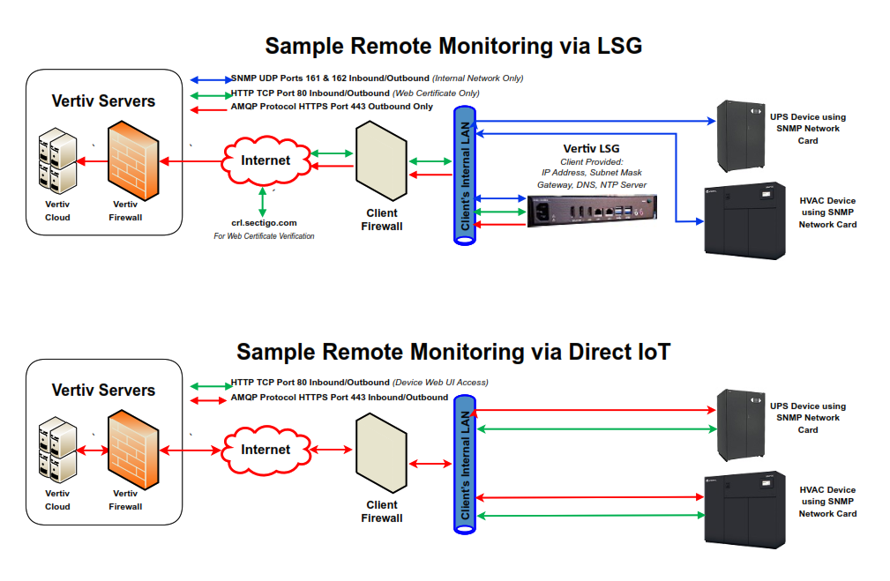

Certificates
- Certificate Overview and Features
  - Overview
    - LSG (non-VPN) certificates are generated in the Cloud Service Portal. The package is encrypted using a PKI public key registered by the LSG when it first connects to the cloud. This encrypted package is then sent to the LSG. The LSG with the private key, which is never shared, then can decrypt it.
    - On the VPN configuration, a client certificate is given to the customer containing the public key to access the Production VPN in Vertiv’s Cloud environment. The Private key is stored in the cloud and only Vertiv Engineers/Support Engineers through services have access to the environment and the private key.
  - Public/Private Key TLS Handshake by LSG to CSP
    - Approved Cryptographic Algorithms in accordance with NIST 131a Rev2 and NIST 800 052 Rev 2
      - Kex Algorithms
        - Ecdh-sha2-nistp256
        - Ecdh-sha2-nistp384
        - Ecdh-sha2-nistp521
        - Diffie-hellman-group-exchange-sha256
        - Diffie-hellman-group16-sha512
        - Diffie-hellman-group18-sha512
        - Diffie-hellman-group14-sha256
      - Server Host Key Algorithms
        - Rsa-sha2-512
        - Rsa-sha2-256
        - Ecdsa-sha2-nistp256
        - Ssh-ed25519
      - Encryption Algorithms
        - Aes128-ctr
        - Aes192-ctr
        - Aes256-ctr
      - Mac Algorithms
        - Hmac-sha2-256
        - Hmac-sha2-512
  - Outbound Connection Encryption
      - TLS 1.2 over HTTPS Port 443

Predict and Response API Connection to Cloud Service Portal
- Predict and Response API Flow/OAuth 2.X Diagram
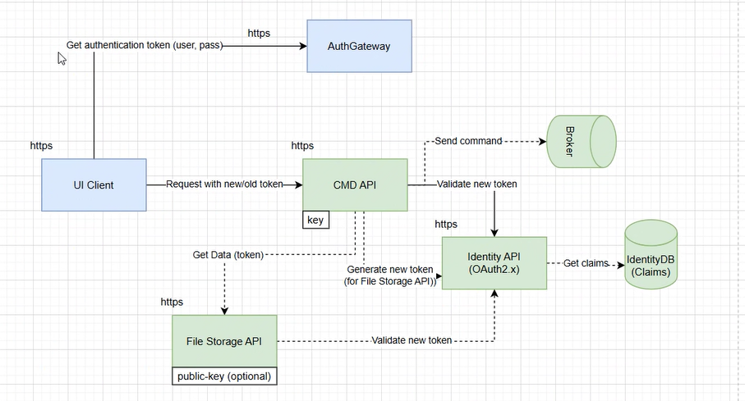
  - Blue part of the diagram is initializing JWT Token to then go through OAuth 2.X using an API Token that is given out by a Data Base “IdentityDB”.

Security Q/A
- What are the Security Concerns or Risks associated with connecting this service?
  - Next Predict and Next Response are proprietary API algorithms that are run on the data aggregated collected and sent out to the VERTIV Service Cloud by LSG or our communication cards (Direct IoT). We use internal metrics from testing our products and feeding those values in our algorithms on the backend. This, however, does not increase any risk from a security standpoint and thus, the same risk associated with our LSG’s, is relevant here.
  - LSG Security Risk
    - SNMP V1 and V2 are susceptible. They have significant security vulnerabilities due to their reliance on unencrypted community strings and lack of strong authentication methods. SNMP V3 has no roadmap but could be an addition to the LSG to encrypt SNMP Traps if feedback for this security is given back to us by our customers. (Offer the VOC Security Form for the customer to fill out linked here for feedback Here)
      - For SNMP V1 and V2 (Ports 161 and 162), it is advised to provide segmentation of the internal network with VLAN’s for device grouping and micro segmentation of those VLAN’s for protocols/ (Ports 161 and 162) allowed, to be used on specific routes between the devices. (See example configuration)
      - Also, changing the community string from its default configuration of public (and or private) to a unique community string across all devices is recommended.
    - Port 80 crl.sectigo.net for Certificate Revocation List
      - This exists on LSG 1.6.1 but will be patched to use port 443 HTTPS and TLS 1.2 for LSG 1.6.4. The windows version LSG v3.2.2 also has the patch to use port 443 HTTPS and TLS 1.2 for communication with entrust.net for AIA and CRL certificate services.
- How will I receive Firmware and Software Updates for Patching & Security Fixes?
  - Go to Critical Equipment Software Downloads | Vertiv
- What is the Risk in connecting to the cloud?
  - The only risk on the customers end connecting to the cloud is the outbound connection to the Vertiv Service Cloud in which use HTTPS over Port 443 using TLS 1.2 with known weak ciphers disabled.
  - If the customer would prefer to use TLS 1.3 and Elliptic Curve Key Algorithms with Perfect Forward Secrecy or MTLS for example, they can request security enhancements through our Voice of Customer Form. We use this form and the data gathered to drive product security enhancements and improvements in our products.
    - Link to form is here: Vertiv Voice of Customer Form
- What are the best practices for configuring our environment with other Vertiv Monitoring Products?
  - VLAN and Network Segmentation are the best practices to follow. We recommended grouping “like devices” by Mac Addresses (IE: SNMP Managers with SNMP Managers, SNMP Agents with SNMP Agents) into their own VLAN’s. This way you can control internal network traffic and move equipment around if needed, without losing the network traffic flow and design. Enable protocols based on the rule of least privilege, making sure to implement routes and policies that LSG or Direct IOT need. IE: Ports 443, 80 (Sectigo), 161 & 162 for SNMP.
  - We also recommend changing SNMP Community Strings to Unique ones with complexity addressed by the customer’s risk level.
- If we scan our environment and have found a Vulnerability, who do we contact?
  - Please relay all security vulnerabilities with the CVE/CVSS/CWE/Nessus Plugin ID information to the contacts list below.
  - External Vulnerabilities received will be included in the next Delta Assessment of the product effected and will adhere to our SECURE 2.0 Requirements, vulnerability triaging SLA’s, and NIST Special Publication 800-131a & 052 Revision 2 “Shall” statements.

Contacts
- Security Concerns and Support Issues - monitoring.support@vertiv.com
- Configuration and Order Issues – rsd@vertiv.com

