VRC Self-Contained Rack Cooler
VRC1 Series

User Manual

VRC Self-Contained Rack Cooler
User Manual
Version | V1.4
Revision date | Mar 18, 2020
BOM | 31014115

Copyright by Vertiv Group Corp.
The content in this document is subject to change without notice. All rights, including rights of translation, reproduced by printing, copying or similar methods, and even of parts, are reserved. Violators will be liable for damages. All rights, including rights deriving from patent license or registration of a utility model or design, are reserved. No part of this document may be reproduced or transmitted in any form or by any means without the prior written consent of Vertiv Group Corp.
Notice
The purchased products, services, and features are stipulated by the contract made between Vertiv Group Corp. and the customer. All or part of the products, services, and features described in this document may not be within the purchasing scope or the usage scope. Unless otherwise specified in the contract, all statements, information, and recommendations in this document are provided "AS IS" without warranties, guarantees or representations of any kind, either express or implied. The information in this document is subject to change without notice. Every effort has been made in the preparation of this document to ensure the accuracy of the contents, but all statements, information, and recommendations in this document do not constitute a warranty of any kind, express or implied.
Vertiv
United States | Australia & New | Indonesia | Malaysia | Singapore
Service Calls; | Zealand | Service Calls; | Service Calls; | Service Calls;
1-800-543-2378 | Service Calls; | 0817 988 2288 | 19 211 1668 | 64674218
General Inquiries; | 1300 367 686 | General Inquiries; | General Inquiries; | General Inquiries;
1-800-543-2778 | General Inquiries; | 021 251 3003 | 3 7884 5000 | 64674218
1-800-222-5877 | 1800 065 345

Romania: 800477000 | Egypt, Bahrain: 390499717744
Croatia: 800989019 | Greece: 80044146622
Qatar: 800100439 | UAE: 800035702985
Ghana: 242426263 | Saudi Arabia: 8008446628
Nigeria: 7080601125 | Non-listed Countries: 49872327750
Turkey: 800448826888
(Austria, Benelux, Czech Republic, France, Germany, Hungary, Ireland, Italy, Poland, Russia, Spain, Sweden, Switzerland, UK, South Africa): 80011554499
Website: www.vertiv.com;
For Technical Support, users may contact the nearest Vertiv local sales office or service center.

Purpose of the Document
This document applies to the VRC1 series of cooling solutions which maintain an optimal environmental control mainly for technological ecosystems at minimal operating costs. This document gives an overview of the technical specification. The figures used in this document are for reference only. Please read this manual carefully.
Important Safety Instructions
The important safety instructions that should be followed during the installation and maintenance of the VRC-Self-contained rack cooler are described in the following sections.
Read the manual prior to installation and operation of the unit. Only qualified personnel should move, install, or service this equipment.
The user reads all of the precautions, compliance, and safety measures before working on the equipment. The unit control must be used exclusively for the purpose for which it is intended; the manufacturer takes no liability for incorrect use or modification to the unit control.
This manual is retained for the entire service life of the machine. The user must read all of the precautions, danger, warnings, and cautionary measures mentioned in the manual prior to carrying out any operations on the machine. Before performing any maintenance operation, switch off the machine to eliminate risks such as electrical shocks, burns, automatic restarting, moving parts, and remote control.
Adhere to all the Warnings and Cautionary measures included in this manual. In the following sections, look at the various cautionary measures and warnings that need to be read carefully prior to installing or operating the system.


WARNING! Only trained and qualified personnel must be allowed to install, maintain, and operate the unit.
WARNING! The sharp edges, sharp angles of the object, and bare buckle can result in severe injury. Only properly trained and qualified personnel wearing appropriate, OSHA-approved PPE should attempt to move, lift, remove packaging from or prepare the unit for installation.
WARNING: Risk of unit falling over. Improper handling can cause equipment damage, injury or death. Read all the guidelines pertaining to the system before unpacking, moving, lifting or installing the components. Read the labels on the unit carefully to understand the safety measures prior to handling the containment.
WARNING! Risk of electric shock. Can cause injury or death. Open all local and remote electric power-supply disconnect switches and verify that power is Off with a voltmeter before working within the condensate pump electrical connection enclosure. The Liebert® controller does not isolate power from the unit, even in the “Unit Off” mode. Some internal components require and receive power even during the “Unit Off” mode of the Liebert® controller.
WARNING! Arc flash and electric shock hazard. Open all local and remote electric power-supply disconnect switches, verify with a voltmeter that power is Off and wear appropriate, OSHA-approved personal protective equipment (PPE) per NFPA 70E before working within the electric control enclosure. Failure to comply can cause serious injury or death. Customer must provide earth ground to unit, per NEC, CEC and local codes, as applicable. Before proceeding with installation, read all instructions, verify that all the parts are included and check the nameplate to be sure the voltage matches available utility power. The Liebert® controller does not isolate power from the unit, even in the “Unit Off” mode. Some internal components require and receive power even during the “Unit Off” mode of the controller. The only way to ensure that there is NO voltage inside the unit is to install and open a remote disconnect switch. Refer to unit electrical schematic. Follow all local codes.
WARNING! Risk of electric shock. Can cause equipment damage, injury or death. Open all local and remote electric power supply disconnect switches and verify with a voltmeter that power is off before working within any electric connection enclosures. Service and maintenance work must be performed only by properly trained and qualified personnel and in accordance with applicable regulations and manufacturers’ specifications. Opening or removing the covers to any equipment may expose personnel to lethal voltages within the unit even when it is apparently not operating and the input wiring is disconnected from the electrical source.
WARNING! Do not power on the unit until authorized technical personnel have confirmed that the unit connections are correct.
WARNING! Risk of improper wire sizing/rating and loose electrical connections. Can cause overheated wire and electrical connection terminals resulting in smoke, fire, equipment and building damage, injury or death. Use correctly sized copper wire only and verify that all electrical connections are tight before turning power On. Check all electrical connections periodically and tighten as necessary.

WARNING! During the operation of the precision air conditioner, very high voltage may be present in the equipment. Adhere to all of the notes and warnings marked on the equipment or contained in this manual, which may otherwise lead to an injury or fatality.
WARNING! Only qualified maintenance personnel can operate and handle the equipment. All maintenance and operation must follow the local laws, especially the regulations about the electric power, refrigeration, and production.
WARNING! Risk of contact with high-speed rotating fan blades. Can cause serious injury or death. Open all local and remote electric power-supply disconnect switches, verify with a voltmeter that power is off, and verify that all fan blades have stopped rotating before working in the unit cabinet or on the fan assembly.
WARNING! Risk of hair, clothing and jewelry entanglement with high speed rotating fan blades. Can cause equipment damage, serious injury or death. Keep hair, jewelry and loose clothing secured and away from rotating fan blades during unit operation.
WARNING! Risk of improper wiring, piping, moving, lifting and handling. Can cause equipment damage, serious injury or death. Installation and service of this equipment should be done only by qualified personnel who have been specially-trained in the installation of air-conditioning equipment and who are wearing appropriate, OSHA-approved PPE.
WARNING! Risk of contact with extremely hot and/or cold surfaces. Can cause injury. Verify that all components have reached a temperature that is safe for human contact or wear appropriate, OSHA-approved PPE before working within the electric connection enclosures or unit cabinet. Perform maintenance only when the system is de-energized and component temperatures have become safe for human contact.
WARNING! Certain circuits carry lethal voltages. Only professional technicians are allowed to maintain the unit. Extra precautions should be taken when troubleshooting a live unit. Be particularly careful troubleshooting with the unit’s power switched on.

WARNING! If jumpers are used for troubleshooting, make sure to remove the jumpers after troubleshooting. If the connected jumpers are not removed, they may bypass certain control functions causing damage to the equipment.


CAUTION: The center of gravity of the unit is inclined, therefore, when moving the unit adjust the bearing position of the forklift or hand pallet truck.
CAUTION: Comply with the manufacturer’s instructions before and during maintenance. Failure to observe this will result in the warranty becoming void. Adherence to the safety instructions is mandatory to ensure personnel safety and prevent any environmental impact apart from equipment damage. Unsuitable components will impede equipment performance and may cause equipment shutdown. Therefore, Vertiv recommends the use of Vertiv OEM or Vertiv-approved components.
CAUTION: Switch off the VRC1 unit and then switch off the power input during equipment maintenance. Switch off the equipment power unless the testing devices need power.
CAUTION: Avoid touching or having skin contact with the residual gas and oils in the compressor. Wear long rubber gloves to handle contaminated parts. The air conditioning system contains refrigerant. The release of refrigerant is harmful to the environment.

Preface
The Vertiv VRC1 series is a compact, integrated, rack mounted precision cooling unit that has the evaporator and the condenser unit installed in one enclosure. It is designed specifically to be installed inside a 19” EIA server rack and is developed based on the Global R&D Platform of Vertiv Group Corp.
This manual focuses on the user instructions, including overview, instructions for installation preparations, mechanical installation, electrical installation, system startup and commissioning, controller operation, system operation and maintenance, and troubleshooting, etc.
Please read this manual carefully before installing, maintaining and troubleshooting, especially the warning information in the manual.

TABLE OF CONTENTS
Table of Contents

1 Product Overview 1
1.1 Product Introduction 1
1.2 Model Description 1
1.3 Model Nomenclature 2
1.4 Components 2
1.5 Technical Specifications 5
2 Pre-Installation 8
2.1 Fittings 9
2.2 Self-Prepared Material 9
2.3 Transportation and Movement 9
2.4 Unpacking 11
2.5 Equipment Installation Room Requirements 13
2.6 Environment 13
2.7 Installation Space Requirements 14
2.8 Condenser Airflow Clearance Requirement 14
2.9 Weight Bearing Capacity 15
2.10 Inspection 15
3 Mechanical Installation (Site Preparation) 16
3.1 Installation Notes 16
3.2 System Installation Layout 16
3.3 Installing the VRC Unit into the Rack 17
3.4 Connecting the Accessories. 20
4 Electrical Installation 28
4.1 Installation Notes 28
4.2 Cable from the Power Supply Connection 29
4.3 Installation Inspection 31
5 Controller Operation Instructions 32
5.1 LCD Screen 32
5.2 Control Buttons 32
5.3 ON Screen 33
5.4 Normal Screen 33
5.5 Password Interface 33
5.6 Unit Working Icons 34
5.7 Menu 34
6 Startup Commissioning 39
6.1 Preparations Before Commissioning 39
6.2 Start-up Inspection Checklist 39
6.3 System Commissioning 39
6.4 Commissioning Complete Inspection 40
7 System Operation and Maintenance 41
7.1 Safety Instructions 41
7.2 Electrical Inspection 42
7.3 Main Components Maintenance 42
7.4 Maintenance Inspection Checklist 44
7.5 Monthly Routine Inspection Items 44
7.6 Routine Inspection Items (Semi-annually) 45
7.7 System Diagnosis Testing 45
7.8 Electrical Maintenance 45
7.9 Controller Connections Maintenance 46
7.10 Filters Maintenance Guidance 46
7.11 Maintenance Guidance for Fan Kit 49
7.12 Cooling System Maintenance 50
8 Troubleshooting 51
8.1 Troubleshooting 51
8.2 Fan Troubleshooting 52
8.3 Fault Diagnosis and Handling of Electronic Expansion Valve 52
8.4 Fault Diagnosis and Handling of the Air Conditioning System 52
Appendix I: System Diagram 54
Appendix II: Wiring Diagram(VRC100 Unit) 55
Appendix III:Wiring Diagram(VRC101 Unit) 56
Appendix IV:Wiring Diagram(VRC102 Unit) 57
Suppliers Declaration of Conformity 58

PART-I
GENERAL INFORMATION

- Product Overview
The VertivTM VRC - VRC100, VRC101 or VRC102 is a compact, integrated, rack mounted cooling unit (hereinafter referred to as “VRC1 Series”) is engineered for utilization in a 19” EIA server rack. The unit should be used after reading the manual or consulting Vertiv. This chapter introduces the product description, model description, product appearance, and main components of the cooling unit.
  - Product Introduction
The cooling unit is an integrated precision cooling unit that is a pre-engineered and pre-fabricated cooling solution for server racks. It is specifically designed for the cooling demands of the equipment mounted inside the rack, is precisely controlled and has a conducive and safe operating environment. The precision air conditioner features high reliability, high sensible heat ratio and high airflow. The unit has the following attributes:
- The cooling unit is installed at the bottom of the cabinet. The airflow path is depicted in Figure 1-1. The hot return air enters the unit from the rear side of the cabinet and the conditioned cold air is supplied from the front of the unit directly in front of the servers.
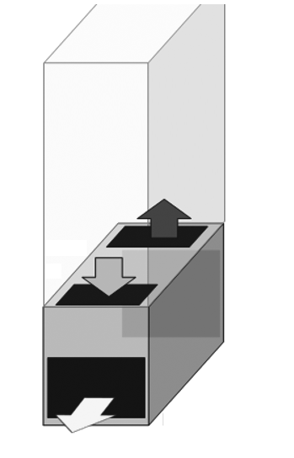
I.T. Space inside cabinet
Evaporator air outlet
Evaporator air inlet
Front
Rear
Condenser air outlet
Figure 1-1 VRC unit in cabinet
- The evaporator and heat rejection unit are placed in one enclosure. It’s easy to install being a plug-and-play unit, eliminating the installation work such as electrical wiring, vacuuming and refrigerant charge on-site and refrigerant piping.
- The cooling capacity varies from 25% to 100%, approximately 0.9 kW to 3.6 kW. It’s designed to efficiently cater to part-load or variable cooling loads.
- The unit is designed by Vertiv for high efficiency and reliability, and includes the variable capacity inverter compressor, electronic expansion valve, variable speed EC-fan, and controller.
- The evaporator EC fan provides energy savings by smoothly varying the fan speed to deliver the airflow required to match the cooling load.
- The condenser fan speed ranges from 30% to 100% in sync with the variation in the compressor cooling capacity.
  - Model Description
The physical appearance of the cooling module is shown in Figure 1-2.
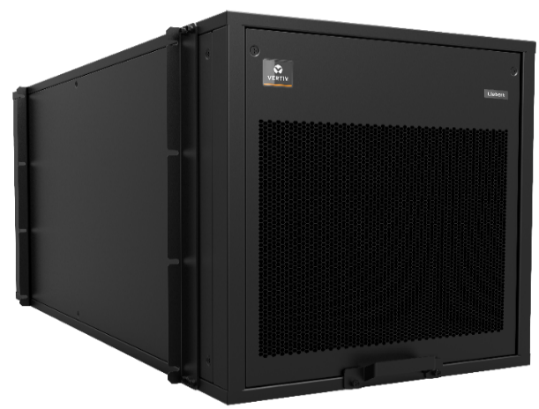
Figure 1-2 Appearance of the VRC precision air conditioner
The rear view and front view of cooling module are shown in Figure 1-3.
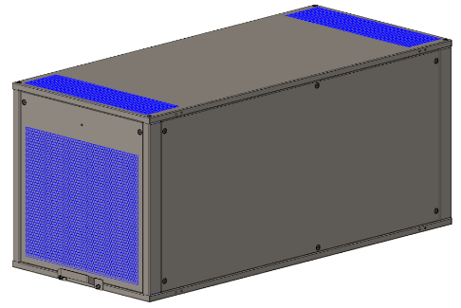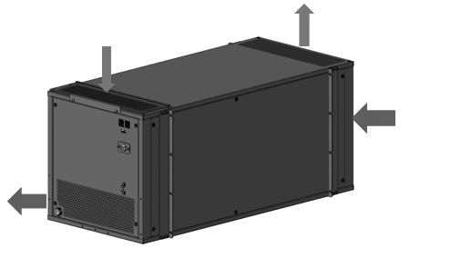
Supply air
Return air
Condenser in
Evaporator Side
Condenser out
Front View
Rear View
Figure 1-3 Front view and rear view of the cooling unit
  - Model Nomenclature
The nomenclature of the VRC units is shown in Figure 1-4.
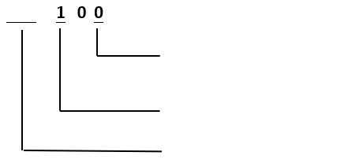
0 = 120 V, 1 Ph, 60 Hz
1 = 208/230 V, 1 Ph, 60 Hz
2 = 230 V,1 Ph, 50/60 Hz
1 = Self Contained Cooling Module
VRC=Vertiv Rack Cooler
VRC
Figure 1-4 Nomenclature
  - Components
The major components of the cooling module include the evaporator coil, evaporator EC fan, electronic expansion valve, compressor, condenser coil, and condenser AC fan which are placed in the VRC unit as shown below.
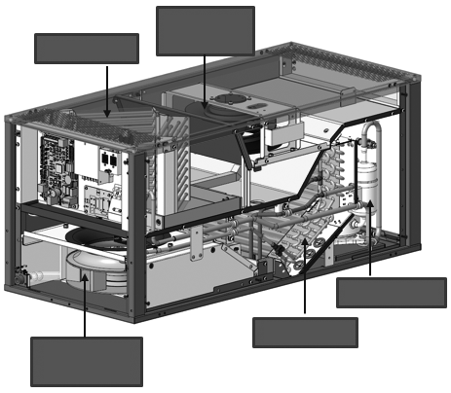
Evaporator EC fan
Condenser AC fan
Condenser
Compressor
Evaporator
Figure 1-5 Schematic diagram of internal parts of cooling section
- Evaporator Coil
The design of the V shaped evaporator coil provides maximum surface area for heat transfer which provides a high sensible heat ratio (SHR) of > 0.9. The coil is constructed from copper tubes with aluminum fins. Low air pressure difference across the coil reduces fan energy even at higher air flow rates, and the coil section is light and compact.
- Condensate Drain Tray
With a metal condensate drain tray placed under the coil assembly, condensation drains to a condensate outlet connection.

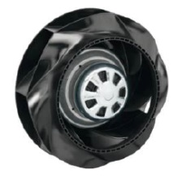
- Variable Speed Evaporator EC Fan
The cooling module is equipped with a high-efficiency EC fan made of aluminum that delivers high airflow rates to meet the airflow demands during the entire time of operational. The EC fan has a smooth speed variation across its operating speeds that work in synchronization with the entire system components to deliver precise output capacity.

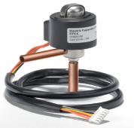
- Electronic Expansion Valve
The system is incorporated with an electronic expansion valve that monitors temperature and pressure signals simultaneously to maintain precise adjustment of the refrigerant flow. The electronic expansion valve ensures even flow distribution from each end.

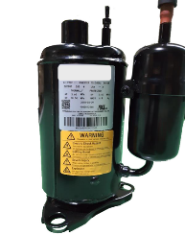
- Compressor
The cooling module is equipped with a variable speed inverter rotary compressor that works on R410A refrigerant and which varies its cooling output capacity as per the cooling demands.

- Condenser Coil
The L-shaped condenser coil is designed for a maximum contact area. It is made of copper tubes with an aluminum fin configuration.
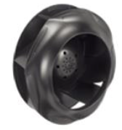
- Condenser Fan
The condenser unit is equipped with an AC fan which varies the operating speed with the cooling variations of the compressor to maintain a suitable condensing pressure. The condenser fans are made of metallic material for prolonged life and durability..

  - Technical Specifications
The detailed technical specifications which include the mechanical and the electrical details are mentioned in the below table:
Table 1-1 Technical specifications
Parameters | Specification
Model | VRC100 | VRC101 | VRC102
Certification | UL484 | UL484 | CE  (EN 60335-1; EN 60335-2-40;  EN 55014-1; EN 55014-2; EN 61000-3-2;  EN 61000-3-3; EN 50581)
Cooling Capacity, kW | 0.9 - 3.6 | 0.9 - 3.6 | 0.9 - 3.6
Air Volume, m3/h (CFM) | 750 (441) | 750 (441) | 750 (441)
Max Power Input, kW | 1.63 | 1.86 | 1.86
Full Load Amperage, A | 16.5 | 13 | 11.5
Dimensions (Without Package)  W x D x H mm (Inches) | 442x978x439 (17.4” x 38.5” x 17.28”)
Input Type | Power Cord (3.2m)  with NEMA 5-20P | Power Cord (3.2m)  with NEMA L6-20P | IEC 60320 C20 Inlet  + Interconnection Cable (3.0m)  IEC 60320 C19 to C20
Voltage (Vac) | L+N+G, 120 Vac | L1+L2+G, 208 Vac/230 Vac | L+N+PE, 230 Vac
Frequency, Hz | 60 |  | 50/60
Color | EG7021 (Black)
System Protection Grade | IP20 (IEC 60529)
Net Weight, kg (lbs) | 72 (158.7) |  | 74 (163.1)
Gross Weight, kg (lbs) | 134 (295.4)
Noise Level, dB(A) | <66
In the case that VRC is installed on the bottom of the rack, the maximum capacities at various evaporator and condenser air inlet temperatures are mentioned below:
Maximum Capacity, kW |  | Condenser Air Temperature
 |  | 29.4 °C (85 °F) | 35 °C (95 °F) | 40 °C (104 °F)
Evaporator Air Temperature to Cooling Module  (Return Control) | 29.4 °C (85 °F) | 3.1 | 2.6 | 2.2
 | 35 °C (95 °F) | 3.4 | 3.3 | 2.8
 | 40 °C (104 °F) | 3.6 | 3.5 | 3.1

Maximum Capacity, kW |  | Condenser Air Temperature
 |  | 25 °C (77 °F) | 30 °C (86 °F) | 35 °C (95 °F)
Evaporator Air Temperature to IT Devices  (Supply Control) | 19 °C (66 °F) | 3.3 | 3.2 | 3.1
Evaporator Air Temperature to IT Devices  (Supply Control) | 21 °C (70 °F) | 3.5 | 3.4 | 3.3
Evaporator Air Temperature to IT Devices  (Supply Control) | 23 °C (73 °F) | 3.6 | 3.5 | 3.4
In the case that VRC is installed on the bottom of the rack, the minimal cooling capacity are mentioned below:
Minimum Capacity, kW |  | Condenser Air Temperature
 |  | 29.4 °C (85 °F) | 35 °C (95 °F) | 40 °C (104 °F)
Evaporator Air Temperature to Cooling Module  (Return Control) | 29.4 °C (85 °F) | 0.90 | 0.88 | 0.86
 | 35 °C (95 °F) | 0.92 | 0.90 | 0.88
 | 40 °C (104 °F) | 0.94 | 0.92 | 0.90

Minimum Capacity, kW |  | Condenser Air Temperature
 |  | 25 °C (77 °F) | 30 °C (86 °F) | 35 °C (95 °F)
Evaporator Air Temperature to IT Devices  (Supply Control) | 19 °C (66 °F) | 0.89 | 0.88 | 0.87
Evaporator Air Temperature to IT Devices  (Supply Control) | 21 °C (70 °F) | 0.90 | 0.89 | 0.88
Evaporator Air Temperature to IT Devices  (Supply Control) | 23 °C (73 °F) | 0.91 | 0.90 | 0.89
NOTES:
- Capacity may be reduced with addition of heat rejection ductwork.
- There are two control methods which are supply control and return control. The return control mode is applied to an open environment, while the supply control mode is applied to an enclosed cabinet, such as Vertiv’s VRC-S.
- Supply air temperature set point variable between 18 °C (64.4 °F) – 23 °C (73.4 °F). The recommended supply air temperature set point is 21 °C (69.8 °F).
- When the VRC unit is used in an enclosed cabinet, the heat load should be evenly placed in the cabinet. And unused rack position should be covered with blanking plates.

PART II
INSTALLATION

- Pre-Installation
The air conditioner is engineered equipment and requires precise installation procedures for which the preliminary preparation is very important. This chapter details the installation preparation, including how to prepare the installation environment and space and reserve the maintenance space, the air conditioner running and storage environment requirement, and how to unpack and inspect. Please read this chapter carefully before installation.

WARNING! Only trained and qualified personnel must be allowed to install, maintain, and operate the unit.
WARNING! The sharp edges, sharp angles of the object, and bare buckle can result in severe injury. Only properly trained and qualified personnel wearing appropriate, OSHA-approved PPE should attempt to move, lift, remove packaging from or prepare the unit for installation.
WARNING: Risk of unit falling over. Improper handling can cause equipment damage, injury or death. Read all the guidelines pertaining to the system before unpacking, moving, lifting or installing the components. Read the labels on the unit carefully to understand the safety measures prior to handling the containment.
CAUTION: The center of gravity of the unit is inclined, therefore, when moving the unit adjust the bearing position of the forklift or hand pallet truck.

  - Fittings
The hardware used for fittings are shown in Figure 2-1.
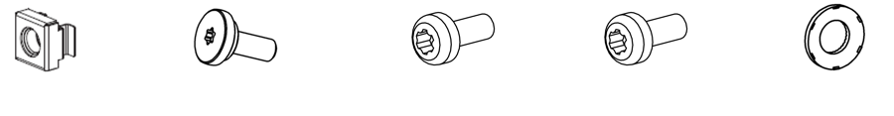
M6 Cage Nut
M5 Center Screw
M5 Pan-head Screw
M6 Pan-head Screw
Contact Washer
Figure 2-1 Fittings
The fitting nuts and their usage are shown in Table 2-1.
Table 2-1 Fitting utilities
Fitting Utility | Usage | Quantity
M6 cage nut | Used with M6 pan-head screws for tightening pillars | 20
M5 center screw | Used to fasten the L-shape rails | 10
M5 pan-head screw | Used to fasten the transition part | 10
M6 Pan-head screw | Used to install the VRC 10X unit | 20
Contact washer | Used together with the M5 pan-head screw | 10
  - Self-Prepared Material
The circuit breakers must be prepared at the customer site or are to be obtained by the customer; the specifications for the same are given in Table 2-2.
Table 2-2 Self-prepared materials
Parts | Specifications
External circuit breaker | Please refer to FLA of Unit
  - Transportation and Movement
The VRC1 need to be moved to the vicinity of the installation site. The cooling unit with heavy components, needs to be transported using equipment such as a hand pallet truck or electric forklift. Table 2-3 and Figure 2-2 show the dimensions of the unit with packaging.
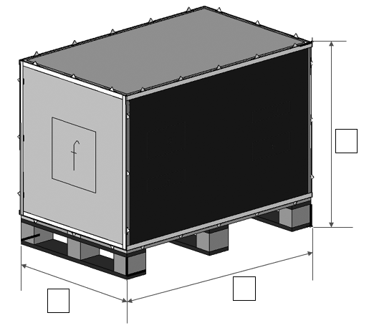
W
D
H
Figure 2-2 Package dimensions
Table 2-3 Overall dimensions and weight of the unit with packaging
Component |  | Packaging Material | Dimensions |  |  | Weight with Packaging
 |  | Packaging Material | H | W | D | Weight with Packaging
The VRC1 (With Packaging) | VRC100 | Wood case | 900 mm  (35.4”) | 730 mm  (28.7”) | 1170 mm  (46.1”) | 134 kg  (295.4 lbs)
The VRC1 (With Packaging) | VRC101
The VRC1 (With Packaging) | VRC102
If a hand pallet truck or an electric forklift truck is used, the tines of the hand pallet or electric forklift must be aligned with the center of gravity to prevent the package from toppling or falling over as depicted in Figure 2-3.
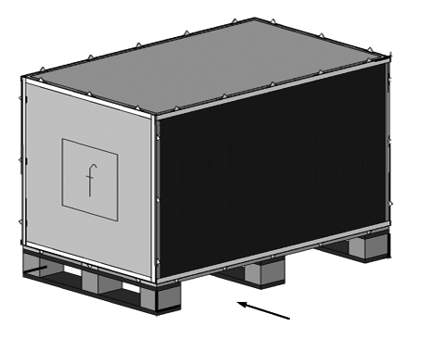
Forklift direction
Figure 2-3 Forklift direction
While moving the package, the obliquity has to be maintained at an angle of 90 ± 10 °. Figure 2-4 depicts the 90 ± 10 ° obliquity that is suitable to move the unit to the vicinity of the desired location.
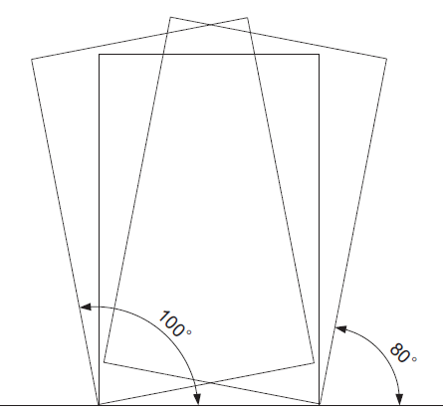
Figure 2-4 Carrying obliquity
NOTES:
- Ensure that the equipment stands upright. Do not place the equipment outdoors.
- While using the forklift or the hand pallet truck, ensure that the fork arms (if adjustable and flexible) open to the greatest extent. This is done so that the fork arms can be placed under the pallet of the equipment in a precise manner.
- Ensure that the length of the fork arms match with that of the equipment.
  - Unpacking
Unpacking the unit is show in Figure 2-5 below.
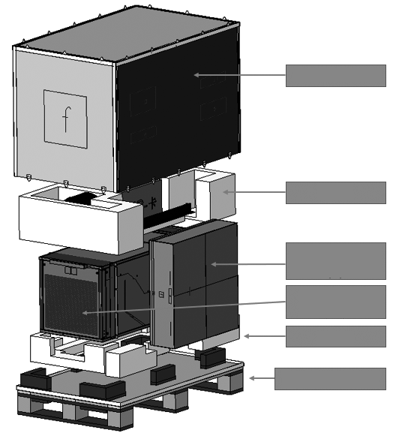
Wooden case
EPE
Wooden pallet
EPE
Ceiling tile kit (4)
Cooling unit (19)

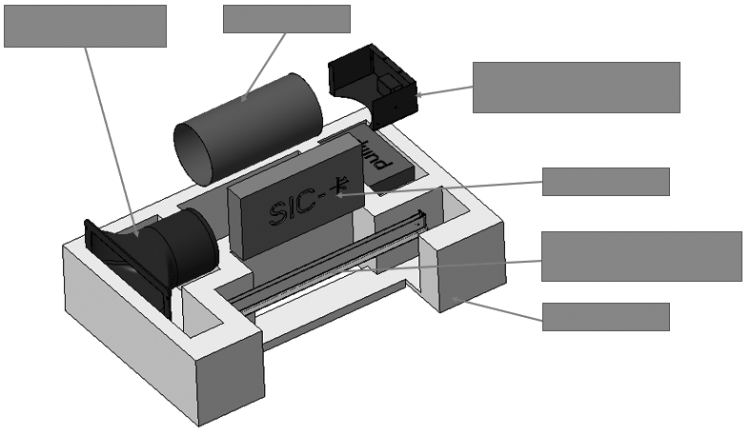
Transition Part (1)
Duct (2)
Pump Bracket (Pump is preinstalled) (5)
EPE
SIC Card (8)
L-shape Mounting Rail (7)
Figure 2-5 Unpacking

NOTES:
- Packing materials of the unit are recyclable. Retain the packing materials for further use or dispose them appropriately as per the protocols and local regulations.

The accessory list is shown in the table below.
Table2-4 Accessory list
Sr No. | Item |  | Quantity
1 | Transition Part |  | 1
2 | Flex Duct (3.8 m / 12.5 ft.) |  | 1
3 | Duct Clamp |  | 2
4 | Ceiling Tile Kit | Ceiling Tile for Air Outtake | 1
4 | Ceiling Tile Kit | Ceiling Tile for Filter Pad | 1
5 | Drainage Kit | Condensate Pump Kit | 1
5 | Drainage Kit | Condensate Pump Brackets | 1
5 | Drainage Kit | Condensate Water Pipe (7.5 m / 24.6 ft.) | 1
6 | L-shape Mounting Rail Kit |  | 2
7 | SIC Card Kit |  | 1
8 | Pan-Head Screws M6x12 (Torx T30) |  | 20
9 | Cage Nuts (M6) |  | 20
10 | Pan-Head Screws M5x12 (Torx T25) |  | 10
11 | Contact Washers for Pan-Head Screw M5x12 |  | 10
12 | Center Screws M5x12 (Torx T20) |  | 10
13 | Display kit | Display | 1
13 | Display kit | 10 m (32.8 ft.) Cable of Display | 1
13 | Display kit | 0.5 m (1.6 ft.) Cable of Display | 1
14 | Evaporator Filter |  | 1
15 | User Manual |  | 1
16 | Cable Ties 100x2.5 |  | 5
17 | USB Converter Cable |  | 1
18 | Lifting Straps |  | 2
19 | VRC Cooling Unit |  | 1
20 | VRC102 Power Cable (Only for VRC102) |  | 1

Following the steps below during the unpacking process. For installation, please refer to chapter 3.
- Move the equipment to level ground.
- Unlock the wooden case from the wooden pallet.
- Pull up the wooden case.
- Put the EPE and the ceiling tile kit aside.
- Remove the VRC 10X unit from the wooden pallet that is beneath the VRC 10X unit.

  - Equipment Installation Room Requirements
For best performance install the unit in thermally separated racks and install blanking panels in unoccupied U spaces to avoid hot air recirculation. Hot Air recirculation could de-stabilize the temperature gradient in front of the IT equipment.

NOTES:
- Avoid locating the indoor unit in concave or narrow areas which can affect the airflow. It is prohibited to use the cooling system in an outdoor environment.

  - Environment
Following are the requirements that need to be observed from the environment point of view for site preparation of the unit:
- Keep the unit in a place far away from flame or any heat source.
- Direct sunshine is detrimental to the system and therefore, the system needs to be placed at a location where it is not directly affected by sunlight.
- Emission of erosive gases and organic solvents should not be near the unit.

    - Operating Environment
The operating environment requirements for the unit are specified in Table 2-5:
Table 2-5 Operating environment
Item | Requirements
Ambient temperature | Indoor: +18 °C - +40 °C (64.4 °F – 104 °F)  Heat rejection Air: 0 °C - +40°C (32 °F – 104 °F)
Ambient humidity | <90% RH (30 °C / 86 °F)
Altitude | <1000 m (3,280 ft.). For every 1000 m (3,280 ft.) increase in elevation, the evaporation temperature drops by 0.5 °C (0.9 °F), and the net cooling capacity drops by 7%.

    - Storage Environment
The storage environment requirements for the unit are specified in Table 2-6.
Table 2-6 Storage environment
Item | Requirements
Storage environment | Clean (without dust)
Ambient humidity | < 95% RH (40 °C / 104 °F)
Ambient temperature | －40 °C - ＋70 °C (-40 °F – 158 °F)
Storage time | The total shipment and storage time should not exceed 6 months. Otherwise, the performance needs to be re-calibrated
  - Installation Space Requirements
The cooling unit is a specifically engineered air conditioning unit. It is recommended to install the unit inside the cabinet at the lowest section, as shown in the installation section 3.3.
- To facilitate ease of installation and maintenance, sufficient space needs to be provisioned as per Figure 2-6 below.
- The distance from the front door to the wall or other obstacles must be greater than 1050 mm, which to ensure the pull-out of the unit entirely for maintenance.
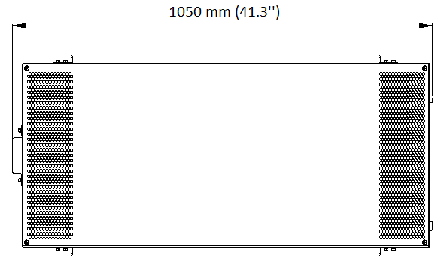
1050 mm (41.3”)
Figure 2-6 Minimum distance to pull-out the unit for maintenance
  - Condenser Airflow Clearance Requirement
To have sufficient space for condenser air inlet or outlet, the clearance in front and behind the VRC1XX unit should not be less than 600 mm (23.6’’).
NOTES:
- In the case that the air conditioner is installed in a rack, please refer to the rack instruction to check the clearance in front and behind the rack for installation or maintenance.
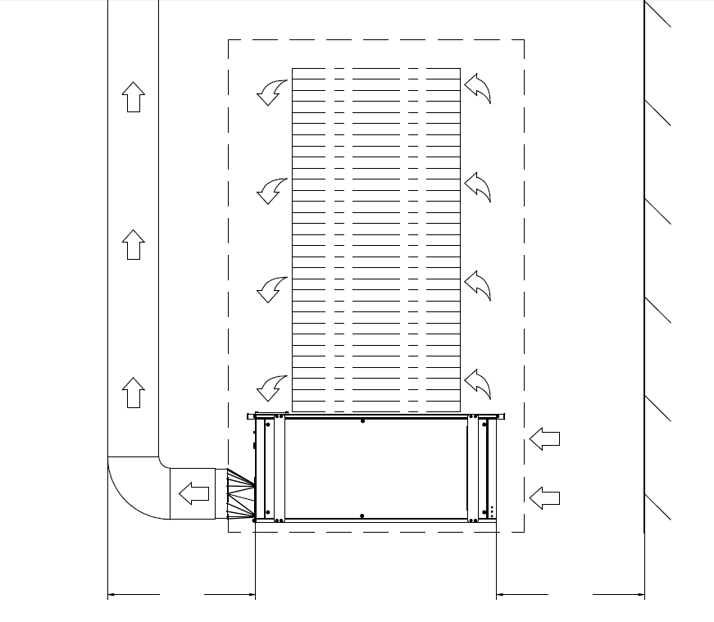
Server
Flexible duct
Hot Air from Servers
Cold Air
Outlet to Servers
Heat Rejection Air Outlet
Heat Rejection Air Inlet
Transition
parts
VRC UNIT
Wall
≥ 23.6"
[≥ 600mm]
≥ 23.6"
[≥ 600mm]
Rack
Figure 2-7 The required airflow clearance
  - Weight Bearing Capacity
The unit will be installed inside the cabinet which will increase the cabinet concentrated floor loading. Therefore, the weight bearing capacity of the floor of the room must be taken into consideration.
  - Inspection
- The unit is pre-charged. Check that there are no refrigerant or oil leaks.
- Check the system fittings and its components against the packing list to ensure that everything is in its designated position and the entire product assembly is intact.
- Immediately report any missing or damaged parts or components to the carrier. If hidden damages are observed, then contact the local service offices as soon as possible.

- Mechanical Installation (Site Preparation)
Proper installation is essential to achieve the intended design performance of the equipment and to maximize its service life. This chapter describes the mechanical installation of the precision air conditioner, including installation notes, system installation layout, end installation, unit piping installation, installation finishing work and installation inspection. This section should be used in conjunction with current mechanical and electrical installation regulations.
  - Installation Notes
NOTES:
- The air conditioner needs to be installed inside the cabinet with the mounting rails as per the procedure mentioned in Section 3.3.
- Before installation, make sure that the installation environment meets the requirements (Table 2-5 Operating Environment) and there must be sufficient provision for connecting the condensate drain line to the drain point.
- Follow the design drawings strictly while installing the equipment and reserving the space for maintenance.
- It needs 2 persons during installation.
- Torx bits T20, T25 and T30 are needed during installation.
Figure 3-1 Torx bits
  - System Installation Layout
    - Overall layout of the system
The overall layout of the unit is depicted in the Figure 3-2 below. Hot air generated by the condenser of VRC 1XX is discharged through transition part and ducted to the ceiling. Condensate water is drained out by the pump.
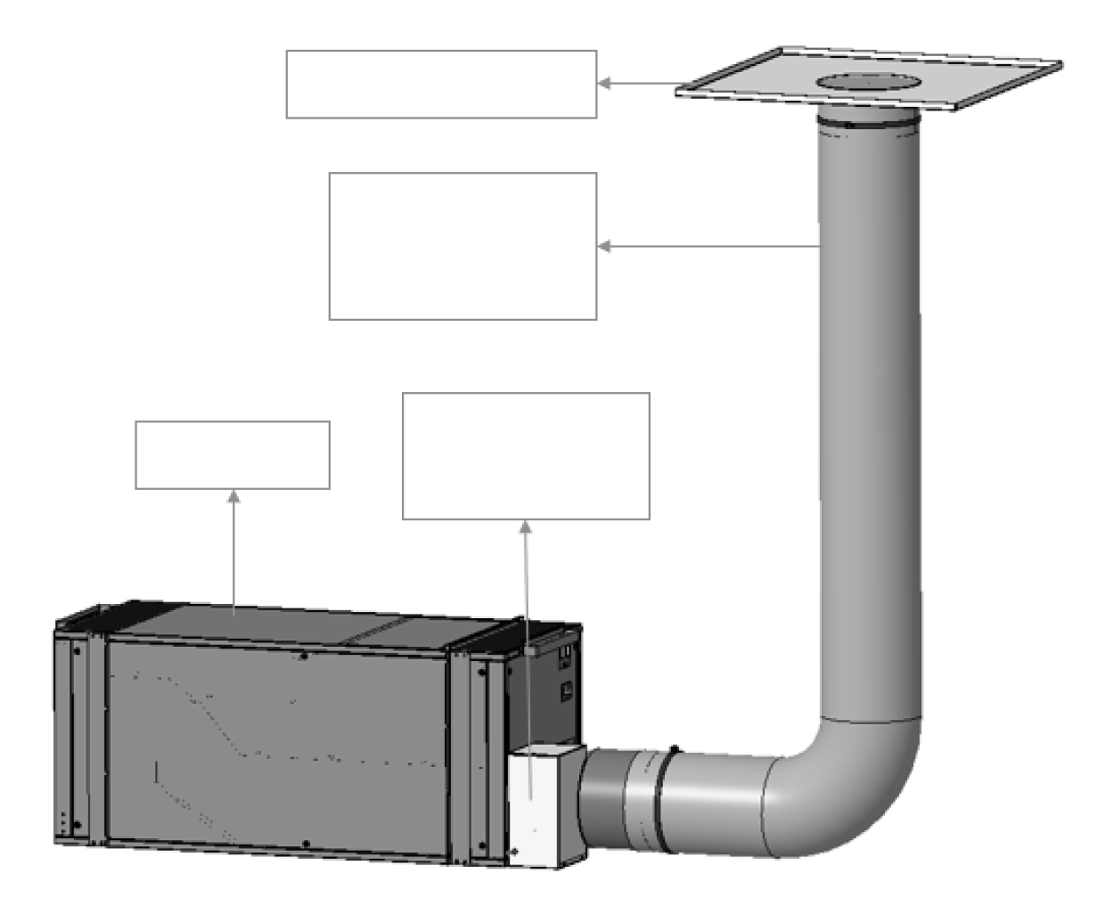
Ceiling Tile Unit
Flex Duct
Max length=3.8 m/12.5 ft
VRC1 Unit
Condensate Pump Unit
Figure3-2 Overall layout of the system
    - Overall layout of the VRC unit
The overall layout of the unit is depicted in the Figure 3-2 below.
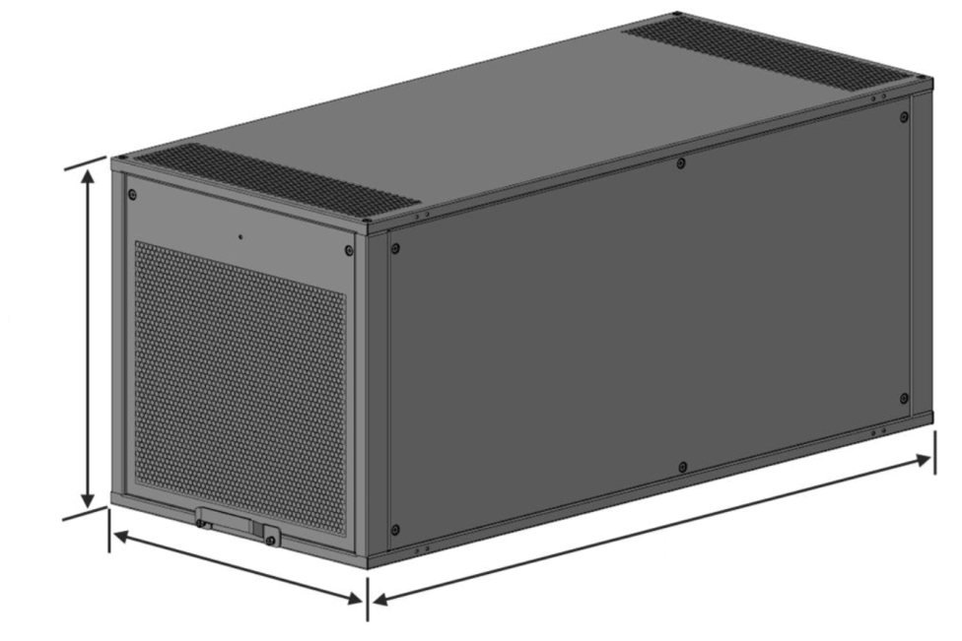
439 mm (17.3 in)
442 mm (17.4 in)
978 mm (38.5 in)
Figure 3-3 Overall layout of the unit
  - Installing the VRC Unit into the Rack
The installation process for the cooling unit consists of mounting the unit inside the cabinet, connecting the condenser duct and the drain piping.
    - Evaporator filter installation
The filter is installed on the air return side of the evaporation side.
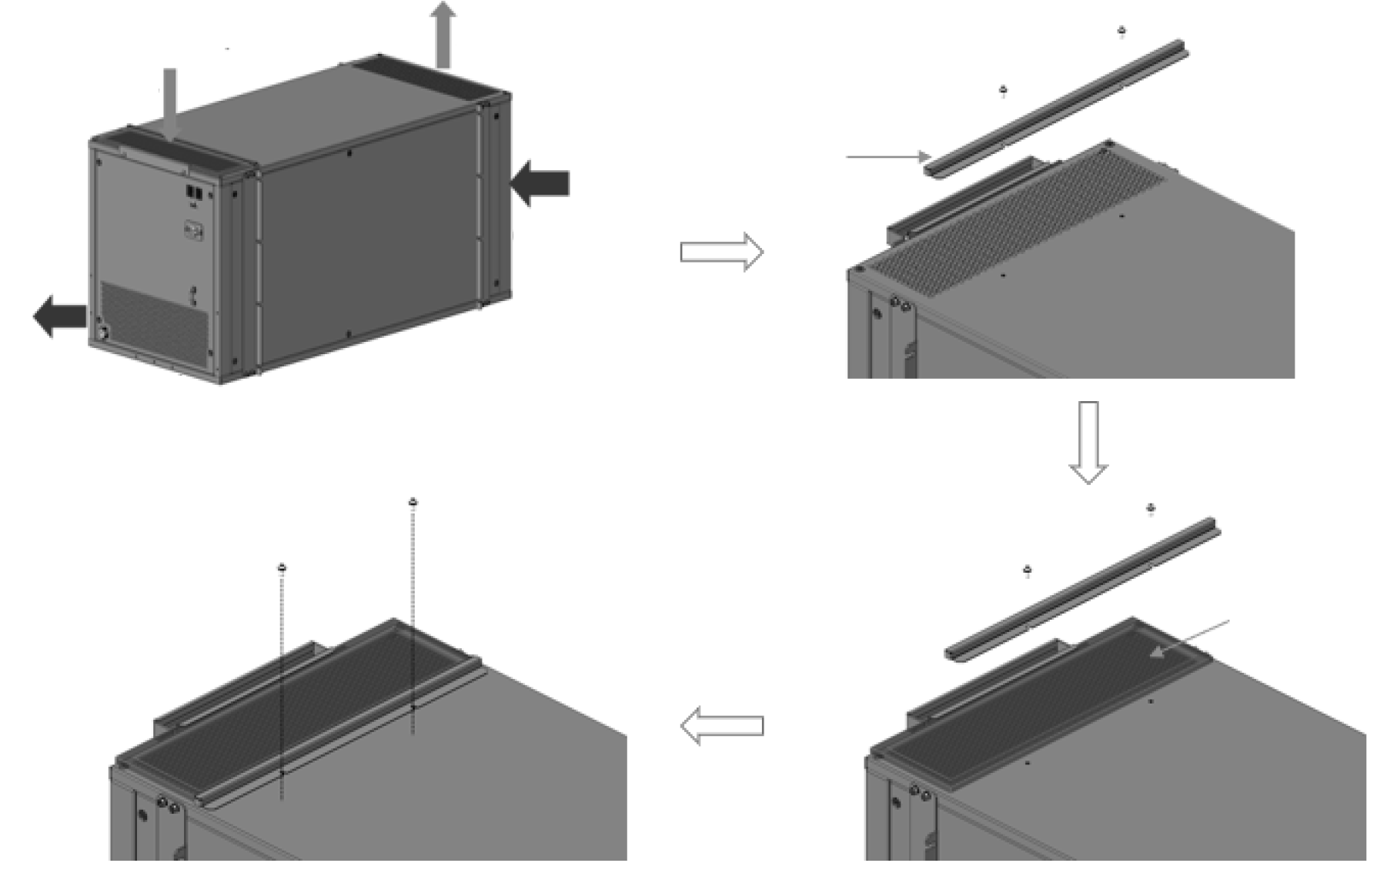
1. Loosen the screws and remove this bracket.
2. Place the filter on the air return position
3. Tighten the screws to secure the filter
Filter
Supply air
Return air
Condenser in
Evaporator Side
Condenser out
Figure 3-4 Install the evaporator filter
    - Installing the unit inside the 4-post rack
For installation in a 4-post rack, please refer to the procedure below.
NOTES:
- For installation in a 2-post rack, please purchase accessory 2POSTRMKITVRC. Installation instructions are included with this rail kit.
- Mount the L-shaped rails in the rack.
Each of the two L-shape rails are comprised of two parts, a long front rail and a slotted rear bracket. There are left and right VRC rails. The flanges of each of the front rails should be on the bottom and pointing toward the center of the rack. Slip the slots in the rear rail bracket over the pressed studs in the front rail part. Loosely fasten with nuts. Fasten the ends of the front rails and rear brackets to the uprights using center screws M5x12 T20. Torque=4.0 Nm (2.95 lb-ft). Once in place, tighten the nuts on the front rail part studs. Torque = 5.6 Nm (4.13 lb-ft).
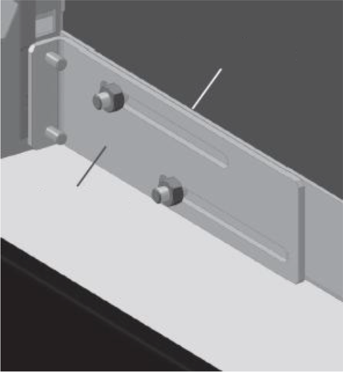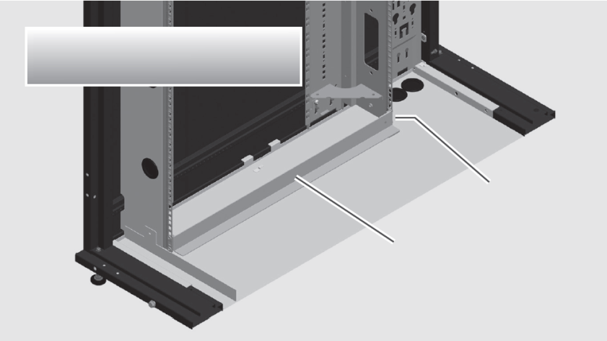
Front rail part
Slotted rear bracket
Cross section of vRack shown for illustrative purposes.
VRC rear left bracket
VRC front left rail
Figure 3-5 L-shape rails installation
- Dismantle the C-pillar and D-pillar from the rear side.
NOTES:
- The direction of the pillar is correct as Figure 3-6 depicted.
- The distance between A-pillar and C-pillar (or between B-pillar and D-pillar) is 737 mm (29’’).
- The distance between C-pillar and D-pillar is 460 mm (18.1’’).
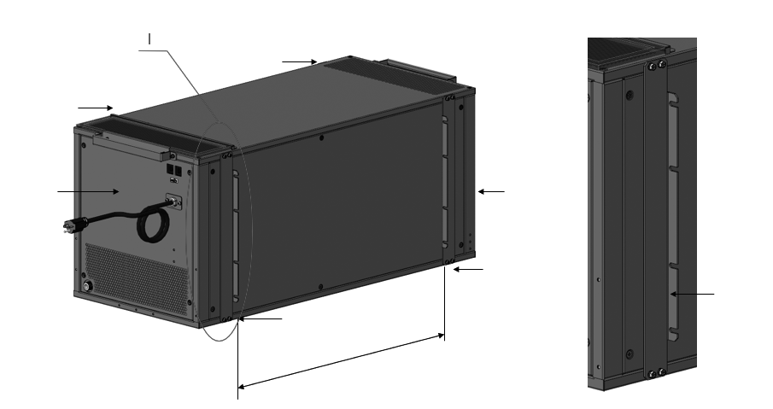
C-pillar
A-pillar
737 mm / 29.0"
C-pillar
Back
Front
I: The direction of the pillar
B-pillar
D-pillar
C-pillar
Figure 3-6 Right-side view
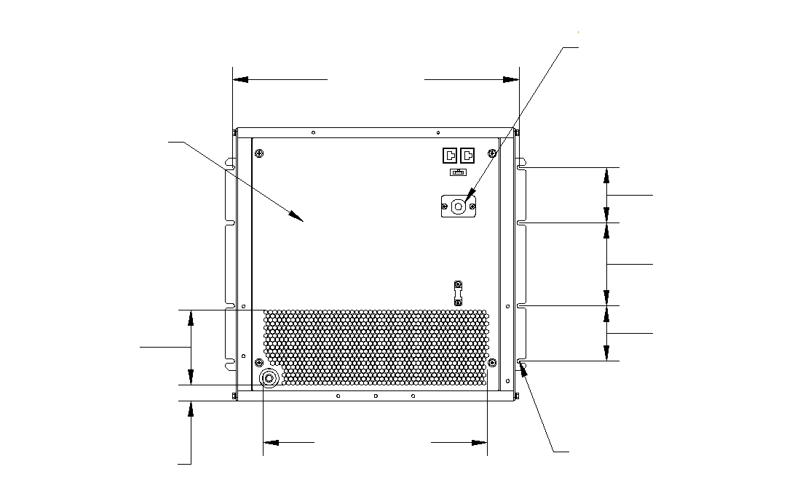
Strain Relief Bushing
Electrical Access Panel
3.5"
[88.9mm]
5.2"
[133.3mm]
3.5"
[88.9mm]
14.2"
[360.3mm]
18.1"
[460mm]
4.8"
[121.1mm]
1.0"
[25.4mm]
8Xø0.27"
[8Xø7mm]
Figure 3-7 Back view
- Use 2 lifting straps and VRC handles to slide in the unit inside the cabinet from the front side till the B-pillar and the A-pillar are completely flushed against the cabinet 19’’ profiles. The distance from front rails to front door is 121 mm (4.76’’).
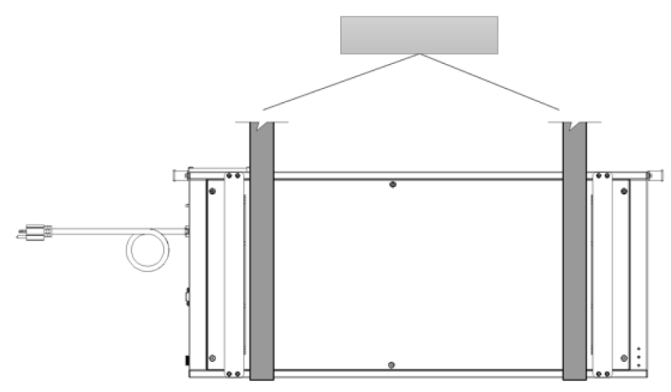
Lifting straps
Figure 3-8 Lifting straps
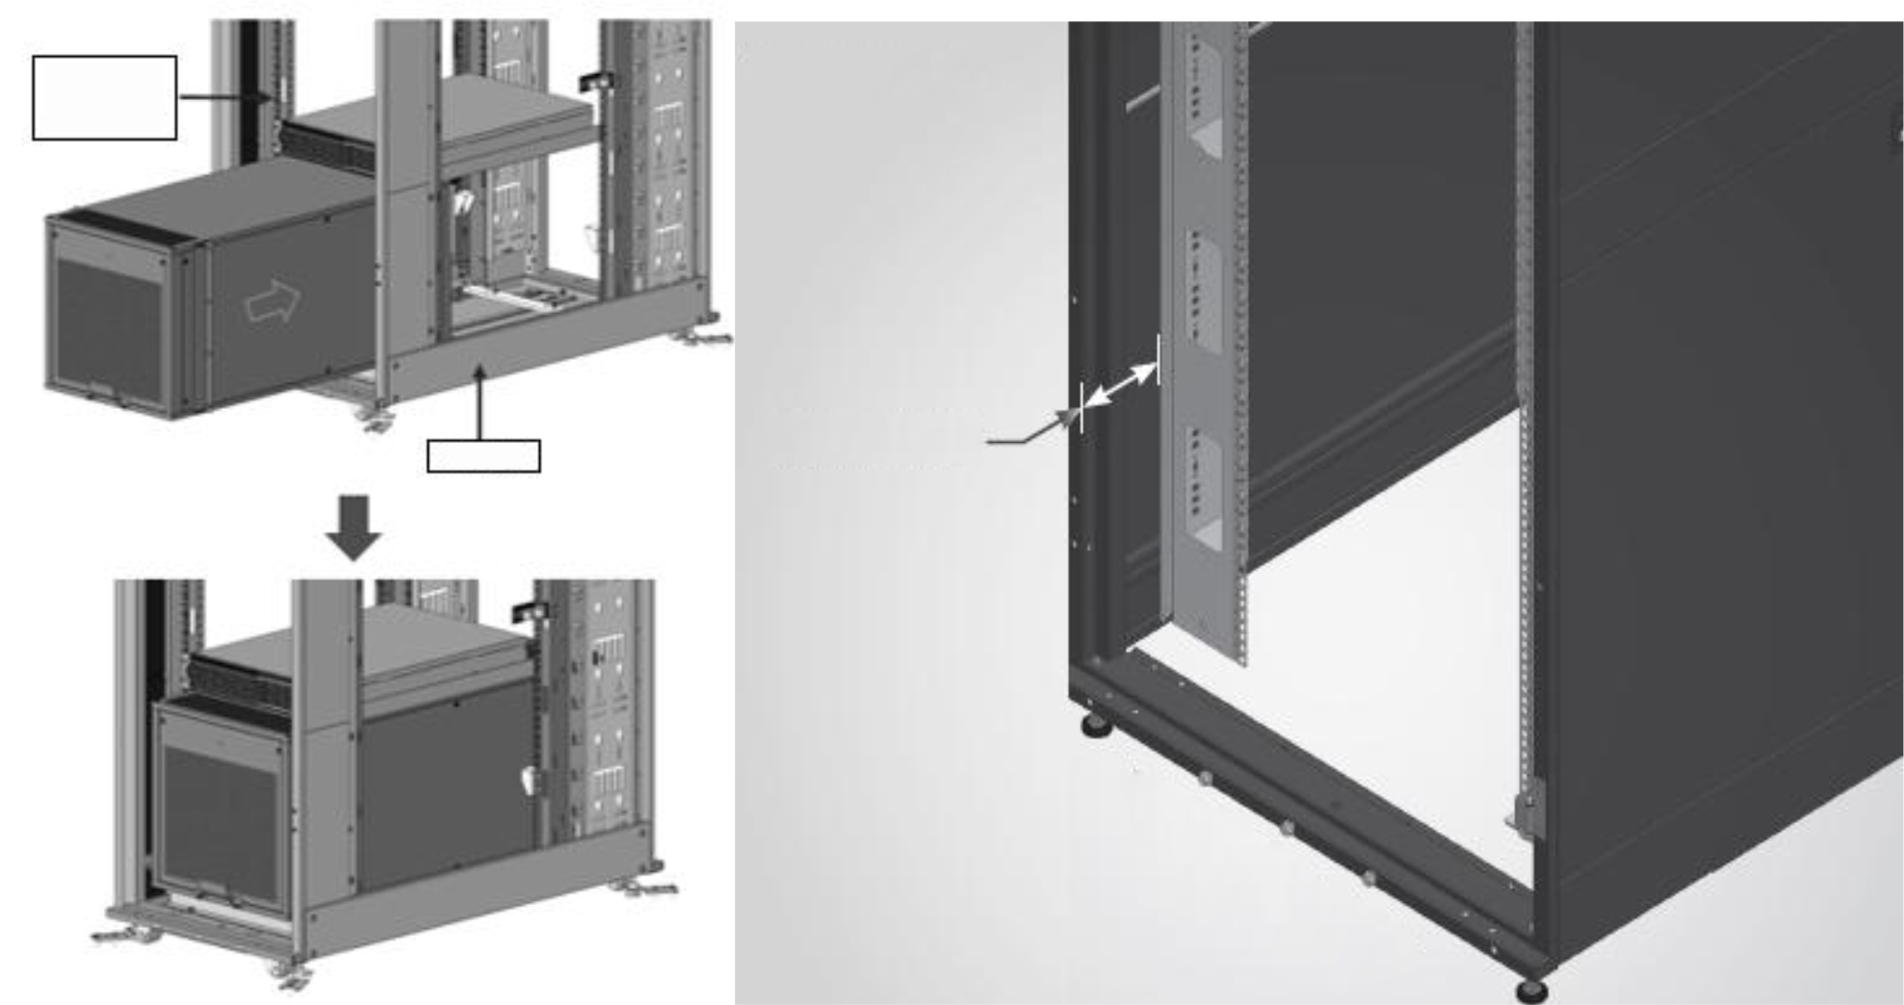
Other devices
Rack
Profile Distance
121 mm/4.76”
FRONT VIEW OF BACK
Figure 3-9 Mounting the VRC into the rack
- The distance between A-pillar and C-pillar (or between B-pillar and D-pillar) is 737 mm (29’’). If the cabinet space is suitable, then install the C-pillar and D-pillar back again onto the unit body casing. If not, then only installing A-pillar and B-pillar is OK.
- Firmly secure A-pillar, B-pillar, C-pillar and D-pillar on the cabinet column with 2 M6x12 screws (fastened with cage nuts) per pillar. Torque = 5.6 Nm (4.13 lb-ft).
NOTES:
- Ensure that the installation direction of pillars is correct. And ensure the VRC unit is installed horizontally, otherwise high-water level alarms may be triggered incorrectly.
  - Connecting the Accessories.
If the unit must be placed in an environment where the hot air from the condenser duct needs to be extracted from the room and discharged at a suitable pre-determined location, an air duct is provided as a part of the accessories shipped with the unit and can be connected to the condenser discharge side.
If a gravity drain is not possible, a condensate pump kit is provided as a part of the accessory shipped with the unit and can be installed in the field.
    - Remove the power cable clamp from the VRC1 unit
The power cable clamp is used to secure the power cable during transportation. Before installing the accessories, it needs to be removed.
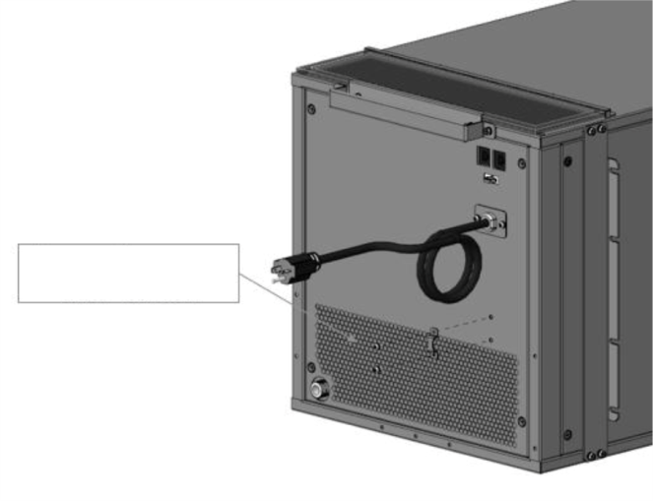
Remove the power cable bracket
Figure 3-10 Remove the power cable bracket
    - Installing the drain fitting to the VRC1 unit
Fasten the drain fitting to the drain port of the VRC1 unit. The drain fitting contains a sealing block, which is used for preventing the water leaking from the drain fitting port. Make sure the sealing block is installed tightly.
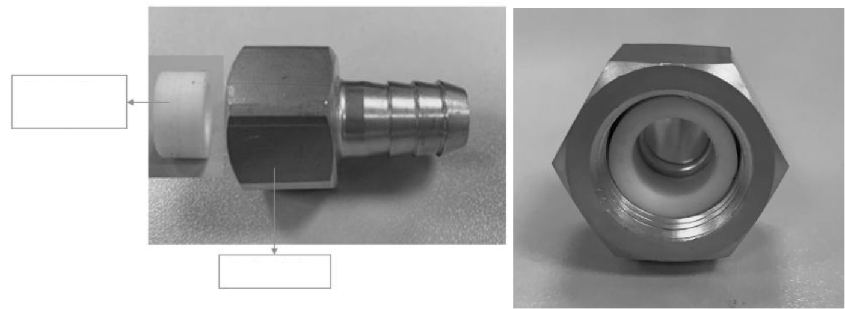
Drain Fitting Sealing Block
Drain Fitting
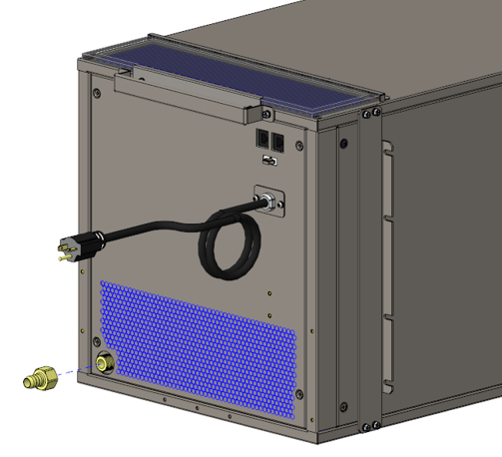
Figure 3-11 Install the drain fitting
    - Installing the transition part on VRC1 unit
The transition part is installed on the condensing air discharge side. On this step, it can be installed with 6 M5x12 pan-head screws and 6 M5 contact washers. Torque=4.0 Nm (2.95 lb-ft)
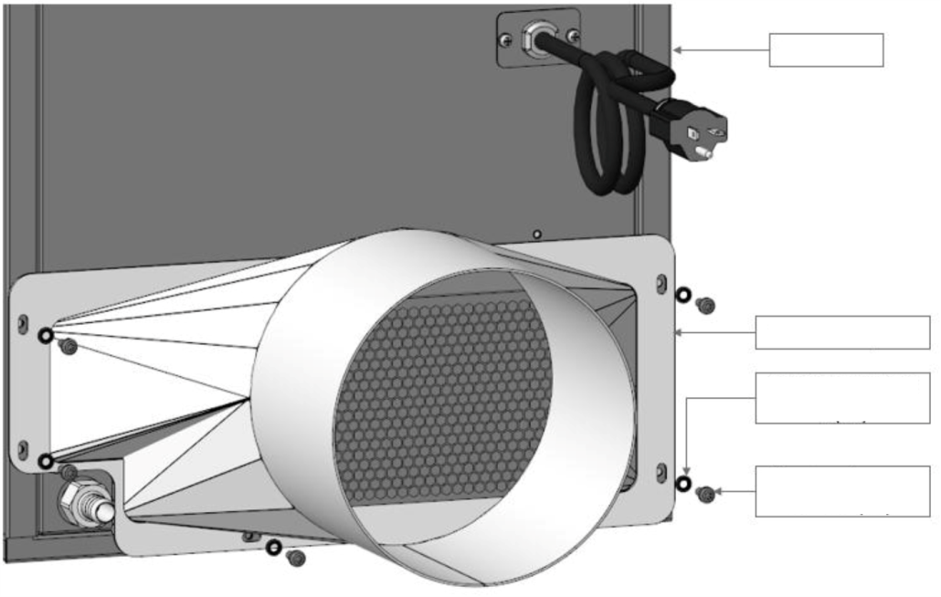
Transition part
Contact washer 5(x6)
Pan-head screw M5x12(x6)
VRC 10X
Figure3-12 Transition part installation

    - Connect the L-shape pipe to the drain fitting
The L-shape pipe, ID=16 mm (5/8’’) is placed in the pump kit.
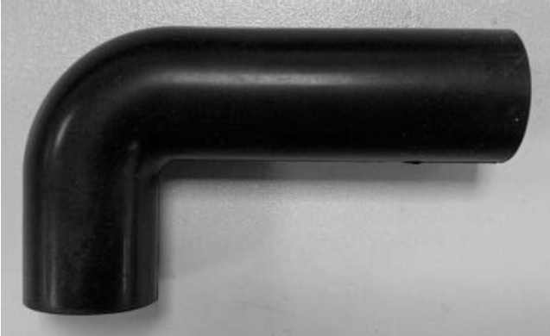
Figure 3-13 L-shape pipe
Connect the L-shape pipe to the drain fitting. Use a cable tie to fasten it.
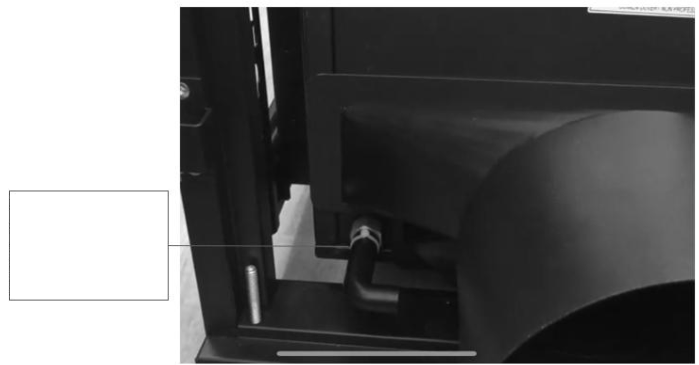
Connect the L-shape pipe, ID=16 mm (5/8") to the drain fitting.
Use a cable tie to fasten it.
Figure 3-14 Connect the pipe 4 to the drain fitting
    - Installing the pump
- The pump bracket is comprised of two parts, pump bracket 1 and pump bracket 2.
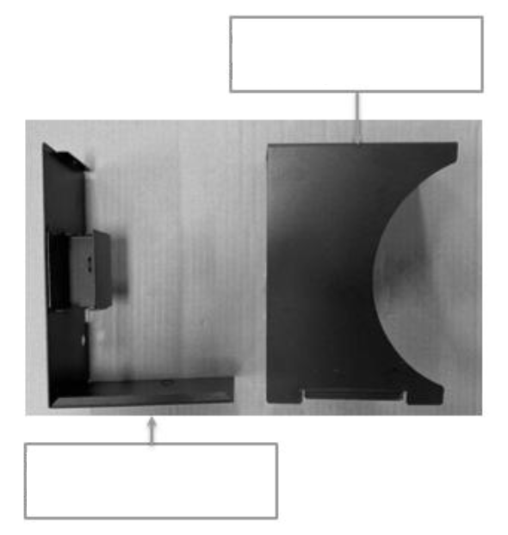
Condensate pump bracket part 2
Condensate pump bracket part 1
Figure 3-15 Pump bracket
- Loose the screw and remove the pump bracket part 2 from the pump bracket part 1. The pump is pre-installed on the pump bracket part 1 in factory.

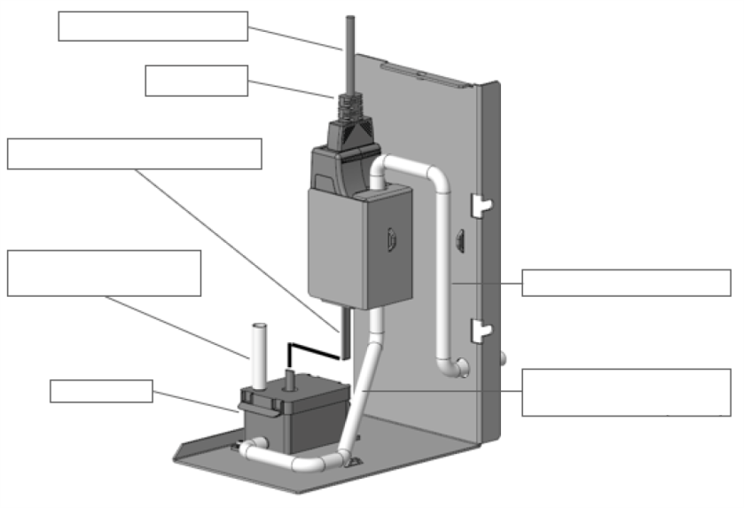
Pump power cable
Pump
Pump communication cable
Pipe 1 ID=6mm (1/4")
L=60mm (2.4")
Pipe 3 ID=6mm (1/4")
Pipe 2 ID=6mm (1/4")
L=300mm (11.8")
Reservoir
Figure 3-16 Pump is pre-installed on the bracket 1
- Install the pump bracket part 1 on the condensing air discharge side of the VRC1, tightened by two pan-head screws with contact washer (M5 x 12). Torque=4.0 Nm (2.95 lb-ft).
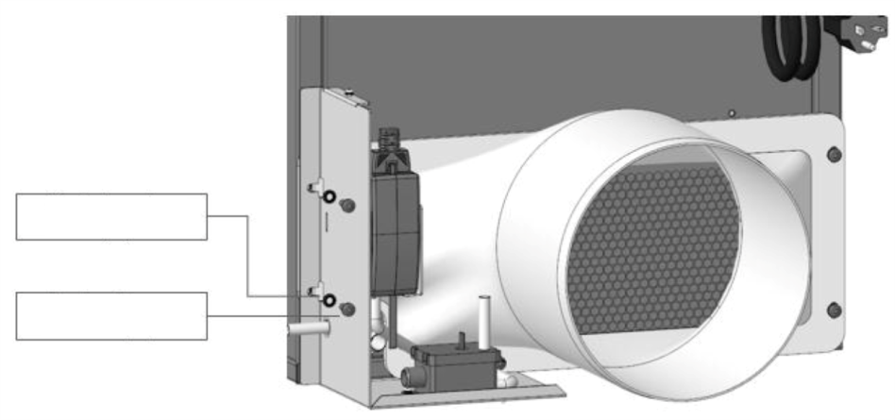
Contact washer
5(x2)
Pan-head screw
M5x12(x2)
Use a cable tie to fix it
Using a screw to install it
Condensate pump bracket part 2
Figure 3-17 Install the pump bracket part 1 on the unit
- Then connect the L-shape pipe and the reservoir. Use a cable tie to fix it.
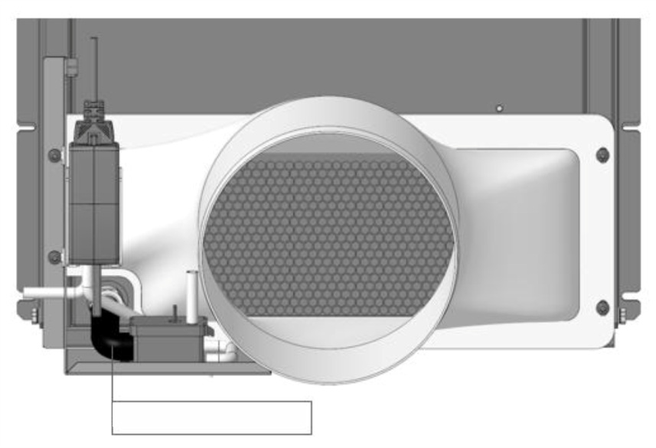
Use a cable tie to fix it
Figure 3-18 Connect the pipe 4 and the reservoir
- After that, condensate pump bracket part 2 should be tightened by a M5 screw. Torque=4.0 Nm (2.95 lb-ft).
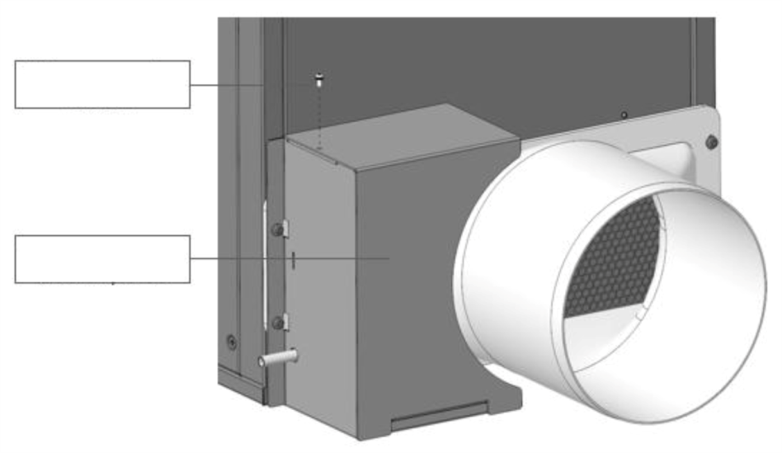
Condensate pump bracket part 2
Using a screw to install it
Figure 3-19 Pump bracket part 2 installation
- There are a condensate water pipe (7.5 m / 24.6 ft) in the package, which can be used to extend drainage lines.
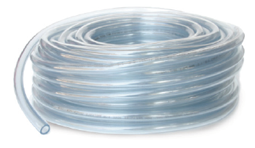
Figure 3-20 Anti-Siphoning device and condensate water pipe
The pump power plug can be pulled out from the gap between the pump bracket and the transition part. In case of powering the condensate pump not through rPDU in vRack, the pump must be protected by a 1 A inline fuse upstream.
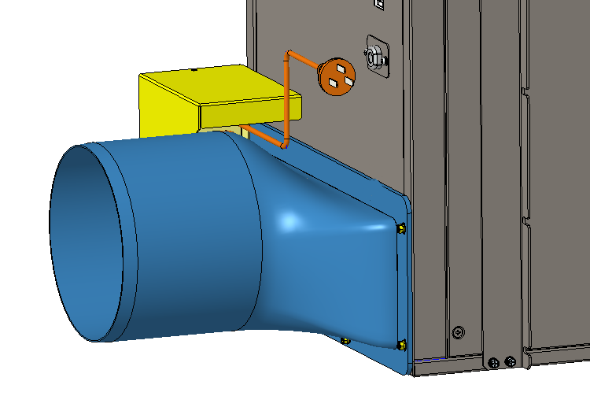
Figure 3-21 Pull out the pump power plug
The pump power plug for different versions of VRC1 units is depicted as the table below.
Table3-1 Pump power plug
Unit | Plug | Rating
VRC100 | NEMA 5-20 | 20 A, 125 Vac
VRC101 | IEC60320 C14 | 10 A, 250 Vac
VRC102 | IEC60320 C14 | 10 A, 250 Vac
    - Connect the duct to the transition part
The total length of the cylindrical part of the transition part is 100 mm (3.94’’). To ensure the connection reliability, the minimal overlapping of duct and transition part should not be less than 90 mm (3.54’’), and make sure the clamping force is sufficient.
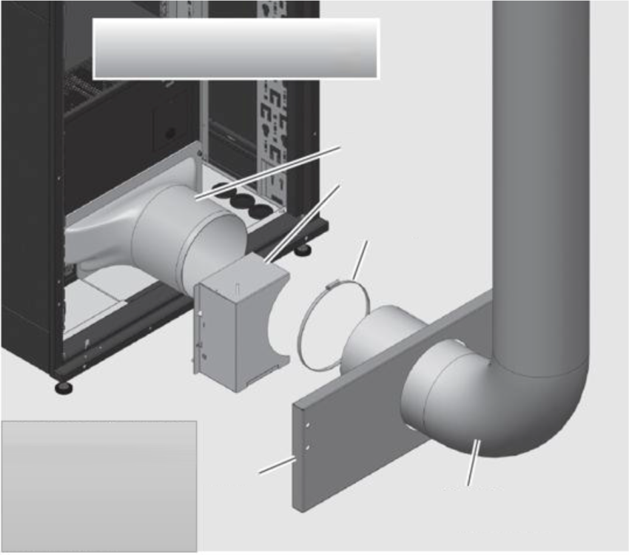
Rear cabinet door shown removed for illustrative purposes.
Transition
PN : 21121507
Condensate pump
PN : 02092419
Pipe clamp
PN : 63128710
It is showed in a VRC-S for illustrative purpose. The thermal separation kit and plinth are not included in the VRC kit.
Plinth
Air duct
PN : 27140303
Figure 3-22 Connect the duct and transition part
NOTES:
- Before connecting the duct, the air duct needs to pass through the rear cabinet plinth firstly.
    - Connect the duct to the ceiling tile for air outtake
Connect the duct to the ceiling tile for air outtake which will be mounted on the ceiling and secure it with a clamp. Also, the minimal overlapping of duct and transition part should not be less than 90 mm (3.54’’), and make sure the clamping force is sufficient to ensure the connection reliability.
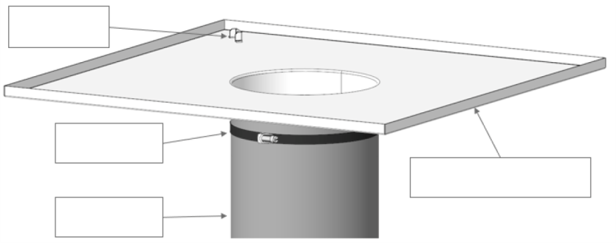
A hook for construction
Flex Air Duct PN:27140303
Clamp
PN:63128710
Ceiling tile for air outtake PN:21243048
Figure 3-23 Connect the duct and ceiling tile for air outtake
NOTES:
- There is a hook on the ceiling tile for air outtake for safety reason when connecting the ceiling tile to the ceiling construction.
    - Install the ceiling tile for filter pad
The ceiling tile for filter pad is installed in a 2’x2’ ceiling tile at the air inlet. The fresh air enters the condenser for heat exchange through the ceiling tile filter. The ceiling tile for filter pad is used to clean the fresh air.
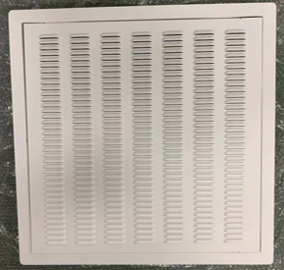
Figure 3-24 The ceiling tile for filter pad
    - Installation/Pre- commissioning Check List
After the unit is installed with all of the necessary mechanical connections, check the installation per Table 3-2.
Table 3-2 Mechanical installation checklist
Items | Results
Sufficient space for maintenance activities at site
Ensure all the fittings are tightly connected.
Make sure that the unit is placed correctly. Verify that the supply air is sent to the cold aisle at the front of the unit and that the hot air is drawn to the return air inlet in the back of the unit.
Foreign materials in and around the equipment are removed (such as shipping materials, removed structural materials, tools, and so on)
The condensate drain pipe is connected properly
After all these items are checked and confirmed, continue with the electrical installation procedure for the unit.
- Electrical Installation
This chapter describes the electrical installation of the air-conditioning unit, including task introduction, installation precautions, end cable connection and electrical inspection.

WARNING! Arc flash and electric shock hazard. Open all local and remote electric power-supply disconnect switches, verify with a voltmeter that power is Off and wear appropriate, OSHA-approved personal protective equipment (PPE) per NFPA 70E before working within the electric control enclosure. Failure to comply can cause serious injury or death. Customer must provide earth ground to unit, per NEC, CEC and local codes, as applicable. Before proceeding with installation, read all instructions, verify that all the parts are included and check the nameplate to be sure the voltage matches available utility power. The Liebert® controller does not isolate power from the unit, even in the “Unit Off” mode. Some internal components require and receive power even during the “Unit Off” mode of the controller. The only way to ensure that there is NO voltage inside the unit is to install and open a remote disconnect switch. Refer to unit electrical schematic. Follow all local codes.
WARNING! Risk of electric shock. Can cause equipment damage, injury or death. Open all local and remote electric power supply disconnect switches and verify with a voltmeter that power is off before working within any electric connection enclosures. Service and maintenance work must be performed only by properly trained and qualified personnel and in accordance with applicable regulations and manufacturers’ specifications. Opening or removing the covers to any equipment may expose personnel to lethal voltages within the unit even when it is apparently not operating and the input wiring is disconnected from the electrical source.
WARNING! Risk of electric shock. Can cause injury or death. Open all local and remote electric power-supply disconnect switches and verify that power is Off with a voltmeter before working within the condensate pump electrical connection enclosure. The Liebert® controller does not isolate power from the unit, even in the “Unit Off” mode. Some internal components require and receive power even during the “Unit Off” mode of the Liebert® controller.
WARNING! Do not power on the unit until authorized technical personnel have confirmed that the unit connections are correct.
WARNING! Risk of improper wire sizing/rating and loose electrical connections. Can cause overheated wire and electrical connection terminals resulting in smoke, fire, equipment and building damage, injury or death. Use correctly sized copper wire only and verify that all electrical connections are tight before turning power On. Check all electrical connections periodically and tighten as necessary.
  - Installation Notes
NOTES:
- All power and control wiring and ground connections must be in accordance with the National Electrical Code and local codes.
- Refer to the equipment nameplate for full load current and electrical requirements. The wire sizes should meet the local wiring standards and regulations.
- Requirements for the main power supply 120 Vac ± 10%, 1 Ph, 60 Hz or 208 Vac ± 10%, 1 Ph, 60 Hz or 230 Vac ± 10%, 1 ph, 50/60 Hz must be consistent with the unit nameplate power supply.
- Power cord is a Y-type connection. If the power cord is damaged, it must be replaced by a professional maintenance person.
- Before performing any electrical works, use a voltmeter to measure the power supply voltage and make sure that the power supply has been switched off.
- The equipment needs to be installed with screws, rails and other methods to avoid shaking during startup or operation process.
- Disconnect the rated circuit breaker from the power supply.
  - Cable from the Power Supply Connection
    - Electrical Box Placement
The electric box is located at the back of the unit as shown in Figure 4-1. For VRC100 and VRC101, the power cord with plug comes pre-attached from the factory.
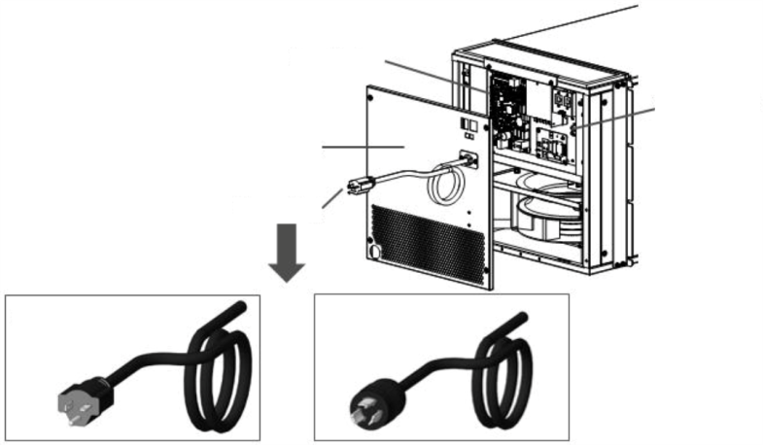
Back Plate
Power Plug
Electric Box
5-20P for VRC100
L6-20P for VRC101
3PIN Terminal
Interconnection Cable (3.0m) IEC 60320 C19 to C20
VRC100 and VRC101
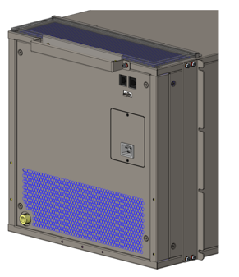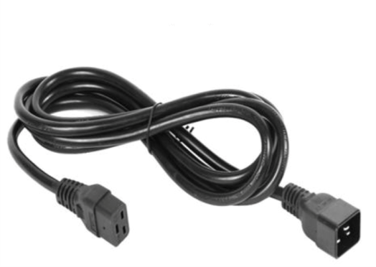
VRC102
Figure 4-1 Electric box of VRC100, VRC101 and VRC102
For the VRC102, the interconnection cable IEC 320 C19 to C20 is provided in the package. Connecting the power cables between the VRC102 and the power supply onsite.
    - Display connection
The display board is connected to the unit with a power cable (Available in two lengths of cables, one is 10 m and the other is 0.5 m) as show in Figure 4-2.
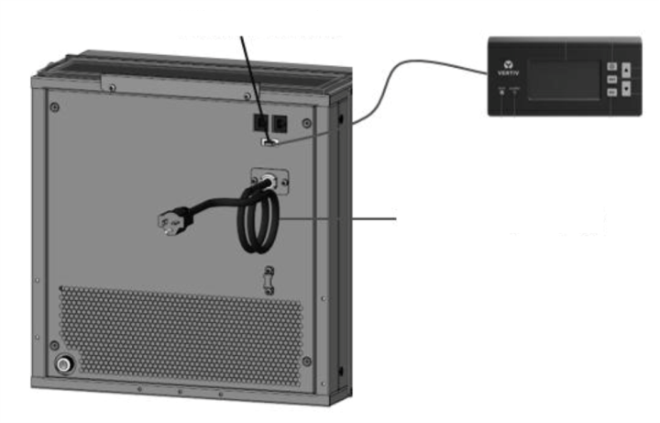
Display board plug
Power cable (with plug)
Figure 4-2 Display, power and monitoring cable connections
    - Communication
There are two RJ-45 ports present on the unit for communication with third party monitoring systems to enable remote monitoring of the unit. The RS485-1 (With 12 V power supply) could connect with the SIC card monitoring kit. For detailed installation, please refer to SIC Field Instructions. The RS485-2 can be used for communication with Vertiv rPDU. The aforementioned connections are shown in Figure 4-3 and Table 4-1.
NOTES:
- The VRC has only one slave port for master (Modbus RTU slave). It cannot support two Modbus RTU masters simultaneously.
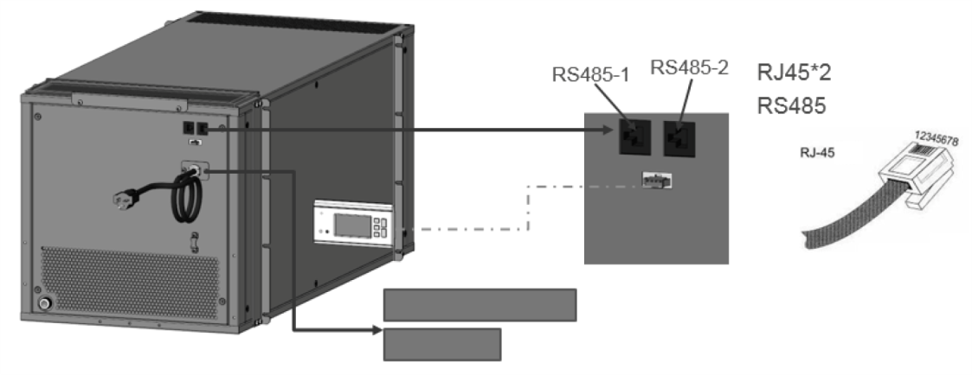
Communication
Strain Relief Bushings
Power cable
Display connector
Figure 4-3 Communication cable connections
Table 4-1 Communication port description
Port Type | RS485-1 | RS485-2
1 | 12 V | NC
2 | 12 V | NC
3 | NC | NC
4 | GND | GND
5 | GND | GND
6 | NC | NC
7 | D+ | D+
8 | D- | D-
  - Installation Inspection
- After the electrical installation is completed, perform the installation inspection listed in Table 4-2.
- After confirming the above items, you can start the commissioning of the VRC unit.

Table 4-2 Installation inspection
Items | Results
The power supply voltage meets the rated voltage on the unit nameplate
The system electric loop has no open circuit or short circuit
There must be no open-circuit or short-circuit in the electrical connections.
The power cable and grounding cable to the air-break switch are connected.
The ratings of the Miniature Circuit Breaker and fuses are correct (Refer to unit nameplate to select suitable Miniature Circuit Breaker or fuses)
The control cables are tightly connected.
All the cables connections are fastened appropriately, with no loose screws at the connections

- Controller Operation Instructions
This chapter gives a detailed description of the features, appearance, LCD screen, control buttons, control interface and menu structure of the air conditioner.
  - LCD Screen
The backlit LCD screen displays English menus. Figure 5-1 depicts the image of the controller display.
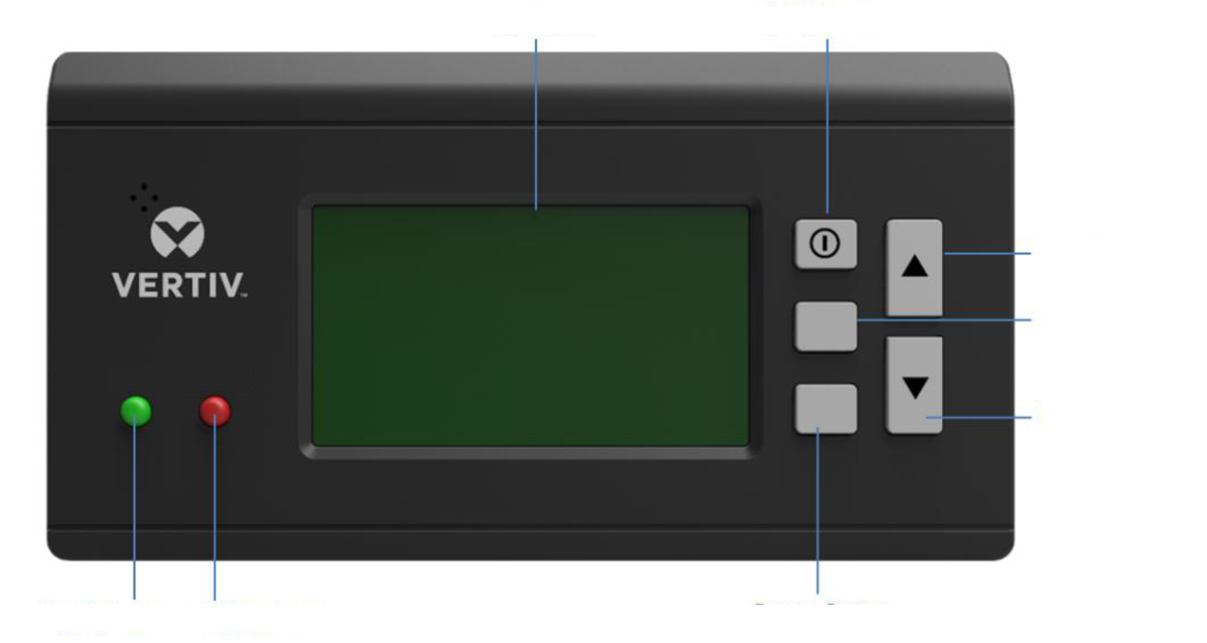
LCD Screen
ON/ OFF Button
Up Arrow
Enter Button
Down Arrow
Run Indicator
Alarm Indicator
Escape Button
RUN
ALARM
ENT
ESC
Figure 5-1 Controller display
  - Control Buttons
The micro-processing controller provides five control buttons, as shown in Figure 5-2, below.
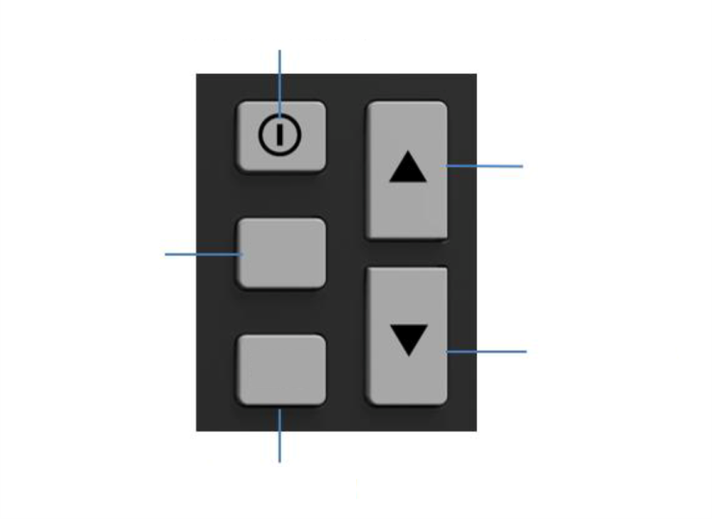
ON/ OFF Button
Up Arrow
Down Arrow
Escape Button
ENT
ESC
ENT Button
Figure 5-2 Control buttons

The functions of the control buttons are described in Table 5-1.
Table 5-1 Functional description of the controller buttons
Key | Function Description
ON/OFF | Switch on/off the controller by pressing for 3 seconds.
ENT  (Enter button) | Enter the selected menu screen. Validate the parameter setting value.
ESC | Exit the current menu and return to the Normal screen or previous menu screen. Abort parameter change; make the audible alarm silent.
Up Arrow Button | Move the cursor up or increase the parameter value. For a toggle selection: scroll through the options. For a multi-screen menu: scroll up the screen
Down Arrow Button | Move the cursor down or decrease the parameter value. For a toggle selection: scroll through the options. For a multi-screen menu: scroll down the screen.
  - ON Screen
After the unit is powered on, the LCD screen will display the ON screen. You can choose the display board language.
  - Normal Screen
After the unit is powered on, the Normal screen will be displayed after 10 seconds, as shown in Figure 5-3.
NOTES:
- The temperature units of VRC100, VRC101 are Fahrenheit. And the temperature units of VRC102 is Celsius. The VRC100 is used as an example.
SUP
ACT
RET
SUP
S / ON
Figure 5-3 Normal screen
It displays the settings and actual values in the upper half of the display related to the settings and actual air supply temperature in the first column, humidity in the second column, and air return temperature in the third column.
In the lower part of the screen, it displays the unit output status (fan, cooling) and unit operation status (off, running, standby, and locked).
The icons on the main screen indicate the unit output status, unit property, and unit operating status.
  - Password Interface
Press the Enter button on the Normal screen to display the Password screen. See Figure 5-4, below.
Password:
Figure 5-4 Password interface
The user does not need to enter the password, just press the ENTER key four times to enter the next interface.
  - Unit Working Icons
The icons and their definitions are listed in Table 5-2.
Table 5-2 Description of Icons
Icon | Description
SUP | Supply air temperature setpoint
ACT | Actual air temperature
RET | Specified return temperature
 | Cooling, the output of compressor. Displays the percentage of actual compressor capacity.
 | Rotating speed rate of the fan, ranging from 40% to 95%. Displays the percentage of actual fan rotating speed.
 | Unit attribute/running state. S: standalone; RUN: running; OFF: shutdown.  Unit property/operation status. S: single; ON: running; R-OFF: remote shutdown; L-OFF: local shutdown; M-OFF: monitoring shutdown; MANU: manual mode; BKUP: backup; Lock: lock.
  - Menu
    - Alarm menu
Select Alarm Menu on the Main Menu screen to enter the screen shown in Figure 5-5. Press the UP or Down button to scroll up or down the menu items.
<ALM Status>
<HP Abnormal>
<ALM Set>
Figure 5-5 Alarm menu screen
    - Alarm status
Alarm status menu is used to monitor the current alarm status of the air conditioner unit. It displays no alarm or specific alarm information. The specific alarm information includes XX/YY, alarm type, and alarm generation time, as shown in Figure 5-6. XX indicates the alarm SN, and YY indicates the total number of reported alarms.
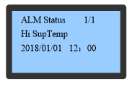
ALM Status 1/1
Hi Sup Temp
2018/01/01 12:00
Figure 5-6 Current alarm menu
NOTES:
- The latest alarm SN is the biggest number. Press the Up or Down button to scroll through the alarm status records if more than one alarm is activated.
- The current alarms are automatically cleared upon system power failure.
    - Alarm Setup
Enter the alarm setup screen on the Alarm Setup menu. Use the Up or Down key to query menu items. The alarm setup menu includes Alarm Setpoint, System Alarms, and Alarm Handle, as shown in Figure 5-7, Figure 5-8 and Figure 5-9. Parameter settings can be saved permanently.
Hi Sup Temp 80.6 °F
Lo Sup Temp 46.4 °F
Hi Ret Temp 86 °F
Figure 5-7 Items of the alarm value setup menu
Hi Sup Temp ON
Lo Sup Temp ON
Hi Ret Temp ON
Water HL ON
Figure 5-8 System alarm setup menu
Filt Maint Yes
Clr HP Abnor No
Figure 5-9 Alarm handle menu
    - Temp Set
Select Main Menu -> Temp Set and press Enter as shown in Figure 5-10, and the Temperature Setting values will be permanently saved.
Ctrl Mode Sup Air
Sup Stpt 60.8 °F
Ret Stpt 82.4 °F
Temp DB 0.9 °F
Cool Prop 9 °F
Figure 5-10 Temp & Hum set menu
NOTES:
- The specified temperature value is the target temperature to ensure that the system is running normally. When the control mode is set to return or supply air, the specified temperature is the temperature of the return air or supply air.
- The default control mode of the unit is supply air control mode.
- If the AC is used in the open rack, use the return air control mode.
    - System Status
Select Main Menu -> System State to enter the System State menu, as shown in Figure 5-11.
<Run Time>
Figure 5-11 System State
    - Run Time
You can query the operation time of the device on this menu, as shown in Figure 5-12.
Fan 23 h
Comp 0 h
Figure 5-12 Run time menu
    - Help Menu
The menu includes Date and Time information. You can view the relevant information, as shown in Figure 5-13.

Date (Y) 2018
Date (M) 1
Date (D) 1
Time (H) 12
<Date&Time>
Time (M) 20
Time (S) 30
Figure 5-13 Date and Time menu

PART III
SYSTEM OPERATION AND
GENERAL MAINTENANCE

- Startup Commissioning
This chapter describes the startup commissioning, including specific operations.
  - Preparations Before Commissioning
Mechanical part
- Connect the condensate water drain system piping and inspect for any leakage in the connections.
- Ensure that the unit has at least 30% of the designated head load. If not, use other heating devices that compensate for the heat load to ensure the necessary amount of heat load for commissioning.
Electronic part
- Ensure that the input voltage of the main power supply is within ± 10% of the rated voltage and that the power disconnector is closed.
- Ensure that the power cord and the communication cable are segregated from each other.

  - Start-up Inspection Checklist
Before powering up the unit, ensure the below mechanical and electrical inspections are properly checked as per the Table 6-1 below.
Table 6-1 Start-up inspection checklist
Inspection | Items | Remarks
Mechanical Inspection | Verify that the drainage pipe is tightly connected.  And there are no kinks or blockages in the hose.
Electrical Inspection | Verify that the AC main voltage and frequency are normal. Make sure that the main connection is correct and does not short circuit.
Electrical Inspection | Make sure that the electrical and control connections are tight.

  - System Commissioning
Start up the unit
- Switch on the circuit breaker and connect to utility power.
- Press and hold the ‘ON’ button on the display board for 3 seconds to power up the unit.
- Pay attention to the controller display to ensure that there are no alarms or warnings displayed.
- There will be short vibration when starting or switching off. After running for more than half an hour, ensure the operating status of the compressor, evaporator fan and condenser fan is smooth and that there are no vibrations or any kind of noise from any of these components.
- Observe and monitor whether the system parameters are within the normal range, such as return air temperature and supply air temperature, etc. as per the set operational functionality.

System Parameters Normal Range
Item | Range
Suction Pressure (Gauge) | 800 kPa (116.0 psig) – 1500 kPa (217.6 psig)
Discharge Pressure (Gauge) | 2000 kPa (290.1 psig) – 3600 kPa (522.1 psig)
Discharge Temperature | 40 ºC (104ºF) – 115 ºC (239 ºF)
Tret - Tsup | 3 ºC(37ºF) - 50 ºC (122 ºF)
- If any abnormal operation is noticed, stop the unit by pressing the ‘ON/OFF’ button on the display board for 3 seconds, and disconnect all air circuit breakers.
  - Commissioning Complete Inspection
Inspect the items in Table 6-2, Checklist after Commissioning.
Table 6-2 Checklist after commissioning
Inspection Items | Inspection Results
Check that all outputs are functional.
Check that the temperature settings are correct and are controlled within range.
Check that there are no abnormal alarms or warnings displayed on the controller.
Make sure all the other functions are set correctly.

- System Operation and Maintenance
Periodic system maintenance is crucial to ensure product reliability and validity. This chapter describes the operation and maintenance of the precision air conditioner, including routine maintenance, system diagnostic testing, and maintenance of filters, fan components, refrigeration systems and drainage systems.
  - Safety Instructions
WARNING! During the operation of the precision air conditioner, very high voltage may be present in the equipment. Adhere to all of the notes and warnings marked on the equipment or contained in this manual, which may otherwise lead to an injury or fatality.
WARNING! Only qualified maintenance personnel can operate and handle the equipment. All maintenance and operation must follow the local laws, especially the regulations about the electric power, refrigeration, and production.
WARNING! Risk of contact with high-speed rotating fan blades. Can cause serious injury or death. Open all local and remote electric power-supply disconnect switches, verify with a voltmeter that power is off, and verify that all fan blades have stopped rotating before working in the unit cabinet or on the fan assembly.
WARNING! Risk of hair, clothing and jewelry entanglement with high speed rotating fan blades. Can cause equipment damage, serious injury or death. Keep hair, jewelry and loose clothing secured and away from rotating fan blades during unit operation.
WARNING! Risk of contact with extremely hot and/or cold surfaces. Can cause injury. Verify that all components have reached a temperature that is safe for human contact or wear appropriate, OSHA-approved PPE before working within the electric connection enclosures or unit cabinet. Perform maintenance only when the system is de-energized and component temperatures have become safe for human contact.
WARNING! Risk of improper wiring, piping, moving, lifting and handling. Can cause equipment damage, serious injury or death. Installation and service of this equipment should be done only by qualified personnel who have been specially-trained in the installation of air-conditioning equipment and who are wearing appropriate, OSHA-approved PPE.
CAUTION: Comply with the manufacturer’s instructions before and during maintenance. Failure to observe this will result in the warranty becoming void. Adherence to the safety instructions is mandatory to ensure personnel safety and prevent any environmental impact apart from equipment damage. Unsuitable components will impede equipment performance and may cause equipment shutdown. Therefore, Vertiv recommends the use of Vertiv OEM or Vertiv-approved components.
CAUTION: Switch off the VRC1 unit and then switch off the power input during equipment maintenance. Switch off the equipment power unless the testing devices need power.

  - Electrical Inspection
Inspect the control board and temperature sensor every 6 months for loose electrical connections and circuit corrosion.
The steps to inspect the boards are as follows:
- Firmly tighten all the electrical contacts.
- Clean the electrical and control components with a brush or by using compressed dry air.
  - Main Components Maintenance
    - Evaporator Fan
Since the fan operates 24/7 throughout the year, any unusual airflow obstruction must be cleared in time to avoid damage to the cooling system and other system components caused by reduced air volume.
    - Air Cooled Condenser
There are times when the airflow through heat rejection unit is restricted. In such a scenario, use compressed air to clean the dust and debris that inhibits airflow off the condenser. The compressed air should be blown in the reverse airflow direction.
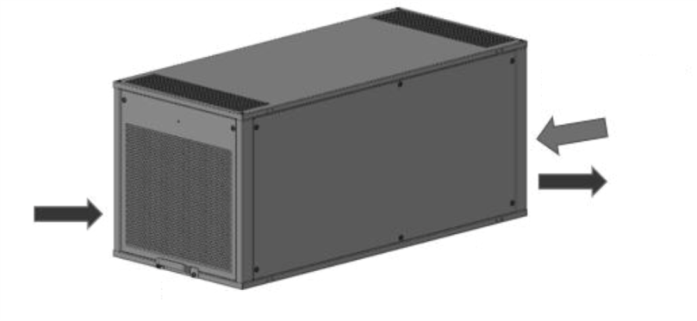
Condenser Air In
Reverse air flow direction
Condenser Air Out
Figure 7-1 Condenser airflow direction
    - Compressor

CAUTION: Avoid touching or having skin contact with the residual gas and oils in the compressor. Wear long rubber gloves to handle contaminated parts. The air conditioning system contains refrigerant. The release of refrigerant is harmful to the environment.

The compressor faults can be categorized into two types:
- Motor faults (such as winding burnout, insulation failure, short circuit between coils, etc.)
- Mechanical faults (such as compressor failure, relief valve faults, etc.)
If the operating pressure is not established, it means that the compressor has failed. Confirm- that the suction pressure and discharge pressure are balanced and verify that the motor does not rotate in reverse. The controller is streamlined with capabilities like powerful alarm and protection functions to ensure safe operation of the compressor. Periodic checks of high pressure and low pressure along with alarm protection for such pressure-related issues should be carried out by maintenance personnel on a regular basis to rule out discrepancies.
VRC1 Series
Date: |  | Prepared by:
Model: |  | Serial number:
Type | Maintenance Components: | Item | Result
Monthly: | Filters | Check for restricted air flow
Monthly: | Filters | Check the filter cleanliness
Monthly: | Filters | Clean the filter
Monthly: | Evaporator fan and condenser fan | Check if fan blades are distorted
Monthly: | Evaporator fan and condenser fan | Check whether the fan generates noise during operation
Semi-annually: | Compressor | Signs of oil leakage
Semi-annually: | Compressor | Check whether the compressor vibrates or makes noise during operation
Semi-annually: | Refrigerant system | Suction pressure
Semi-annually: | Refrigerant system | Discharge pressure
Semi-annually: | Refrigerant system | Superheat
Semi-annually: | EEV electric board | Check whether the wiring and coil of the electronic expansion valve control board are loose
Semi-annually: | EEV electric board | Check electrical connections
Semi-annually: | EEV electric board | Check the surface for signs of corrosion

    - Drain Pipe
Inspect the drain pipe for normal operation every 6 months.
Ensure no pipe buckling is present. If the pipe buckling happens, the new pipe should be used.
Ensure that reservoir, pump filter and inlet tube are free of sludge and debris. If not, please clean it.
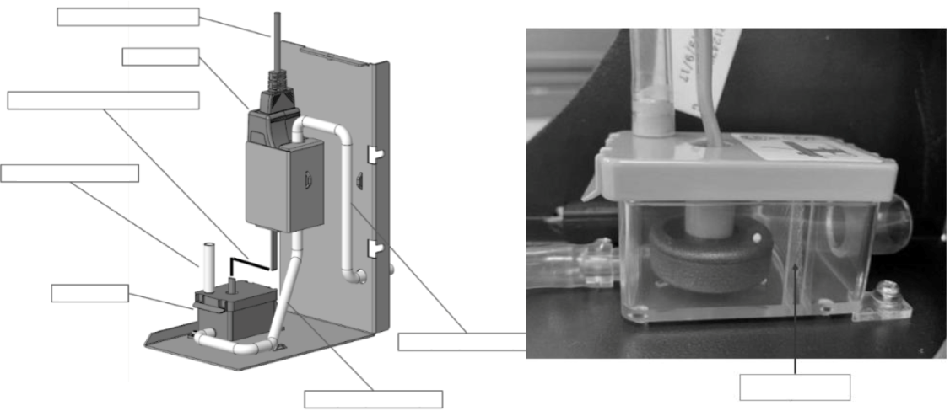
Pump filter
Pump power cable
Pump
Pump communication cable
Pipe 1 (ID=6mm)
Pipe 3 (ID=6mm)
Pipe 2 (ID=6mm)
Reservoir
Figure 7-2 Condensate pump kit

Component | Inspection Items | Remarks
Pump Filter | Check if filter is clogged or damaged
Pump Filter | Clean the filter
Pump Pipes | Check whether the pipes are loose.
Drainage Pump | Check whether there are impurities and debris in the water tray.
Drainage Pump | Check the drain pump connection line for clogging.
Drainage Pump | Check whether the cable of the drain pump is loose.

  - Maintenance Inspection Checklist
Periodic system maintenance is crucial to ensure product reliability and validity. This chapter describes operation and maintenance of the precision air conditioner, including routine maintenance, system diagnostic testing, and maintenance of filters, fan components, refrigeration systems and drainage systems.
Component | Inspection Items | Remarks
Filters  (2 VRC filters;  1 pump filter;  1 ceiling tile filter) | Check if filter is clogged or damaged
 | Check whether the unit prompts for filter maintenance.
 | Clean the filter
Fans | Check if fan blades are distorted.
Fans | Check whether the fan generates any noise during operation.
Fans | Check whether the fan stopped rotating.
Fans | Check and fasten the circuit connector.
Electronic Expansion Valve | Check whether the wiring and coil of the electronic expansion valve control board are loose
Cooling Circulation System | Check the cleanliness of the evaporator surface.
Cooling Circulation System | Check whether the refrigeration pipe has leakage and proper support.
Cooling Circulation System | Check whether refrigerant is filled into the system
Electrical Control Part | Check and fasten the circuit connector.
Electrical Control Part | Check whether the cables and meter reading of each sensor are within prescribed range.

  - Monthly Routine Inspection Items
Check the system components monthly, focusing on system function and component wearing symptoms, and the inspection items shown in Table 7-1.
Table 7-1 Monthly routine inspection items
Component | Inspection Items | Remarks
Filters  (2 VRC filters;  1 ceiling tile filter) | Check if filter is clogged and damaged
Filters  (2 VRC filters;  1 ceiling tile filter) | Clean the filter
Fans | Check whether the fan generates any noise during operation.
Fans | Check whether the fan has stopped rotating.
Drainage | Check that the drain pipe is unblocked, no pipe buckling is present, and the pump works normally.
  - Routine Inspection Items (Semi-annually)
See Table 7-2 for the routine semi-annual maintenance items.
Table 7-2 Routine maintenance items every half a year
Components | Item | Remark
Pump Filter | Check for clogging or damage
Pump Filter | Clean the filter
Fans | The Fan blades are not distorted
Fans | Check whether the fan generates any noise during operation
Fans | Check and fasten the circuit connections
Compressor | Check for leakage
Compressor | Check whether the compressor vibrates or makes noise during operation
Compressor | Check and fasten the circuit connections
Condenser | Check the cleanliness of the fins
Condenser | The fan base should be firm
Condenser | The fan vibration absorber is not deteriorated or damaged
Condenser | The temperature switch is set at the required position
Condenser | The refrigerant pipes are properly supported
Condenser | Check and fasten the circuit connections
Refrigeration System | Check the suction pressure
Refrigeration System | Check the discharge pressure
Refrigeration System | Check the superheat
Refrigeration System | Check the refrigerant pipes
Electric Control Part | Check the fuse and the MCB
Electric Control Part | Check and fasten the circuit connections
Electric Control Part | Check the control program
  - System Diagnosis Testing
The microprocessor controller supports the manual mode and provides diagnostic functions such as manually enabling and disabling parts. Such functions can be used to detect states of the system functional parts.
  - Electrical Maintenance
Check the appearance of the electrical connections and follow the steps below.
- Switch off the VRC1 unit and then switch off the power input during the equipment maintenance. Switch off the equipment power unless the testing devices need power.
- Conduct overall electrical insulation test: find out the non-insulated contacts and rectify them with proper insulation covering.
- Check if unplug the power cord during the test because high voltage may damage the control components.
- Clean the dust from the electrical panel and control panel boards by using a brush or blowing low pressure dry compressed air.
- Properly fasten all the electric connection terminals.
- Check that the sockets and plugs are in good condition. Replace the loose ones with new sockets and plugs.
- If the power cables are damaged, the cables must be replaced by professional personnel to avoid any non-standard installation practices.
  - Controller Connections Maintenance
Check the appearance of the controller and follow the steps below.
- Check the appearance of the power module and measure the output voltage.
- Check whether the surface of the control interface board, control board, temperature NTC and electronic expansion valve control board show any signs of aging or wear and tear.
- Clean up dust and dirt from the electrical control components and control board with a brush using an electronic dust cleaning agent.
- Check and fasten the input and output connectors of the control interface boards, including the control board, interface board, temperature NTC, and electronic expansion valve control board.
- Check whether the contact and connection of the fan power cable, signal cable, and rotating speed feedback signal cable are firmly fixed.
- Check whether the interconnection terminals between the control interface board and the temperature or pressure sensor are firmly connected. If they are loose, faulty or have a bad connection immediately replace the interconnection terminal.
- Replace the faulty electrical components such as the control fuse (or air breaker) and control board.
- Use a high-precision temperature measurement meter to measure and calibrate the reading of the temperature sensor.
- Adjust the set points. Check the motion of each functional component according to the control logic.

  - Filters Maintenance Guidance
    - VRC filters
There are two filters for each unit. A filter net is mounted on the condenser air in side (PN: 02560118). And another is mounted on the return air side (PN: 02560155). To ensure the normal operation of the filter, the filter service alarm logic is provided by the controller. The default fan running time is 2000 hours (settable according to the local running environment), when the time is exceeded, the filter service alarm is triggered. The filter needs to be replaced based on its clogged condition. The filter must be checked once a month and be replaced as required during operation. If the VRC unit is used in a dirty environment, please check the filter once a week.
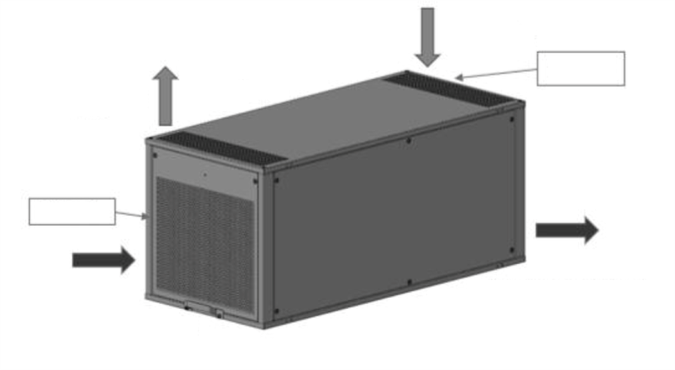
Evaporator Side
Condenser Air In
Condenser Air Out
Supply Air
Return Air
Filter 1
Filter 2
Figure 7-3 VRC filters
    - Pump filter
There is a filter in the pump reservoir. Inspect it every 6 months.
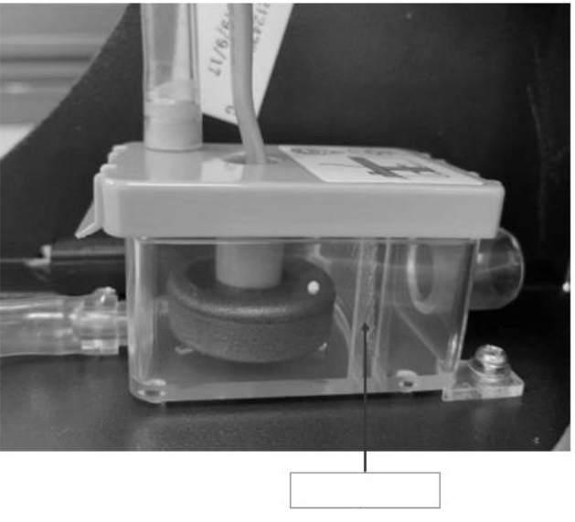
Pump filter
Figure 7-4 Pump filter

    - Ceiling tile filter
The ceiling tile filter is installed in the ceiling tile for filter pad. It needs to be checked once a month.
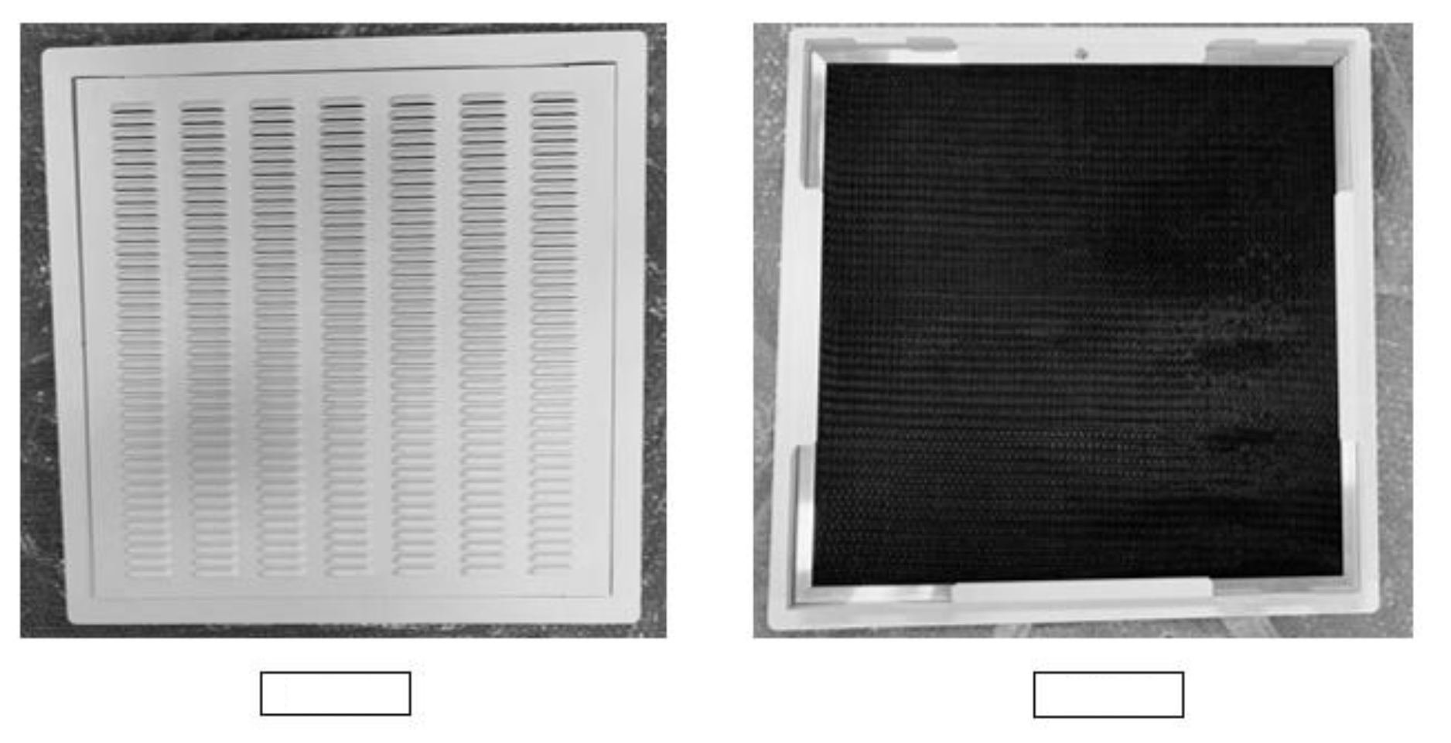
Front
Rear
Figure 7-5 Ceiling tile for filter pad
Uninstalling the ceiling tile filter.
The ceiling tile filter pad consists of 3 parts, 2 sheet metals and 1 ceiling tile filter. The ceiling tile filter is fixed by 2 sheet metals. Loose the M5 screw, the filter can be uninstalled.
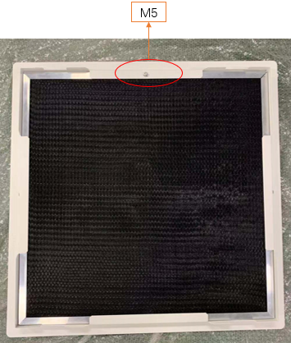
Figure 7-6 Loose the M5 screw
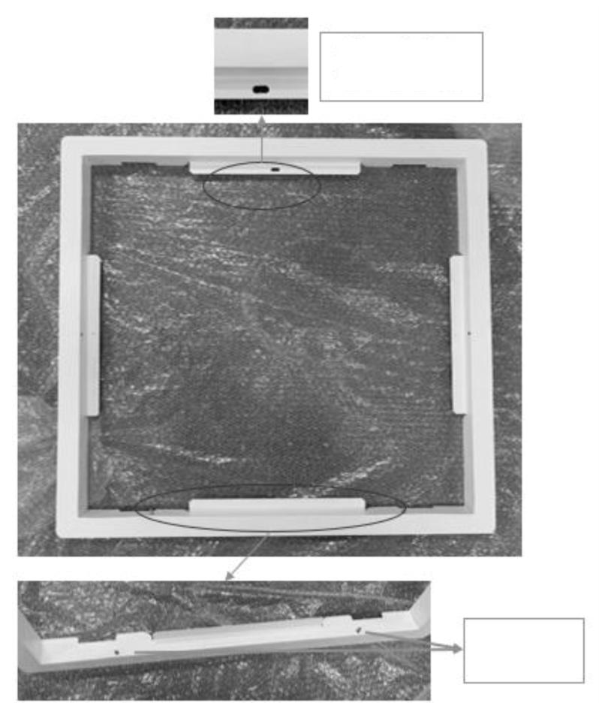
Through hole for M5 screw
Two limit columns
M5 screw threaded hole
Two limit holes
Front
Rear
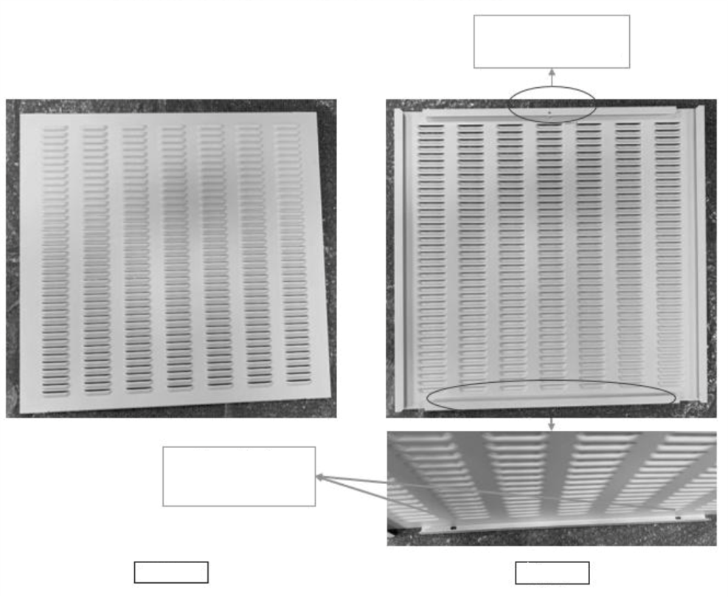
Figure 7-7 Sheet metals of the ceiling tile for filter pad
  - Maintenance Guidance for Fan Kit
- Periodic inspection covers the state of the fan impellers, fastening of fan components, abnormal fan noise, and fan cable connection.
- Pay close attention to assess whether the fan kit and impeller are properly fixed, and the rotation of the fan blade does physically interfere with other components. Ensure that the air discharge path is free from any obstacles to the airflow.
- If the EC fan does not rotate, check the analog signal cable, rotating speed feedback cable, power module power cable, and the power module.
- Do not operate the fan during maintenance to avoid injury to the operator or damage to the fan blades.
- During the unit operation, do not touch the fan cover as the fan rotation may cause mechanical damage.
  - Cooling System Maintenance
The cooling system components must be inspected monthly for abnormalities in the operation which can cause abrasions due to continuous operation. As the failure or damage of components is usually accompanied by corresponding faults, check regularly to prevent system faults.
The surface of the evaporator coil should be kept clean and have no rupture.
The major reasons for electronic expansion valve failure are related to electrical failure and/or mechanical failure. The electrical failure may be attributed to the failure of the power supply of the electronic expansion valve control panel and coil, loosely connected control board wiring, and pressure and temperature sensor failure. The mechanical failure may be caused by blockage in the refrigerant flow in an electronic expansion valve. Therefore, when the electronic expansion valve is faulty, pay close attention to the control panel power supply, control board wiring, pressure and temperature sensor wiring or the valve itself.
NOTES:
- It is not recommended to adjust the electronic expansion valve without prior permissions.

- Troubleshooting
This chapter introduces the failure diagnosis and troubleshooting and can be used together with the alarm section in Chapter 5.
WARNING! Certain circuits carry lethal voltages. Only professional technicians are allowed to maintain the unit. Extra precautions should be taken when troubleshooting a live unit. Be particularly careful troubleshooting with the unit’s power switched on.

WARNING! If jumpers are used for troubleshooting, make sure to remove the jumpers after troubleshooting. If the connected jumpers are not removed, they may bypass certain control functions causing damage to the equipment.
  - Troubleshooting
Troubleshooting for the entire unit is listed in Table 8-1, below.
Table 8-1 Troubleshooting for Unit
Fault Occurrence | Possible Cause | Check or Remedy
High temperature alarm | Unreasonably high temperature alarm setpoint | Check and reset high temperature alarm setpoint
High temperature alarm | Overload condition | Check whether the max. actual heating load is over the rated value
High temperature alarm | Condenser fan does not run normally or is faulty | Check if the fan power cable is disconnected
High temperature alarm | Compressor does not run normally | Check if the compressor power cable is disconnected
Low temperature alarm | Unreasonably low temperature alarm setpoint | Check and reset low temperature alarm setpoint
Low temperature alarm | Evaporator fan does not run normally or is faulty | Check if the fan power cable is disconnected
Low temperature alarm | Compressor does not run normally | Check to see if the compressor power cable is disconnected
High pressure alarm | Condenser fan does not run normally or is faulty | Check if the fan power cable is disconnected
High pressure alarm | High pressure sensor is abnormal | Check if the high-pressure sensor is normal
High pressure alarm | Insufficient condensing airflow | Remove debris from the coil and air inlet
High pressure alarm | Insufficient condensing airflow | Check if the fan speed controller operates normally
Low pressure alarm | Refrigerant leakage | Check for leaking points and re-charge refrigerant
Low pressure alarm | Condenser fan runs at full speed when ambient temperature is too low | Check if wire connection of outdoor fan is reversed
Low pressure alarm | EEV adjusts abnormally or is closed | Check if the EEV coil or EEV cable is loose
Low pressure alarm | Evaporator fan does not run normally or is faulty | Check if the cable of fan is disconnected
Low pressure alarm | Insufficient airflow across evaporator coil | Remove debris from the coil and air inlet
Severe condensation or water leakage | The air humidity is too high | Use other dehumidifier to control the air humidity
Severe condensation or water leakage | EEV adjusts abnormally | Check if the EEV coil or EEV cable is loose
Severe condensation or water leakage | Compressor runs at high speed | Check if the compressor is out of control
Severe condensation or water leakage | The drainage pan or pipe is loose or blocked | Check if drainage pipe is loose or clean the debris in the drainage pan or pipe
Compressor vibration or abnormal noise | The mounting position is not even | Check mounting position state
Compressor vibration or abnormal noise | The fixing parts are loose | Check the fixing nuts of compressor and fasten again
Compressor vibration or abnormal noise | Compressor is faulty | Call the customer service hotline of Vertiv

  - Fan Troubleshooting
Fan troubleshooting is listed in Table 8-2.
Table 8-2 Fan fault diagnosis and handling
Symptom | Probable Causes | Check Items and Handling Methods
EC fan cannot be started | The circuit breaker is open | Check if the fan circuit breaker is closed.
EC fan cannot be started | Fan power module failure | Check the Fan power module alarm indicator to see if the control board fails
EC fan cannot be started | The cable is faulty | Check whether the cable from the main control board, fan fault detection board, or power module to the control terminal bar is firmly connected.  Check whether the cable from the control terminal bar to the plug wire terminal of the fan is firmly connected.
  - Fault Diagnosis and Handling of Electronic Expansion Valve
As a key component for refrigerant system and cooling capacity adjustment, the electronic expansion valve is important. Table 8-3 describes the fault diagnosis and handling methods.
Table 8-3 Fault diagnosis and handling methods
Symptom | Probable Causes | Check Items and Handling Methods
The adjustment of the electronic expansion valve is faulty. | The temperature sensor or pressure sensor is faulty. | Check whether the sensor cable is firmly connected.  Check whether the sensor cable position on the control board is correct.
The adjustment of the electronic expansion valve is faulty. | The control board is powered off. | Check whether the output fuse of the transformer has tripped/broken.  Check whether the input power of the control board of the electronic expansion valve is a 24 V power supply.
The adjustment of the electronic expansion valve is faulty. | The cable connection of the control board is faulty. | Check whether the valve cable connection on the control board of the electronic expansion valve is faulty.  Check whether the communication cable between the electronic expansion valve control board and the main control board is properly connected.

  - Fault Diagnosis and Handling of the Air Conditioning System
When the air conditioning system component is faulty, identify the causes and tackle the problem to ensure normal operation of the unit. Table 8-4 describes the major faults and troubleshooting methods.

Table 8-4 Refrigeration system faults and troubleshooting methods
Symptom | Probable Causes | Check Items and Handling Methods
The surface of the evaporator has serious condensation. | Check whether the surface of the evaporator is blocked with debris. | Check the surface of the evaporator. Blockage may result in uneven discharge of the condensate water.
Air volume decrease | The air filter is blocked. | Periodically check the filter and replace it in a timely manner to avoid reduction in air volume due to blockage.
Air volume decrease | The fan is faulty. | Check whether the fan is faulty. Table 8-2 describes the diagnosis and handling methods.
Air volume decrease | Blockage of the evaporator | Check the surface of the micro-channel evaporator and periodically handle the blockage problem.

Appendix I: System Diagram

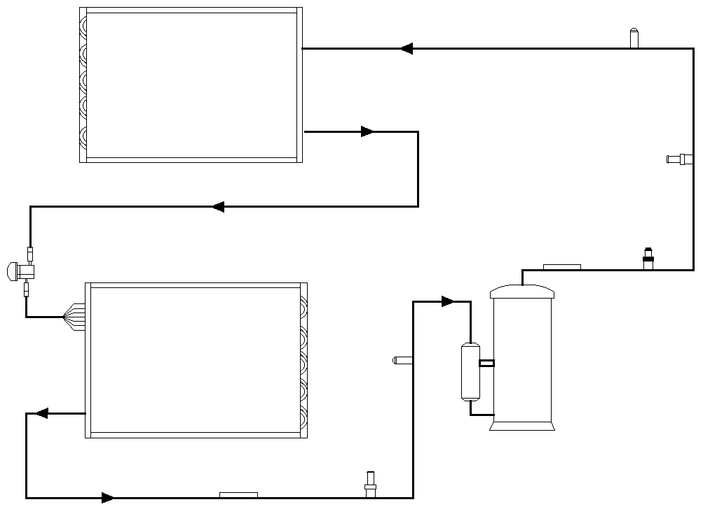
Condenser
Electronic Expansion Valve
Distributor
Evaporator
Service Valve
Service Valve
High Pressure Transducer
Discharge Temperature Sensor
High Pressure Switch
Suction Temperature Sensor
Suction Pressure Transducer
Compressor

Appendix II: Wiring Diagram(VRC100 Unit)

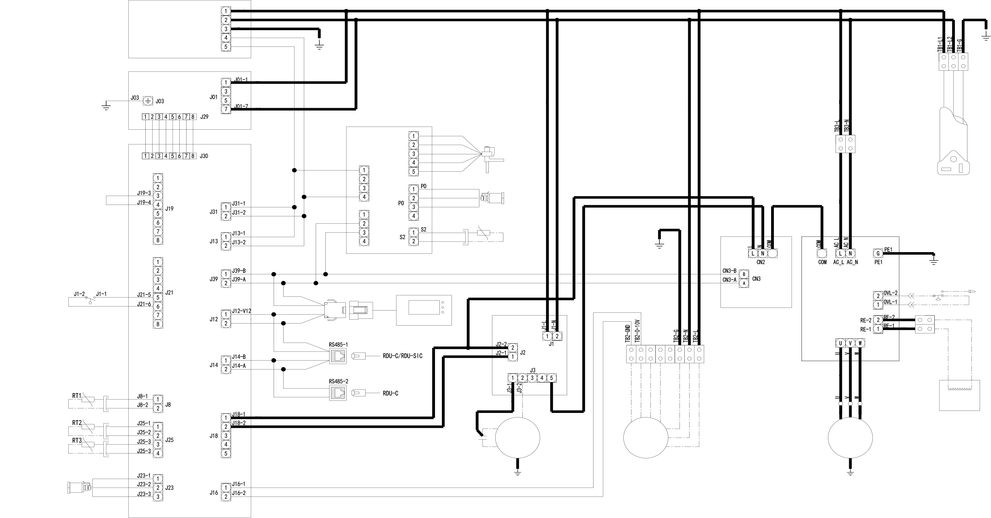
AC/DC Power Module
Power Protector ACM02A1
GND
AC/L
AC/N
FG
DC/-V
DC/+V
BR
BL
Y/G
BR
BK
BR

BL
BK
BR
BK
BR
BK
BR
GND
BK
BK
BR
OR
R
BK
BR
BK
BK
BK
BR
BK
BR
BK
BR
BK
BR
R
BR
BK
BK

BR
BK
BR
R
BK
BR
BR
BL
BL
BR
Water Level Sensor
WLS
Discharge TEMP.Sensor
Supply Air TEMP.Sensor
Return Air TEMP.Sensor
High Pressure Sensor
HPS
Remote Monitor
Communication
Display
PACC
Controller
ACM05U1
EMI Filter
ACM02X2
Suction TEMP. Sensor
Low Pressure Sensor
LPS
EEV Controller
EEV
EEV
EEV
PWR
PWR
COM
COM
J12-GND
NTC4
BK

BR
Capacitor
Outdoor Fan
GND
BK
BL
BR
BL
BR
BL
BK
Y/G
GND
GND
GND
BK
WH
GR
LINE VOLTAGE
1 PHASE SUPPLY
GND
Y/G
High Pressure Switch
BL
WH
BK
BR
BK
R
WH
Compressor Inverter
Communication Board
Inductor
L1
Compressor
Indoor Fan
BL
YE
R
WH
Y/G
BL
BR
BL
Y
R
Y/G
HPS
OVL

Appendix III:Wiring Diagram(VRC101 Unit)
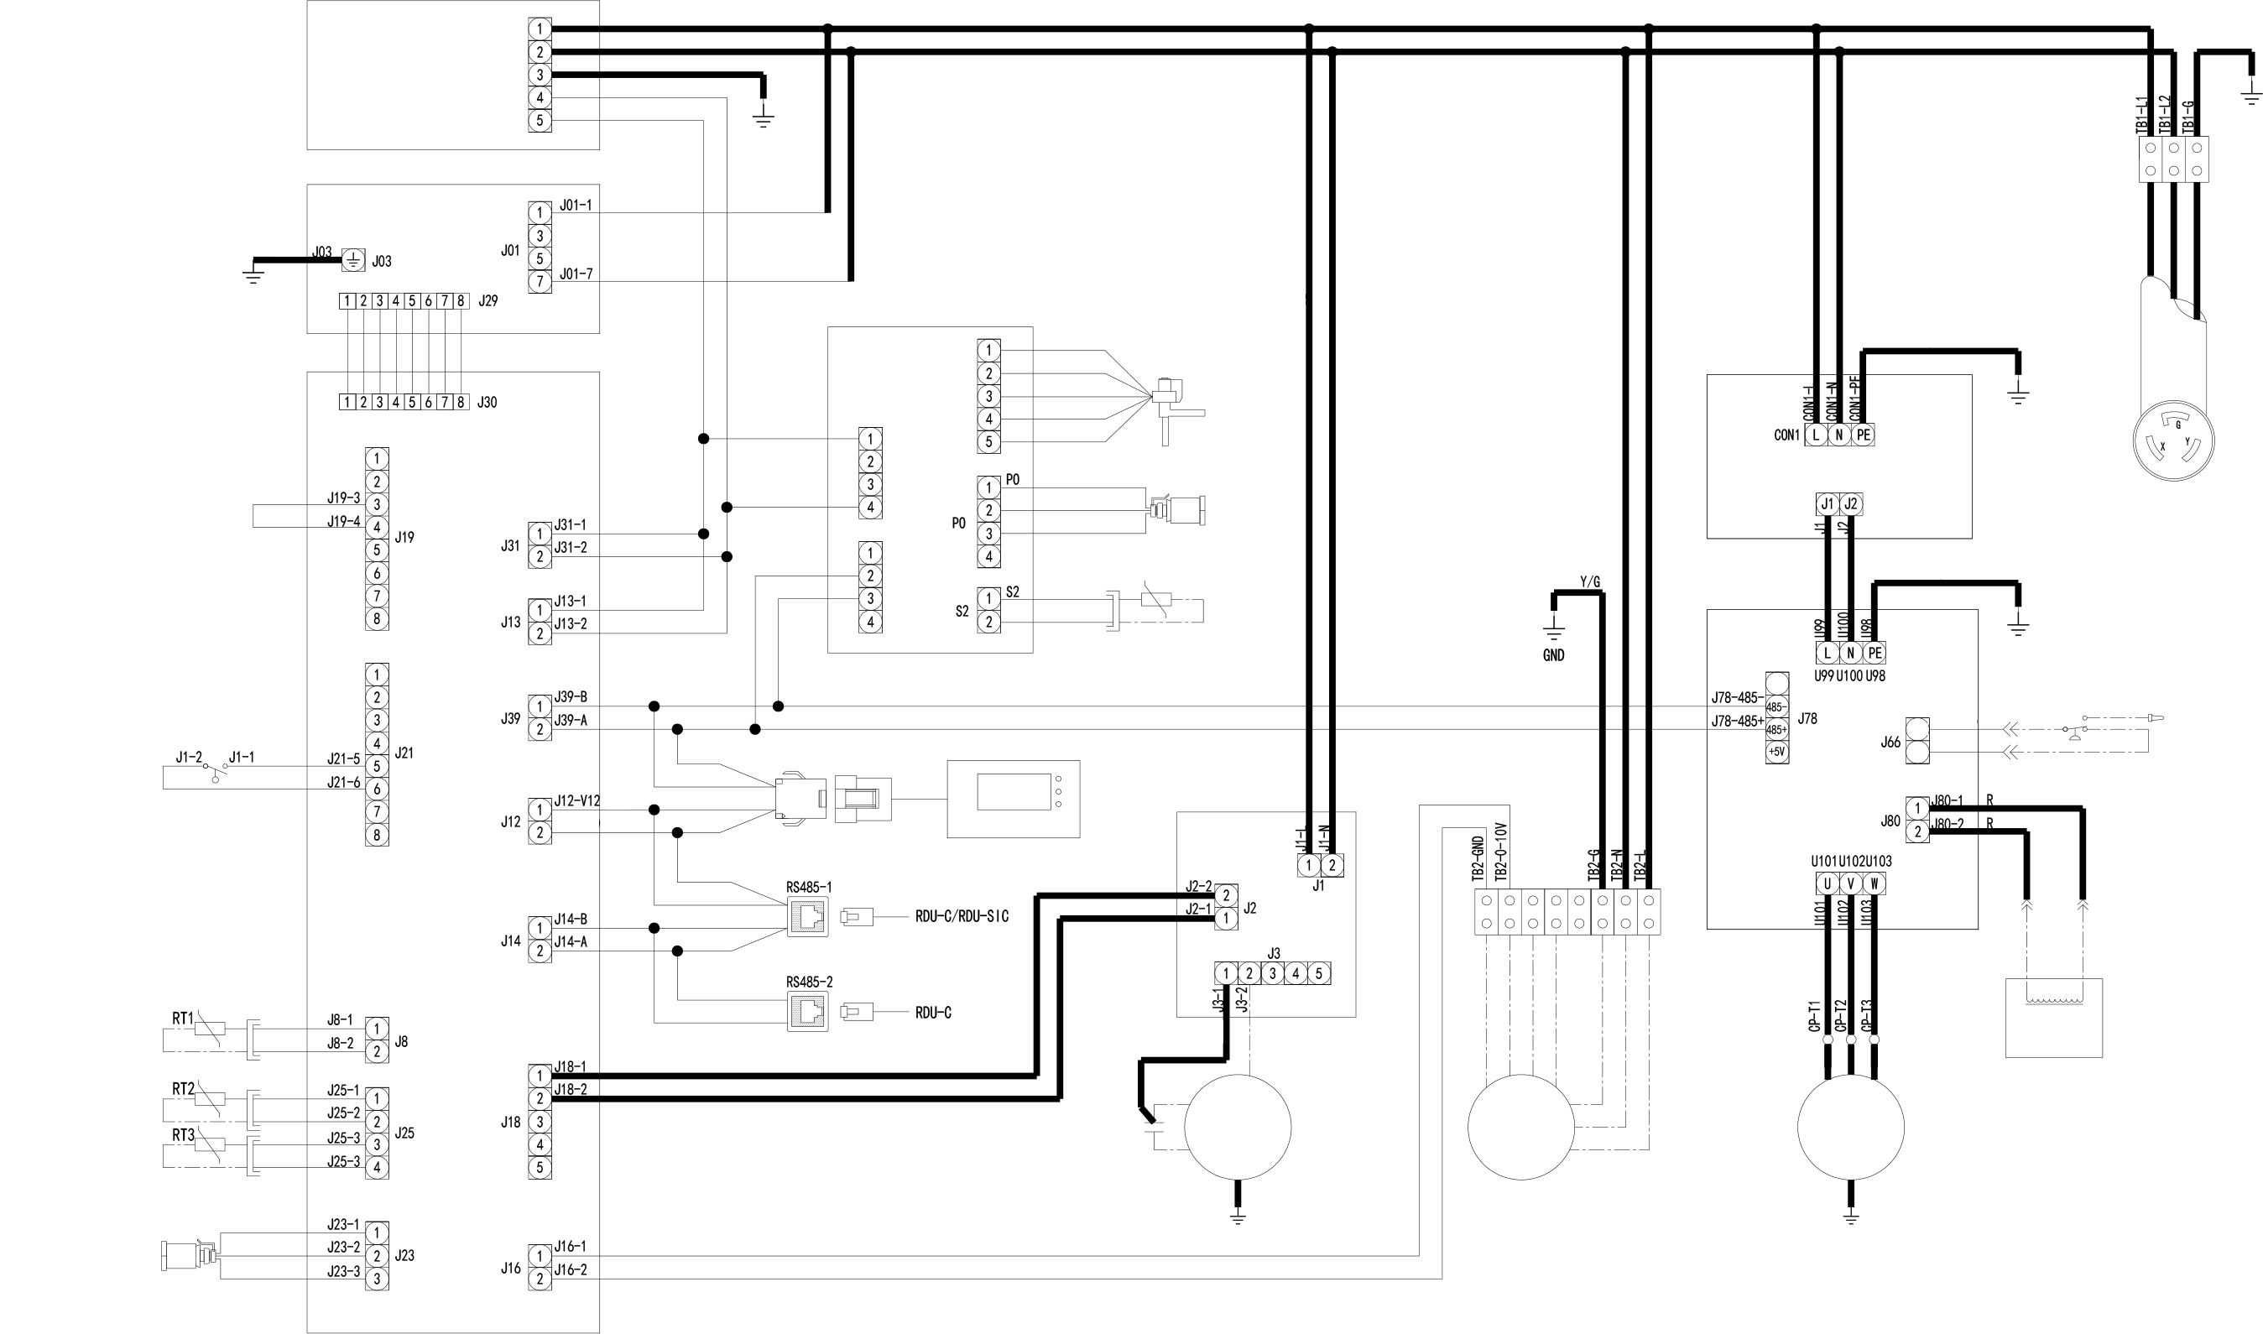
AC/DC Power Module
Power Protector ACM02A1
GND
AC/L
AC/N
FG
DC/-V
DC/+V
BR
BL
Y/G
BR
BK
BR

BL
BK
BR
BK
BR
BK
BR
GND
BK
BK
BR
OR
R
BK
BR
BK
BK
BK
BR
BK
BR
BK
BR
BK
BR
R
BR
BK
BK

BR
BK
BR
R
BK
BR
BR
BL
BL
BR
Water Level Sensor
WLS
Discharge TEMP.Sensor
Supply Air TEMP.Sensor
Return Air TEMP.Sensor
High Pressure Sensor
HPS
Remote Monitor
Communication
Display
PACC
Controller
ACM05U1
EMI Filter
ACM02X2
Suction TEMP. Sensor
Low Pressure Sensor
LPS
EEV Controller
EEV
EEV
EEV
PWR
PWR
COM
COM
J12-GND
NTC4
BK

BR
Capacitor
Outdoor Fan
GND
BK
BL
BR
BL
Y/G
GND
GND
GND
BK
WH
GR
LINE VOLTAGE
1 PHASE SUPPLY
GND
Y/G
High Pressure Switch
BL
WH
BK
BR
BK
R
R
Compressor Inverter
Inductor
L1
Compressor
Indoor Fan
BL
YE
R
WH
Y/G
BL
BR
Y/G
HPS
GND
Y/G
EMI Filter
Terminal Block
BK
BK
BK
GND
EN
J66-GND
J66-EN
GND

Appendix IV:Wiring Diagram(VRC102 Unit)
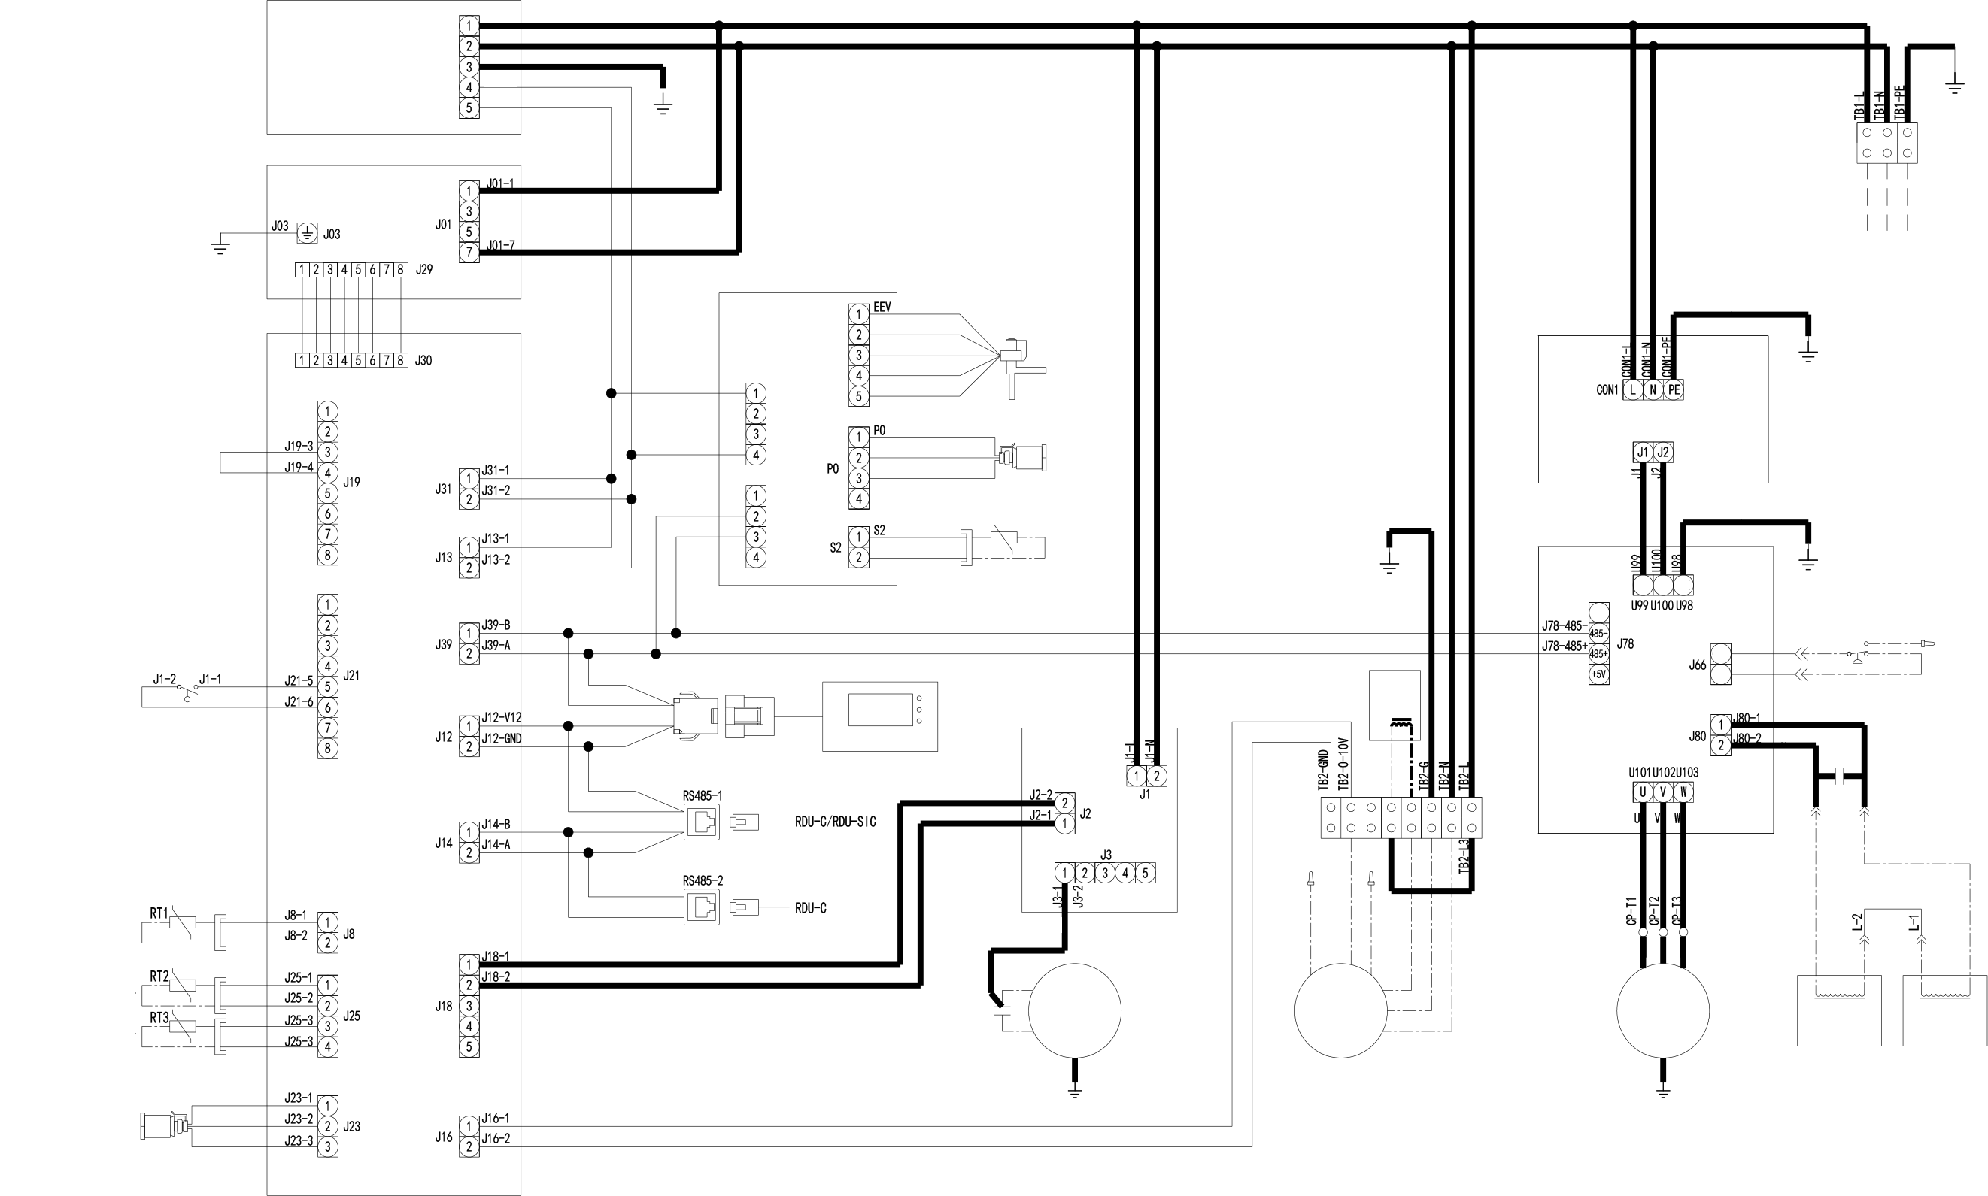
AC/DC Power Module
Power Protector ACM02A1
PE
AC/L
AC/N
FG
DC/-V
DC/+V
BR
BL
Y/G
BR
BK
BR

BL
BK
BR
BK
BR
BK
BR
PE
BK
BK
BR
OR
R
BK
BR
BK
BK
BK
BR
BK
BR
BK
BR
BK
BR
R
BR
BK
BK

BR
BK
BR
R
BK
BR
BR
BL
BL
BR
Water Level Sensor
WLS
Discharge TEMP.Sensor
Supply Air TEMP.Sensor
Return Air TEMP.Sensor
High Pressure Sensor
HPS
Remote Monitor
Communication
Display
PACC
Controller
ACM05U1
EMI Filter
ACM02X2
Suction TEMP. Sensor
Low Pressure Sensor
LPS
EEV Controller
EEV
EEV
EEV
PWR
PWR
COM
COM
NTC4
BK

BR
Capacitor
Outdoor Fan
PE
BK
BL
BR
BL
Y/G
PE
PE
PE
L
N
PE
LINE VOLTAGE
1 PHASE SUPPLY
PE
Y/G
High Pressure Switch
BL
WH
BK
BR
BK
R
R
Compressor Inverter
Inductor
L1
Compressor
Indoor Fan
R
BL
YE
WH
Y/G
BL
BK
Y/G
HPS
PE
Y/G
EMI Filter
Terminal Block
BK
BK
BK
GND
EN
J66-GND
J66-EN
GND
SEE UNIT NAMEPLATE FOR MAIN SUPPLY WIRE SIZING
Inductor
L2
Inductor
L3
L
N
PE

Suppliers Declaration of Conformity


Unique Identifier: VRC100, VRC101

Party Issuing Supplier’s Declaration of Conformity
Vertiv Group Corp.
1050 Dearborn Driver
Columbus, OH
US
Customer service hotline: 1-800-LIEBERT (1-800-543-2378)

FCC Compliance Statement (for products subject to Part 15)
This device complies with part 15 of the FCC Rules. Operation is subject to the following two conditions: (1) This device may not cause harmful interference, and (2) this device must accept any interference received, including interference that may cause undesired operation.

Note:
Note: This equipment has been tested and found to comply with the limits for a Class A digital device, pursuant to part 15 of the FCC Rules. These limits are designed to provide reasonable protection against harmful interference when the equipment is operated in a commercial environment. This equipment generates, uses, and can radiate radio frequency energy and, if not installed and used in accordance with the instruction manual, may cause harmful interference to radio communications. Operation of this equipment in a residential area is likely to cause harmful interference in which case the user will be required to correct the interference at his own expense.



Vertiv.com I 1-4/F, 6-10F, Block B2, Nanshan I Park, No.1001 Xueyuan Road, Nanshan District, 518055 Shenzhen, Guangdong, CHINA
© 2019 Vertiv Group Corp. All rights reserved. Vertiv and the Vertiv logo are trademarks or registered trademarks of Vertiv Group Corp. All other names and logos referred to are trade names, trademarks or registered trademarks of their respective owners. While every precaution has been taken to ensure accuracy and completeness here, Vertiv Group Corp. assumes no responsibility, and disclaims all liability, for damages resulting from use of this information or for any errors or omissions. Specifications are subject to change without notice.
V1.4 / REV 18-03-2020 / Code-31014115

