VRC Split System
VRC2 Series Rack Cooler
VRC3 Series Condensing Unit

User Manual

VRC Split System
User Manual
Version | V1.2
Revision date | Mar 18, 2020
BOM | 31014128

Copyright by Vertiv Group Corp.
The content in this document is subject to change without notice. All rights, including rights of translation, reproduced by printing, copying or similar methods and even of parts are reserved. Violators will be liable for damages. All rights, including rights deriving from patent license or registration of a utility model or design, are reserved. No part of this document may be reproduced or transmitted in any form or by any means without the prior written consent of Vertiv Group Corp.
Notice
The purchased products, services and features are stipulated by the contract made between Vertiv Group Corp. and the customer. All or part of the products, services and features described in this document may not be within the purchasing scope or the usage scope. Unless otherwise specified in the contract, all statements, information recommendations in this document are provided "AS IS" without warranties, guarantees or representations of any kind, either express or implied. The information in this document is subject to change without notice. Every effort has been made in the preparation of this document to ensure the accuracy of the contents, but all statements, information recommendations in this document do not constitute a warranty of any kind, express or implied.
Vertiv
United States | Australia & New | Indonesia | Malaysia | Singapore
Service Calls; | Zealand | Service Calls; | Service Calls; | Service Calls;
1-800-543-2378 | Service Calls; | 0817 988 2288 | 19 211 1668 | 64674218
General Inquiries; | 1300 367 686 | General Inquiries; | General Inquiries; | General Inquiries;
1-800-543-2778 | General Inquiries; | 021 251 3003 | 3 7884 5000 | 64674218
1-800-222-5877 | 1800 065 345

Romania: 800477000 | Egypt, Bahrain: 390499717744
Croatia: 800989019 | Greece: 80044146622
Qatar: 800100439 | UAE: 800035702985
Ghana: 242426263 | Saudi Arabia: 8008446628
Nigeria: 7080601125 | Non-listed Countries: 49872327750
Turkey: 800448826888
(Austria, Benelux, Czech Republic, France, Germany, Hungary, Ireland, Italy, Poland, Russia, Spain, Sweden, Switzerland, UK, South Africa): 80011554499
Website: www.vertiv.com;
For Technical Support, users may contact the nearest Vertiv local sales office or service center.

Purpose of the Document
This document applies to the VRC2 series and VRC3 series of cooling solutions which maintain an optimal environmental control mainly for technological ecosystems at minimal operating costs. This document gives an overview of the technical specification. The figures used in this document are for reference only. Please read this manual carefully.
Important Safety Instructions
The important safety instructions that should be followed during the installation and maintenance of the VRC Split System are described in the following sections.
Read the manual prior to installation and operation of the unit. Only qualified personnel should move, install, or service this equipment.
The user reads all of the precautions, compliance safety measures before working on the equipment. The unit control must be used exclusively for the purpose for which it is intended; the manufacturer takes no liability for incorrect use or modification to the unit control.
This manual is retained for the entire service life of the machine. The user must read all of the precautions, danger, warnings cautionary measures mentioned in the manual prior to carrying out any operations on the machine. Before performing any maintenance operation, switch off the machine to eliminate risks such as electrical shocks, burns, automatic restarting, moving parts remote control.
Adhere to all the Warnings and Cautionary measures included in this manual. In the following sections, look at the various cautionary measures and warnings that need to be read carefully prior to installing or operating the system.

WARNING! Risk of improper wiring, piping, moving, lifting and handling. Can cause equipment damage, serious injury or death. Installation and service of this equipment should be done only by qualified personnel who have been specially-trained in the installation of air-conditioning equipment and who are wearing appropriate, OSHA-approved PPE.

WARNING! The components of the unit are comparatively large and heavy. Therefore, there may be a risk when the containment collapses. The collapse may result in physical injury, fatality and damage to the equipment.

WARNING! Arc flash and electric shock hazard. Open all local and remote electric power-supply disconnect switches, verify with a voltmeter that power is Off and wear appropriate, OSHA-approved personal protective equipment (PPE) per NFPA 70E before working within the electric control enclosure. Failure to comply can cause serious injury or death. Customer must provide earth ground to unit, per NEC, CEC and local codes, as applicable. Before proceeding with installation, read all instructions, verify that all the parts are included and check the nameplate to be sure the voltage matches available utility power. The Liebert® controller does not isolate power from the unit, even in the “Unit Off” mode. Some internal components require and receive power even during the “Unit Off” mode of the controller. The only way to ensure that there is NO voltage inside the unit is to install and open a remote disconnect switch. Refer to unit electrical schematic. Follow all local codes.

WARNING! Risk of electric shock. Can cause equipment damage, injury or death. Open all local and remote electric power supply disconnect switches and verify with a voltmeter that power is off before working within any electric connection enclosures. Service and maintenance work must be performed only by properly trained and qualified personnel and in accordance with applicable regulations and manufacturers’ specifications. Opening or removing the covers to any equipment may expose personnel to lethal voltages within the unit even when it is apparently not operating and the input wiring is disconnected from the electrical source.

WARNING! Risk of electric shock. Can cause injury or death. Open all local and remote electric power-supply disconnect switches and verify that power is Off with a voltmeter before working within the condensate pump electrical connection enclosure. The Liebert® controller does not isolate power from the unit, even in the “Unit Off” mode. Some internal components require and receive power even during the “Unit Off” mode of the Liebert® controller.

WARNING! Do not power on the unit until authorized technical personnel have confirmed that the unit connections are correct.

WARNING! Risk of improper wire sizing/rating and loose electrical connections. Can cause overheated wire and electrical connection terminals resulting in smoke, fire, equipment and building damage, injury or death. Use correctly sized copper wire only and verify that all electrical connections are tight before turning power On. Check all electrical connections periodically and tighten as necessary.

WARNING! During the operation of the precision air conditioner, very high voltage may be present in the equipment. Adhere to all of the notes and warnings marked on the equipment or contained in this manual, which may otherwise lead to an injury or fatality.

WARNING! Only qualified maintenance personnel can operate and handle the equipment. All maintenance and operation must follow the local laws, especially the regulations about the electric power, refrigeration, and production.

WARNING! Risk of contact with high-speed rotating fan blades. Can cause serious injury or death. Open all local and remote electric power-supply disconnect switches, verify with a voltmeter that power is off, and verify that all fan blades have stopped rotating before working in the unit cabinet or on the fan assembly.

WARNING! Risk of hair, clothing and jewelry entanglement with high speed rotating fan blades. Can cause equipment damage, serious injury or death. Keep hair, jewelry and loose clothing secured and away from rotating fan blades during unit operation.

WARNING! Risk of contact with extremely hot and/or cold surfaces. Can cause injury. Verify that all components have reached a temperature that is safe for human contact or wear appropriate, OSHA-approved PPE before working within the electric connection enclosures or unit cabinet. Perform maintenance only when the system is de-energized and component temperatures have become safe for human contact.

CAUTION: Risk of contact with sharp edges, splinters, and exposed fasteners. Can cause injury. Only properly trained and qualified personnel wearing appropriate, OSHA-approved PPE should attempt to move, lift, remove packaging from or prepare the unit for installation.

WARNING! Risk of improper wiring, piping, moving, lifting and handling. Can cause equipment damage, serious injury or death. Installation and service of this equipment should be done only by qualified personnel who have been specially-trained in the installation of air-conditioning equipment and who are wearing appropriate, OSHA-approved PPE.

CAUTION: Comply with the manufacturer’s instructions before and during maintenance. Failure to observe this will result in the warranty becoming void. Adherence to the safety instructions is mandatory to ensure personnel safety and prevent any environmental impact apart from equipment damage. Unsuitable components will impede equipment performance and may cause equipment shutdown. Therefore, Vertiv recommends the use of Vertiv OEM or Vertiv-approved components.

CAUTION: Avoid touching or having skin contact with the residual gas and oils in the compressor. Wear long rubber gloves to handle contaminated parts. The air conditioning system contains refrigerant. The release of refrigerant is harmful to the environment.


CAUTION: Certain circuits carry lethal voltages. Only professional technicians are allowed to maintain the unit. Extra precautions should be taken when troubleshooting a live unit. Be particularly careful troubleshooting with the unit’s power switched on.


CAUTION: If jumpers are used for troubleshooting, make sure to remove the jumpers after troubleshooting. If the connected jumpers are not removed, they may bypass certain control functions causing damage to the equipment.
Preface
The Vertiv VRC2 series is a split-type cooling unit which should be installed at the bottom of the rack. It is designed to be installed inside any 480 mm (19 in.) 2 or 4-post rack, including those developed by Vertiv. The Vertiv VRC3 series is the split-type condensing unit designed for outdoor installation and must be installed with the Vertiv VRC2 series to form a complete system.
This manual focuses on the using instructions, including overview, instructions for installation preparations, mechanical installation, electrical installation, system startup and commissioning, controller operation, system operation and maintenance troubleshooting, etc.
Please read this manual carefully before installing, maintaining and troubleshooting, especially the warning information in the manual.

TABLE OF CONTENTS
Table of Contents

1 Product Overview 1
1.1 Product Introduction 1
1.2 Model Description 2
1.3 Model Nomenclature 2
1.4 Components 3
1.5 Technical Specifications 5
2 Pre-Installation 10
2.1 Fittings 10
2.2 Self-Prepared Materials 10
2.3 Transportation and Movement 11
2.4 Unpacking 13
2.5 Equipment Installation Room Requirements 15
2.6 Environment 16
2.7 Installation Space Requirements 16
2.8 Clearance Space 17
2.9 Weight Bearing Capacity 18
2.10 Inspection 18
3 Mechanical Installation 19
3.1 Installation Notes 19
3.2 System Installation Layout 19
3.3 Installing the Unit 21
3.4 Connecting the Copper Pipes to the Unit 28
3.5 Refrigerant Charge 32
3.6 Installation/Pre- commissioning Check List 34
4 Electrical Installation 35
4.1 Installation Notes 35
4.2 Cable Connection 36
4.3 Communication Cable Connecting 39
4.4 Installation Inspection 40
5 Controller Operation Instructions 41
5.1 LCD Screen 41
5.2 Control Buttons 41
5.3 ON Screen 42
5.4 Normal Screen 42
5.5 Unit Working Icons 43
5.6 Menu 43
6 Startup Commissioning 48
6.1 Preparations Before Commissioning 48
6.2 Start-up Inspection Checklist 48
6.3 System Commissioning 48
6.4 Commissioning Complete Inspection 49
7 System Operation and Maintenance 50
7.1 Safety Instructions 50
7.2 Electrical Inspection 50
7.3 Indoor Unit Maintenance 51
7.4 Condensing Unit Maintenance 52
7.5 Electrical Connection Maintenance 53
7.6 Cooling System Maintenance 54
7.7 Leakage Detection (F-gas) 54
7.8 System Diagnosis Testing 55
7.9 Maintenance Inspection Checklist 56
8 Troubleshooting 57
8.1 Troubleshooting 57
8.2 Fan Troubleshooting 58
8.3 Fault Diagnosis and Handling of Electronic Expansion Valve 58
8.4 Fault Diagnosis and Handling of the Air Conditioning System 59
Appendix I: System Diagram (Standard Unit) 61
Appendix II: System Diagram (Low Ambient Unit) 62
Appendix III: Wiring Diagram (VRC200/VRC201 Unit) 63
Appendix IV:Wiring Diagram (VRC300/VRC301 Unit) 64
Appendix V:Wiring Diagram (VRC350/VRC351 Unit) 65
Appendix VI:Wiring Diagram (VRC202 Unit) 66
Appendix VII:Wiring Diagram (VRC302 Unit) 67
Appendix VIII:Wiring Diagram (VRC352 Unit) 68
Suppliers Declaration of Conformity 69

PART I
GENERAL INFORMATION

- Product Overview
The Vertiv™ - VRC2 series and VRC3 series are split-type cooling units for utilization in the rack which does not permit any access to any unauthorized and unqualified personnel. If the rack is placed in shopping malls, light industry, or any business environment, it must be used only by professionally trained personnel. This chapter introduces the product description, model description, product appearance main components of the cooling unit.
  - Product Introduction
The unit is a split-type conditioner which is designed to be installed inside the rack and includes a separate indoor unit and outdoor condensing unit. The indoor unit installed in the rack unit, which contains EC fan, evaporator coil and the electronic expansion valve. The condensing unit should be mostly installed external to the room in which the rack is placed as it includes the compressor, condenser coil and the condenser fan.
Primary technical details of the unit shown in Figure 1-1 are mentioned below:
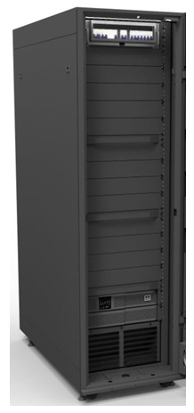
- The unit can be installed inside the rack.
- The airflow rate can be modulated based on site conditions.
- The output cooling capacity modulates as per the cooling load demands at site.
- Operates on R410A refrigerant.
- Quick installation and deployment being of a modular construction
- Less work and cost for installation compared to other air conditioner.
- White space-saving owing to a relatively small-footprint and mounted inside the rack utilizing lesser rack unit space.
- With the unit installed inside the rack, the hot air from the rear side of the rack is drawn inside the unit and cold conditioned air is discharged from the front-side of the unit delivering it right in front of the server’s intake side.
Figure 1-1 Mounting location of the Indoor unit

- The unit can be installed on both the top and bottom of the rack inside the rack.
- The unit also can be installed at the ceiling outside the rack.
- The direction of supply air discharged from the front side of the unit can be changed by adjusting the grilles, up or down.
- The cooling capacity is modulated automatically by the built-in control system and can range from 25% to 100%, about 0.9 kW to 3.5 kW. This makes the unit best-suited for part-loads or dynamic cooling loads.
- The unit is built-in with high efficiency and reliable components which include the compressor, electronic expansion valve, EC-fan and an advanced controller specifically designed by Vertiv for this unit.
- Utilizes EC-fan technology for the evaporator fan which saves energy by varying the airflow rate exactly as per the requirement.
- The condensing unit is equipped with a variable speed condenser fan with a speed variation ranging from 30% to 100% of the entire operating range.
  - Model Description
The physical appearance of air conditioner is shown in Figure 1-2.
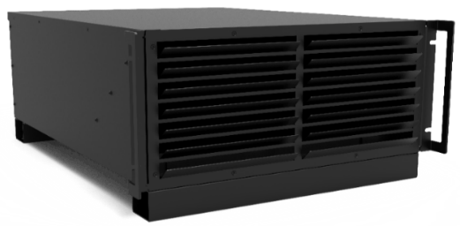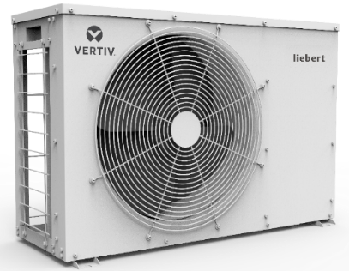
Indoor unit Standard condensing unit
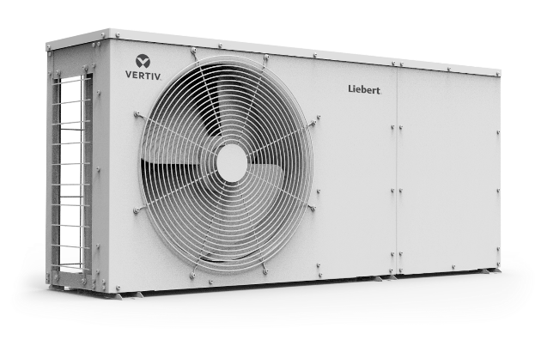
Low ambient condensing unit
Figure 1-2 Appearance of the air conditioner units
The indoor unit is installed in the rack or at the ceiling. The condensing unit is mounted external to the rack, preferably outside in an exposed environment.

  - Model Nomenclature
The nomenclature of the units is shown in Figure 1-3.
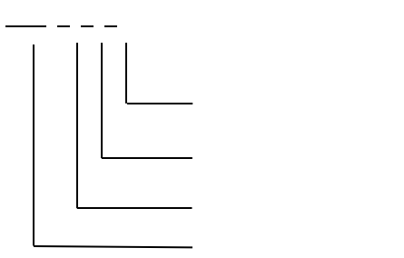
VRC 2 0 0
0 = 120 V, 1 Ph, 60 Hz
1 = 208/230 V, 1 Ph, 60 Hz
2 = 230V, 1 Ph, 50/60 Hz

0 = Standard Unit
5 = Low Ambient Unit

2 = Split System Indoor Unit
3 = Split System Condensing Unit
VRC=Vertiv Rack Cooler
Figure 1-3 Nomenclature

Table 1-1 mentions the description of the indoor and condensing units as per the nomenclature.
Table 1-1 Model coding description
Model | Power Supply | Part Code | Description
VRC200 | 120 V, 60 Hz | 01304032 | Indoor unit, 3.5 kW, 120 V
VRC300 | 208/230 V, 60 Hz | 01304036 | Condensing unit, 3.5 kW, 208/230 V for compressor and 120 V for condensing fan
VRC350 | 208/230 V, 60 Hz | 01304536 | Low ambient condensing unit, 3.5 kW, 208/230 V for compressor and 120 V for condensing fan
VRC201 | 208/230 V, 60 Hz | 01304034 | Indoor unit, 3.5 kW, 208/230 V
VRC301 | 208/230 V, 60Hz | 01304035 | Condensing unit, 3.5 kW, 208/230 V for compressor 208/230 V for condensing fan
VRC351 | 208/230 V, 60 Hz | 01304537 | Low ambient condensing unit, 3.5 kW, 208/230 V for compressor 208/230 V for condensing fan
VRC202 | 230 V, 50/60 Hz | 01304534 | Indoor unit, 3.5 kW, 230 V
VRC302 | 230 V, 50/60 Hz | 01304535 | Condensing unit, 3.5 kW, 230 V for compressor 230 V for condensing fan
VRC352 | 230 V, 50/60 Hz | 01304538 | Low ambient condensing unit, 3.5 kW, 230 V for compressor 230 V for condensing fan

  - Components
The major components of the unit include the evaporator coil, condensate drain tray, evaporator EC fan, electronic expansion valve (EEV), inverter rotary compressor, condenser coil and condenser fan which are placed in the Indoor and the Condensing unit as shown below.
    - Indoor Unit
The components of the indoor unit are depicted in Figure 1-4.
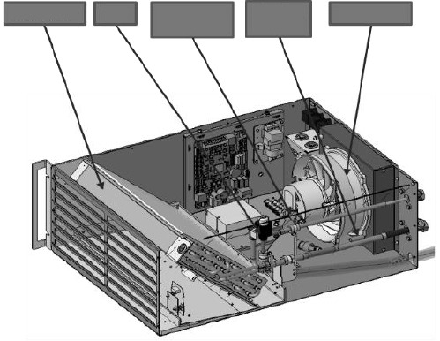
evaporator
EEV
Pressure transducer
Suction temp
Indoor fan
Figure 1-4 Indoor unit

- Evaporator Coil
The slant evaporator coil provides maximum surface area for heat transfer which ensures the delivered SHR > 0.9 always. The coil is constructed from copper pipes with aluminum fins in a slit type configuration. With low air pressure difference across the coil even at higher air flow rates, the coil section is light and compact and has an easy access for removal and repair/replacement.
- Condensate Drain Tray
With a metallic condensate drain tray placed under the coil assembly, it is ensured that the entire condensate drain has easy disposal/removal from the unit with a precise condensate outlet connection.
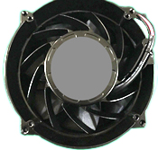
- Evaporator EC Fan
The indoor unit is equipped with a high-efficiency EC fan made of aluminum that delivers high airflow rates to ensure the airflow demands are met during the entire operational time. The EC fan has a smooth speed variation across its operating speeds that working in synchronization with the entire system components to deliver the precise output capacity.
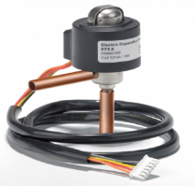
- Electronic Expansion Valve
The system is incorporated with an electronic expansion valve that monitors temperature and pressure signals simultaneously to maintain precise adjustment of the refrigerant flow. The electronic expansion valve can ensure even flow distribution of each end.
    - Condensing Unit
The components of the condensing unit are depicted in Figure 1-5 and Figure 1-6.
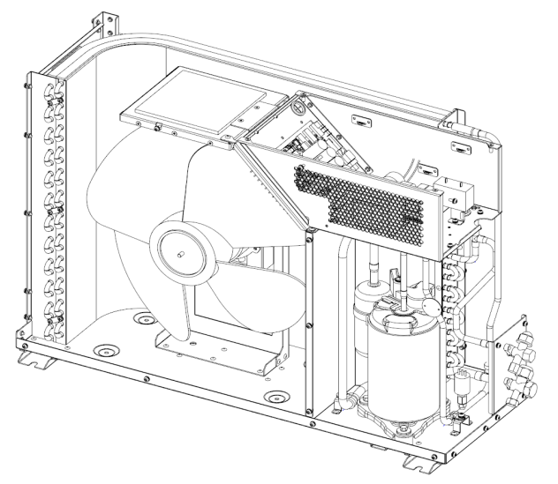
Inverter rotary compressor
Condenser coil
Condenser fan
Figure 1-5 Standard condensing unit internal parts
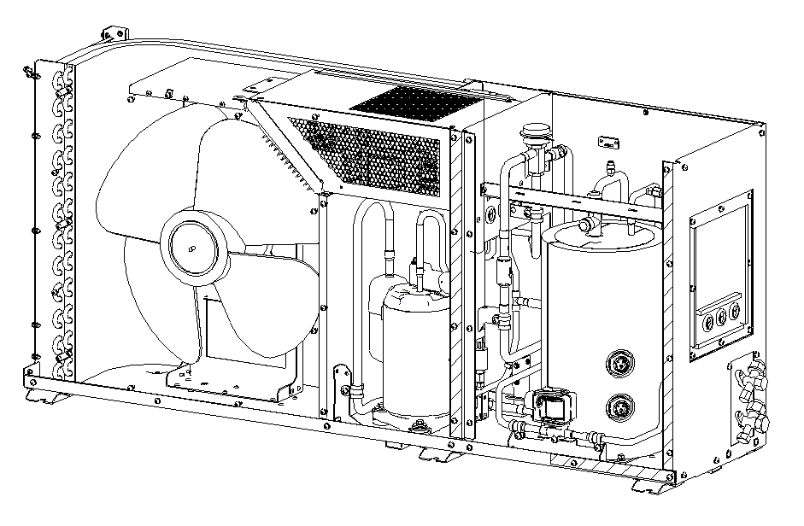
Condenser fan
Condenser coil
Receiver
Inverter rotary compressor
Figure 1-6 Low ambient condensing unit internal parts
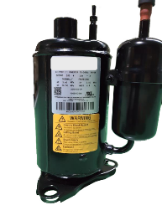
- Compressor
The condensing unit is equipped with an inverter rotary compressor that works on R410A refrigerant and which varies its cooling output capacity as per the cooling demands. It ensures that the cooling capacity of the unit precisely matches the cooling demand under all circumstances.
- Condenser Coil
The L-shaped condenser coil is designed for a maximum contact area. It is made of copper with aluminum slit fin configuration.
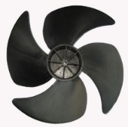
- Condenser Fan
The condensing unit is equipped with an AC fan which varies the operating speed as per the cooling variations of the compressor to always maintain a suitable condensing pressure.
- Low Ambient Module
The low ambient module is equipped with a receive, a solenoid valve and a head pressure control valve. This module ensures that the air conditioner system can work at -34 °C (-29.2 °F).
  - Technical Specifications
The detailed technical specifications which include the mechanical and the electrical details are mentioned in Table 1-2.

Table 1-2 Technical specifications
Parameters | Specification
Model | VRC200 | VRC201 | VRC202 | VRC300 | VRC301 | VRC302 | VRC350 | VRC351 | VRC352
Certification | UL 1995  (CSA C22.2 NO.236-11) |  | CE  (EN 60335-1;  EN 60335-2-40;  EN 55014-1;  EN 55014-2;  EN 61000-3-2;  EN 61000-3-3;  EN 50581) | UL 1995  (CSA C22.2 NO.236-11) |  | CE  (EN 60335-1;  EN 60335-2-40;  EN 55014-1;  EN 55014-2;  EN 61000-3-2;  EN 61000-3-3;  EN 50581) | UL 1995  (CSA C22.2 NO.236-11) |  | CE  (EN 60335-1;  EN 60335-2-40;  EN 55014-1;  EN 55014-2;  EN 61000-3-2;  EN 61000-3-3;  EN 50581)
Cooling Capacity, kW | 0.9 - 3.5 |  |  | /
Air Volume, m3/h (CFM) | 750 (441) |  |  | /
Max Power Input, kW | 0.21 |  |  | 1.12 |  |  | 1.12
Input Voltage, Vac | L1+L2+G,120 Vac | L1+L2+G,  208/230 Vac | L+N+PE,  230 Vac | L1+L2+G,  208/230 Vac |  | L+N+PE,  230 Vac | L1+L2+L3+G,  208/230 Vac |  | L+N+PE,  230 Vac
Full Load Amperage, A | 2.1 | 1.7 | 1.5 | 7.2 | 7.2 | 6.5 | 7.2 | 7.2 | 6.5
Condenser Fan- Full Load Amperage, A | / |  |  | 0.87 | 0.37 | 0.37 | 0.87 | 0.37 | 0.37
Liquid Line Solenoid Valve - Full Load Amperage, A | / |  |  |  |  |  | 0.13 | 0.08 | 0.08
Dimensions (W×D×H, mm (in.)) | 442×602×264  (17.40×23.70×10.39) |  |  | 786×282×527  (30.94×11.10×20.75) |  |  | 1158×282×527  (45.60×11.10×20.75)
Frequency, Hz | 60 | 60 | 50/60 | 60 | 60 | 50/60 | 60 | 60 | 50/60
Color | EG7021 (Black) |  |  | G103 (White)
IP Code | / |  |  | IPX4 (IEC 60529) |  |  | IPX4 (IEC 60529)
Net Weight, kg (lbs.) | 23 (50) |  |  | 44 (97) |  |  | 68 (150)
Gross Weight, kg (lbs.) | 51 (112) |  |  | 70 (154) |  |  | 85 (187)
Noise Level (tested within the rack) | <60 dB(A) |  |  | <55 dB(A) |  |  | <55 dB(A)
Outdoor Temperature range, °C (°F) | / |  |  | -15 (5) to 45 (113) |  |  | -34 (-29.2) to 45 (113)

NOTES:
- There are two control methods which are supply air control and return air control. The return air control mode is applied to an open environment, while the supply control mode is applied to a closed rack.
- Supply air temperature set point varies between 12.8 °C (64.4 °F)- 23 °C (73.4 °F). The recommended supply air temperature set point is 21 °C (69.8 °F).
- When the VRC unit is used in a closed rack, the heat load should be evenly placed in rack and unused rack position should be covered with blanking plates.

The maximum capacities vary with temperatures, as shown below.
Standard Condensing Unit  Maximum Capacity, kW |  | Condenser Air Temperature
 |  | 29.4 °C  (85 °F) | 35 °C  (95 °F) | 40 °C  (104 °F)
Evaporator Air Temperature to IT Devices  (Supply Air Control) | 19 °C  (66 °F) | 3.7 | 3.6 | 3.6
 | 21 °C  (70 °F) | 3.9 | 3.8 | 3.8
 | 23 °C  (73 °F) | 3.9 | 3.8 | 3.8

Standard Condensing Unit  Maximum Capacity, kW |  | Condenser Air Temperature
 |  | 29.4 °C  (85 °F) | 35 °C  (95 °F) | 40 °C  (104 °F)
Evaporator Air Temperature to Cooling Module  (Return Air Control) | 29.4 °C  (85 °F) | 3.4 | 3.3 | 2.8
 | 35 °C  (95 °F) | 3.8 | 3.7 | 3.2
 | 40 °C  (104 °F) | 4.0 | 3.9 | 3.4

Low Ambient Condensing Unit  Maximum Capacity, kW |  | Condenser Air Temperature
 |  | 29.4 °C  (85 °F) | 35 °C  (95 °F) | 40 °C  (104 °F)
Evaporator Air Temperature to IT Devices  (Supply Air Control) | 19 °C  (66 °F) | 3.2 | 3.1 | 3.1
 | 21 °C  (70 °F) | 3.4 | 3.4 | 3.4
 | 23 °C  (73 °F) | 3.5 | 3.4 | 3.4

Low Ambient Condensing Unit  Maximum Capacity, kW |  | Condenser Air Temperature
 |  | 29.4 °C  (85 °F) | 35 °C  (95 °F) | 40 °C  (104 °F)
Evaporator Air Temperature to Cooling Module  (Return Air Control) | 29.4 °C  (85 °F) | 3.1 | 3.0 | 2.5
 | 35 °C  (95 °F) | 3.5 | 3.4 | 2.9
 | 40 °C  (104 °F) | 3.6 | 3.5 | 3.0

The minimum capacities vary with temperatures, as shown below.
Standard Condensing Unit  Minimum Capacity, kW |  | Condenser Air Temperature
 |  | 29.4 °C  (85 °F) | 35 °C  (95 °F) | 40 °C  (104 °F)
Evaporator Air Temperature to IT Devices  (Supply Air Control) | 19 °C  (66 °F) | 0.92 | 0.90 | 0.88
 | 21 °C  (70 °F) | 0.94 | 0.92 | 0.90
 | 23 °C  (73 °F) | 0.96 | 0.94 | 0.92

Standard Condensing Unit  Minimum Capacity, kW |  | Condenser Air Temperature
 |  | 29.4 °C  (85 °F) | 35 °C  (95 °F) | 40 °C  (104 °F)
Evaporator Air Temperature to Cooling Module  (Return Air Control) | 29.4 °C  (85 °F) | 0.92 | 0.90 | 0.88
 | 35 °C  (95 °F) | 0.94 | 0.92 | 0.90
 | 40 °C  (104 °F) | 0.96 | 0.94 | 0.92

Low Ambient Condensing Unit  Minimum Capacity, kW |  | Condenser Air Temperature
 |  | 29.4 °C  (85 °F) | 35 °C  (95 °F) | 40 °C  (104 °F)
Evaporator Air Temperature to IT Devices  (Supply Air Control) | 19 °C  (66 °F) | 0.91 | 0.89 | 0.87
 | 21° C  (70 °F) | 0.93 | 0.91 | 0.89
 | 23 °C  (73°F) | 0.95 | 0.93 | 0.91

Low Ambient Condensing Unit  Minimum Capacity, kW |  | Condenser Air Temperature
 |  | 29.4 °C  (85 °F) | 35 °C  (95 °F) | 40 °C  (104 °F)
Evaporator Air Temperature to Cooling Module  (Return Air Control) | 29.4 °C  (85 °F) | 0.91 | 0.89 | 0.87
 | 35 °C  (95 °F) | 0.93 | 0.91 | 0.89
 | 40 °C  (104 °F) | 0.95 | 0.93 | 0.91

PART II
INSTALLATION

- Pre-Installation
The air conditioner is an equipment and requires installation works. The preliminary preparation is very important. This chapter details the pre-installation, including how to prepare the installation environment and space and reserve the maintenance space, the air conditioner running and storage environment requirement, and how to unpack and inspect. Please read this chapter carefully before installation.
WARNING! Risk of improper wiring, piping, moving, lifting and handling. Can cause equipment damage, serious injury or death. Installation and service of this equipment should be done only by qualified personnel who have been specially-trained in the installation of air-conditioning equipment and who are wearing appropriate, OSHA-approved PPE.
  - Fittings
The fittings are shown in Figure 2-1.
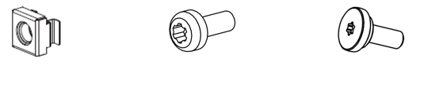
M5 Center Screw
M6 Pan-head Screw
M6 Cage Nut
Figure 2-1 Fittings
The usage of fittings is shown in Table 2-1.
Table 2-1 Fittings instruction
Fitting Utility | Usage | Quantity
M6 cage nut | Used with M6 pan-head screws for tightening pillars | 6
M6 Pan-head screw | Used to install the VRC 20X unit | 6
M5 center screw | Used to fasten the L-shape mounting rails | 10

  - Self-Prepared Materials
The cables routed from the room to the unit and the circuit breakers must be prepared at the customer site or are to be obtained by the customer; the specifications for the same are given in the Table 2-2.

Table 2-2 Self-prepared materials
Parts | Specifications
External circuit breaker 1 | Please refer to FLA (Full Load Amperage) of indoor unit in Table 1-2
External circuit breaker 2 | Please refer to FLA of condensing unit in Table 1-2
Input power supply cables for indoor unit | Please refer to FLA of indoor unit in Table 1-2
Input power supply cables for condensing unit | Please refer to FLA of condensing unit in Table 1-2
Cables for condenser fan | Please refer to FLA of condenser fan in Table 1-2
Cables for liquid line solenoid valve (only used in VRC350, VRC351 and VRC352) | Please refer to FLA of liquid line solenoid valve in Table 1-2
Liquid copper pipe | Please refer to pipe connection of unit
Gas copper pipe | Please refer to pipe connection of unit
Communication line between indoor and condensing unit | Communication line with RJ45 ports

  - Transportation and Movement
WARNING! The components of the unit are comparatively large and heavy. Therefore, there may be a risk when the containment collapses. The collapse may result in physical injury, fatality and damage to the equipment.

CAUTION: Risk of contact with sharp edges, splinters, and exposed fasteners. Can cause injury. Only properly trained and qualified personnel wearing appropriate, OSHA-approved PPE should attempt to move, lift, remove packaging from or prepare the unit for installation.
The unit consists of an indoor unit and an outdoor unit. Both of them are comparatively heavy equipment and need to be moved by hand pallet truck or electrical forklift to the vicinity of the pre-decided location to be installed. Table 2-3, Figure 2-2 and Figure 2-3 show the dimensions of the units component with the package.
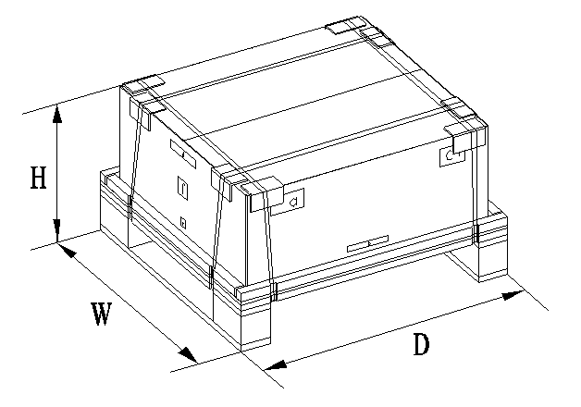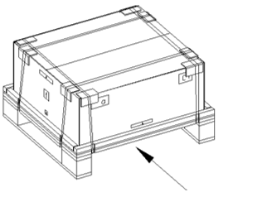
Forklift Direction
Figure 2-2 Package dimensions – indoor unit

Forklift Direction
Figure 2-3 Package dimensions – condensing unit

The unit with packing dimensions and weights are listed in Table 2-3:

Table 2-3 Packaging dimensions
Component |  | Packaging | Range of Dimensions  (Unit: mm (in.)) |  |  | Weight with Package  (Unit: kg (lbs.))
 |  | Packaging | H | W | D | Weight with Package  (Unit: kg (lbs.))
Unit with package | VRC200  VRC201  VRC202 | Wooden pallet with cardboard box | 460  (18.11) | 760  (29.92) | 830  (32.68) | 51  (112)
Unit with package | VRC300  VRC301  VRC302 | Wooden pallet with cardboard box | 750  (29.53) | 480  (18.90) | 970  (38.19) | 70  (154)
Unit with package | VRC350  VRC351  VRC352 | Wooden pallet with cardboard box | 755  (29.72) | 480  (18.90) | 1350  (53.20) | 85  (187)

Figure 2-4 depicts the schematic diagram of a hand pallet truck and an electric forklift.
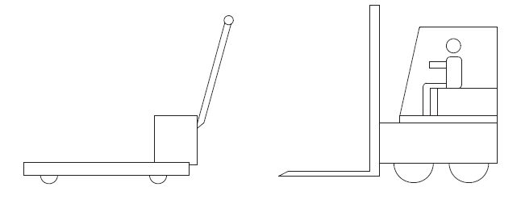
Hand pallet truck
Electrical forklift
Figure 2-4 A hand pallet truck and an electric forklift
If a hand pallet truck or an electric forklift truck is used, the tines of the hand pallet or electric forklift must be aligned with the center of gravity to prevent the package from toppling or falling over as depicted in Figure 2-5.
Forklift Direction
Figure 2-5 Forklift direction
While moving the package, the obliquity must be maintained at an angle of 90° ± 10°. Figure 2-6 depicts the 90° ± 10° obliquity is suitable to move the rack to the vicinity of the desired location.
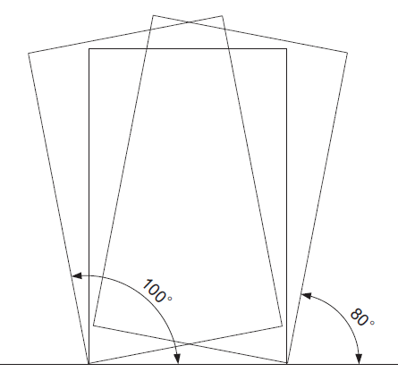
Figure 2-6 Carrying obliquity
NOTES:
- Ensure that the equipment stands upright.
- While using the forklift or the hand pallet truck, ensure that the fork arms (if adjustable and flexible) open to the greatest extent. This is done so that the fork arms can be placed under the pallet of the equipment in a precise manner.
- Ensure that the length of the fork arms match with that of the equipment.

  - Unpacking
Following are the steps and procedures that are to be observed during the unpacking process:
    - Unpacking of Indoor Unit
- The unpacking of the indoor unit from the packing materials is shown in Figure 2-7. Move the equipment of the assembled package to an open, firm leveled ground in the vicinity of the predetermined installation site.
- Cut off the packing strip on the package paper box using a utility knife followed by removing the package paper box of the unit.
- Remove the packing materials, including paper cover, support cardboard, paper box, cushion and paper corner in a specific order as mentioned from the top side of the unit.
- Remove the unit from the wooden pallet.
The accessory list of the indoor unit is shown in Table 2-4.
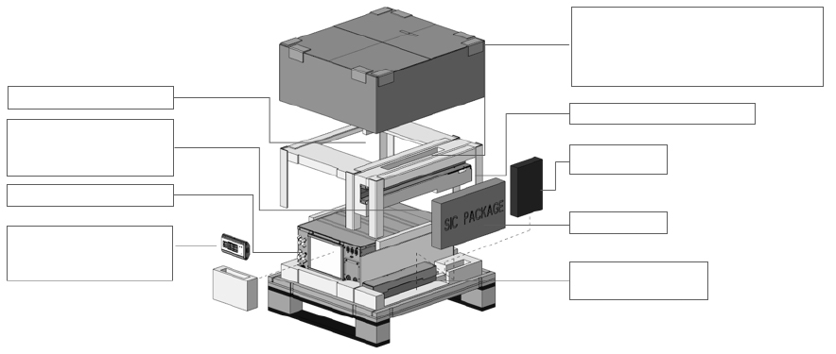
Display and Display Magnetic Box
User Manual,
VRC Cooling Unit
Condensate Water Pipe, USB Converter Cable, Cables of display
Cage Nuts (M6),
Pan-Head Screws M6×12 (Tor× T30),
Center Screws M5×12 (Tor× T20),
Cable Ties 100×2,5
L-shape Mounting Rail Kit
Drain fitting
SIC Card Kit
Condensate Pump and Pump Bracket
Figure 2-7 Unpacking indoor unit
Table 2-4 VRC2 series accessories
Sr No. | Item |  | Quantity
1 | Drainage Kit | Condensate Pump and Pump Bracket | 1
2 | Drainage Kit | Condensate Water Pipe (7.5 m /24.6 ft.) | 1
3 | Drainage Kit | Drain fitting | 1
4 | Display kit | Display and Display Magnetic Box | 1
5 | Display kit | 10 m (32.8 ft.) Cable of Display | 1
6 | Display kit | 0.5 m (1.6 ft.) Cable of Display | 1
7 | SIC Card Kit |  | 1
8 | L-shape Mounting Rail Kit |  | 2
9 | Cage Nuts (M6) |  | 6
10 | Pan-Head Screws M6x12 (Torx T30) |  | 6
11 | Center Screws M5x12 (Torx T20) |  | 10
12 | USB Converter Cable |  | 1
13 | Cable Ties 100x2,5 |  | 10
14 | User Manual |  | 1
15 | VRC Cooling Unit |  | 1

    - Unpacking of Condensing Unit
- The unpacking of the condensing unit from the packing materials is shown in Figure 2-8.
- Move the equipment of the assembled package to an open, firm leveled ground in the vicinity of the installation site.
- Cut off the packing strip on the package paper box using a utility knife followed by removing the package paper box of the unit.
- Remove the packing materials, including paper cover, support cardboard, paper box, cushion and paper corner in a specific order as mentioned from the top side of the unit.
- Remove the unit from the wooden pallet.
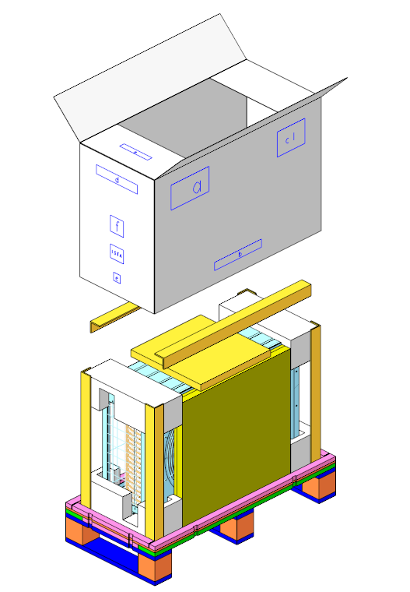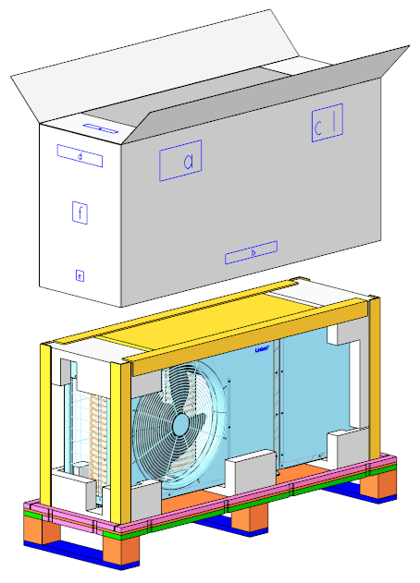
Standard condensing unit Low ambient condensing unit
Figure 2-8 Unpacking condensing unit

NOTES:
- Packing materials of the unit are recyclable. Retain the packing materials for further use or dispose them appropriately as per the protocols and local regulations.
The accessory list of the condensing unit is shown in Table 2-5.
Table 2-5 VRC3 series accessories
Sr No. |  | Item | Quantity | Model
1 |  | Side Panel | 2 | VRC300  VRC301  VRC302
2 |  | Front Panel | 1 | VRC300  VRC301  VRC302
3 |  | Screws (M4x10) | 10 | VRC300  VRC301  VRC302

  - Equipment Installation Room Requirements
The requirements are as follows:
- To ensure the normal operation of environmental control system, the rack should be free from air leakages that de-stabilize the temperature gradient and also could lead into moisture occurrence.
- The rack should have appropriate thermal separation.
- The condensing air entering the equipment room should be reduced to a minimum as the entry of condensing air may increase the load of the system. It is recommended that the leakage rate of condensing air be kept below 5% of the total internal airflow.
- All the doors and windows should be closed properly to avoid any air infiltration from outside into the room.

NOTES:
- Avoid locating the indoor unit in concave or narrow areas which can affect the airflow. It is prohibited to use the cooling unit in an unconducive condensing environment.

  - Environment
Following are the requirements that need to be observed from the environment point of view for site preparation of the unit:
- CAUTION: Keep the unit in a place far away from sparks or any heat source.
- CAUTION: Emission of erosive gases and organic solvents should not be near the unit.

    - Operating Environment
The operation environment requirements are mentioned in Table 2-6.
Table 2-6 Operating environment
Item | Requirements
Installation position | The maximal equivalent length of piping between the indoor unit and condensing unit [1]: 30 m (98.43 ft.)  Vertical distance ΔH [2]: -5 m (-16.40 ft.) ≤ ΔH ≤15 m (49.21 ft.)
Ambient temperature | Indoor: 18 °C-40 °C (64.4 °F-104 °F)  Standard condensing: -15 °C - 45 °C (5 °F -113 °F)  Low ambient condensing unit: -34 °C - 45 °C (-29.2 °F -113 °F)
Ambient humidity | <90% RH 30 °C (86 °F) (Non-condensing)
Protection level | Condensing unit: IPX4 (IEC 60529)
Altitude | < 1000 m (3280.84 ft.). For every 1000m increase in elevation, the evaporation temperature drops by 0.5 °C (0.9 °F) the net cooling capacity drops by 7%.
Note:
[1] - For the equivalent length of parts, refer to Table 3-7.
[2] - The value is positive if the condensing unit is installed above the indoor unit; negative if the indoor unit is installed above the condensing unit.

    - Storage Environment
The storage environment requirements are mentioned in Table 2-7.
Table 2-7 Storage environment
Item | Requirements
Storage environment | Clean (without dust)
Ambient humidity | < 95% RH 40 °C (104 °F) (Non-condensing)
Ambient temperature | -40 °C-70 °C (-40 °F -158 °F)
Storage time | The total shipment and storage time should not exceed 6 months. Otherwise, the performance needs to be re-calibrated

  - Installation Space Requirements
The indoor unit is a specifically engineered air conditioning unit. It is recommended to install the indoor unit inside the rack at the lowest rack unit space, as shown in the installation section.

  - Clearance Space
    - Indoor Unit
To facilitate ease of installation and maintenance, enough space must be provisioned at site. When the indoor unit is installed in room, the distance from the front and other sides of the unit to the wall or other obstacles must be greater than 1000 mm (30.00 in.) and 600 mm (18.00 in.) respectively, as shown in Figure 2-9. When the indoor unit is installed in the rack, the distance from the front and rear sides of the rack to the wall or other obstacles must be greater than 1000 mm (30.00 in.) and 600 mm (18.00 in.) respectively.
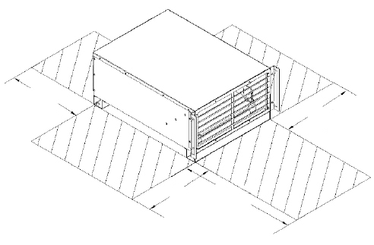
1000mm
[30'']
600mm
[18'']
600mm
[18'']
600mm
[18'']
Figure 2-9 The minimum distance for pull-out during maintenance (top view)
    - Condensing Unit
The required distance for installing condensing unit is shown in the following picture. For standard unit, the recommended distance from the wall should be 200 mm (7.87 in.). For low ambient condensing unit, the distance from the wall should be large enough to be maintained. And the minimum distance from the front side (supply air side) of the condensing unit should be 450 mm (17.72 in.) from any wall, obstacles or adjacent devices. It is a must to provide these clearance distances as shown in Figure 2-10 and Figure 2-11 to ensure appropriate airflow across the condensing unit.
Wall
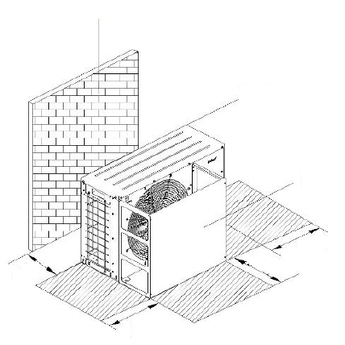
200mm
[7.87'']
450mm
[17.72'']
450mm
[17.72'']
450mm
[17.72'']
Front
Back
Figure 2-10 Recommended clearance space required for standard condensing unit
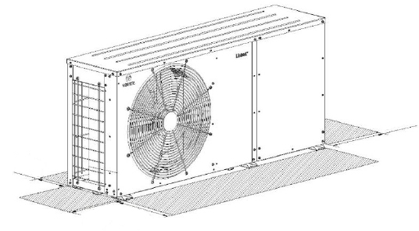
450mm
[17.72'']
450mm
[17.72'']
200mm
[7.87'']
450mm
[17.72'']
Figure 2-11 Recommended clearance space required for low ambient condensing unit

  - Weight Bearing Capacity
The cooling unit will be installed inside the rack due to the concentrated floor loading of the rack will increase. Therefore, the weight bearing capacity of the floor of the computer room must be taken into consideration.
  - Inspection
- The unit is pre-charged. Check there is no refrigerant and oil leaks.
- Check the system fittings and its components against the packing list to ensure that everything is in its designated position and the entire product assembly is intact.
- If any parts or components are missing or damaged, immediately report to the carrier about the same. If hidden damages are observed, then contact the local offices of that carrier as well as Vertiv Group Corp. at the earliest.
- Mechanical Installation
Proper installation is essential to achieve the intended design performance of the equipment and to maximize its service life. This chapter describes the mechanical installation of cooling system, including installation notes, system installation layout, end installation, unit piping installation, installation finishing work and installation check. This section should be used in conjunction with current mechanical and electrical installation regulations.

  - Installation Notes
NOTES:
- The indoor unit needs to be installed inside the rack or in room.
- Before installation, make sure that the installation environment meets the requirements and there must be sufficient provision for connecting the condensate drain line to the drain point.
- Follow the design drawings strictly when installing the equipment and reserve the space for maintenance. The manufacturer’s engineering dimensions drawings can serve as a reference.
- It needs 2 persons during installation.
- Torx bits T20 and T30 are needed during installation, as shown in Figure 3-1.
Figure 3-1 Torx bits
  - System Installation Layout
The overall layout of the unit which comprises of both the indoor unit and the condensing unit is depicted in Figure 3-2, Figure 3-3 and Figure 3-4.
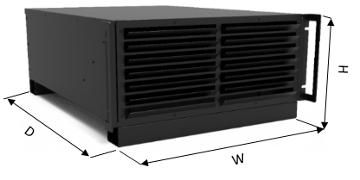
Figure 3-2 Indoor unit
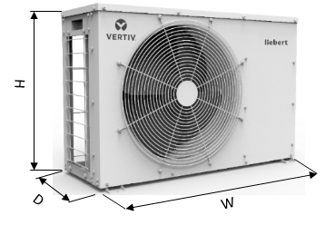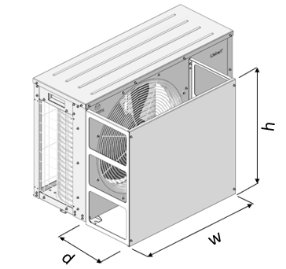
Figure 3-3 Standard condensing unit
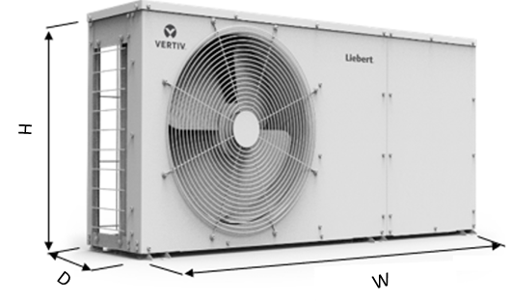
Figure 3-4 Low ambient condensing unit

The dimensions of indoor unit and condensing unit are listed in Table 3-1:
Table 3-1 Dimensions of indoor and condensing unit
Component |  | Range of Dimensions (Unit: mm (in.))
 |  | H | W | D
Indoor Unit | VRC200  VRC201  VRC202 | 264  (10.39) | 442  (17.40) | 602  (23.70)
Condensing Unit | VRC300  VRC301  VRC302 | 527  (20.75) | 786  (30.94) | 282  (11.10)
Condensing Unit | VRC350  VRC351  VRC352 | 527  (20.75) | 1158  (45.60) | 282  (11.10)

Each standard condensing unit (VRC300, VRC301, VRC302) has a set of air deflector. The dimension of the air deflector is shown in the Table 3-2.
Table 3-2 The dimension of the air deflector
Component |  | Range of Dimensions (Unit: mm (in.))
 |  | h | w | d
Standard Condensing Unit | VRC300  VRC301  VRC302 | 500  (19.68) | 563  (22.17) | 233  (9.17)

  - Installing the Unit
    - Installing the indoor unit inside the rack
A front view intricate detailed image depicting the dimensions which would help enable to mount the unit inside the rack are shown in Figure 3-5 and Figure 3-6.
Figure 3-5 Indoor unit dimensions
491.6 mm
[19.35'']
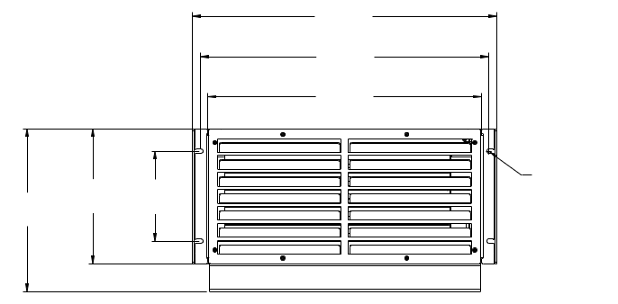
Φ7.2 mm
[0.28'']
146.0 mm
[5.75'']
219.0 mm
[8.62'']
263.5 mm
[10.37'']
442.0 mm
[17.40'']
465.0 mm
[18.31'']
Figure 3-6 The front view of indoor unit
The detailed dimensions of the indoor unit with their weights are mentioned in Table 3-3.
Table 3-3 Dimensions of cooling unit
Model | Dimensions (W × D × H, mm (inch)) | Net Weight (kg. (lbs))
Cooling unit | 442 × 602 × 264  (17.40×23.70×10.39) | 23.0 (50.7)

- Mounting the L-shaped rails in the rack
Each of the two L-shape rails are comprised of two parts, a long front rail and a slotted rear bracket, as shown in Figure 3-7. There are left and right VRC rails. The flanges of each of the front rails should be on the bottom and pointing toward the center of the rack. Slip the slots in the rear rail bracket over the pressed studs in the front rail part. Loosely fasten with nuts. Fasten the ends of the front rails and rear brackets to the uprights using center screws M5x12 T20. Torque=4.0 Nm (2.95 ft.-lb.). Once in place, tighten the nuts on the front rail part studs. Torque = 5.6 Nm (4.13 ft.-lb.).
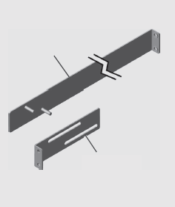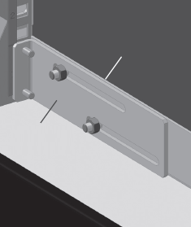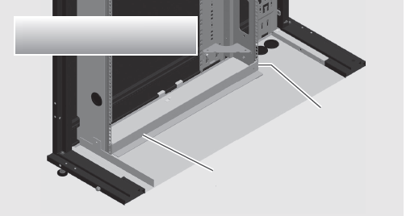
Front rail part
Front rail part
Slotted rear bracket
Slotted rear bracket
Cross section of VertivTM VRC-S shown for Illustrative purposes.
Left VertivTM VRC slotted rear bracket
Left VertivTM VRC front rail
Figure 3-7 L-shape rails installation
- Inserting the indoor unit into the rack
Insert the indoor unit into the front of the rack until the its front brackets are against the rack’s uprights.
- Fastening the indoor unit
Fasten the indoor unit front brackets to both front uprights using four M6 cage nuts and M6x12 T30 screws (5.6 Nm/4.13 ft.-lb. torque), as shown in Figure 3-8.
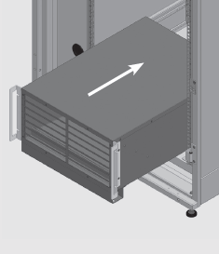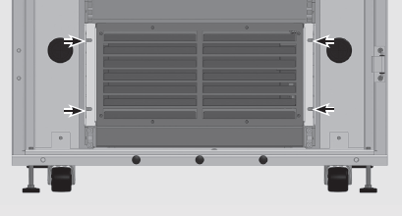
Figure 3-8 Indoor unit installation
NOTES:
- Make sure the indoor unit is installed horizontally, otherwise high-water level alarms may be triggered incorrectly.
- For installation in a 2-post rack, please purchase accessory 2POSTRMKITVRC. Installation instructions are included with this rail kit.
    - Installing the Condensing Unit
The physical appearance of the condensing unit is shown in Figure 3-3 and Figure 3-4. The top view of the standard condensing unit is shown in Figure 3-9 and the low ambient condensing unit is shown in Figure 3-10.
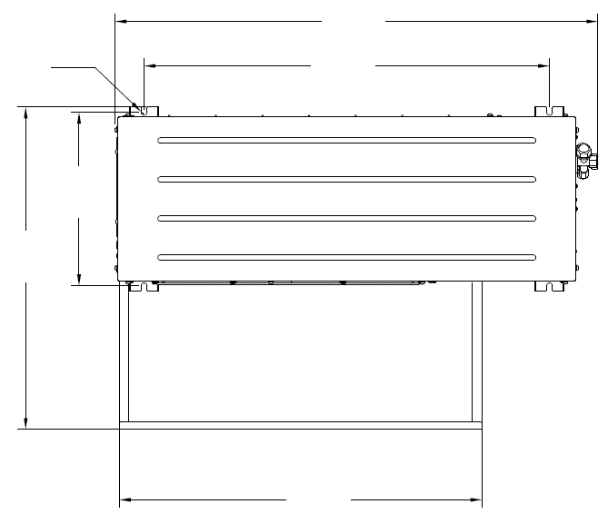
563mm
[22.2'']
R5mm
[R0.2'']
530mm
[20.9'']
298mm
[11.7'']
696mm
[27.4'']
829mm
[32.6'']
Figure 3-9 Standard condensing unit top view
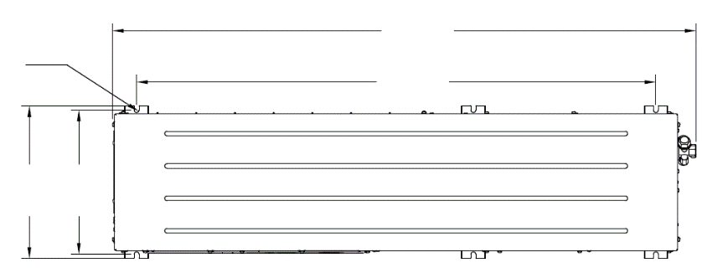
R5mm
[R0.2'']
298mm
[11.7'']
316mm
[12.4'']
1073mm
[42.2'']
1206mm
[47.5'']
Figure 3-10 Low ambient condensing unit top view
Table 3-4 Condensing unit dimensions
Model | Dimensions (W × D × H, mm (in.)) | Net Weight (kg (lbs.))
VRC300  VRC301  VRC302 | 786×282×527  (30.94×11.10×20.75) | 44.0 (97.0)
VRC350  VRC351  VRC352 | 1158×282×527  (45.60×11.10×20.75) | 68.0 (149.9)

The condensing unit must be installed vertically. The condensing unit can either be installed higher than the indoor unit or lower than the indoor unit. Figure 3-11 shows the scenario where the condensing unit is installed higher than the indoor unit. When installing the condensing unit 7.5m higher than the indoor unit, a trap should be installed on the discharge pipe. This trap will retain refrigerant oil in the off cycle of the compressor. When the compressor starts, oil in the trap will be carried up the vertical riser and return to the compressor immediately.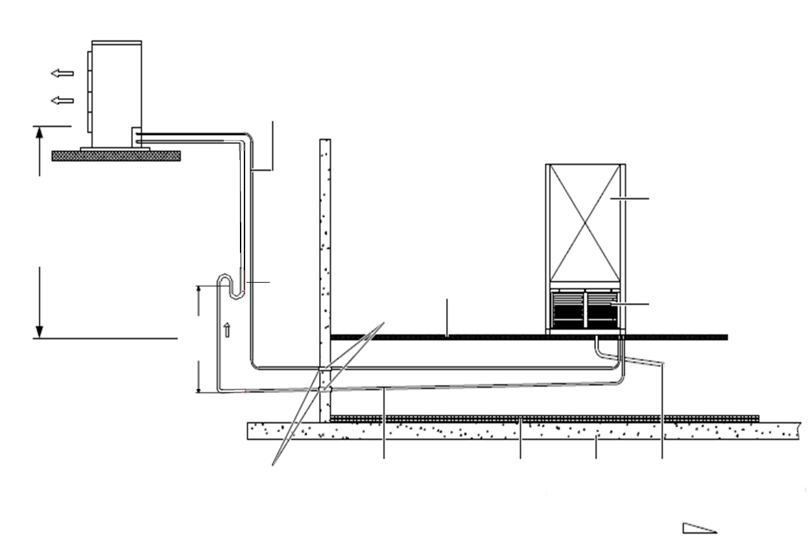
15m
[49.21ft]
Drain pipe of condensate water (extend to outdoor to drain condensate water)
1:200
Floor
Heat insulation material
Gas side pipe
Sealing on inlets
7.5m
[24.60 ft]
Max
Indoor unit
Cabinet
Trap
Wall bushing
Isolation floor
Liquid side pipe (no direct sunlight)
Outdoor unit
Figure 3-11 The Condensing unit is installed higher than the indoor unit

Figure 3-12 shows the scenario where the condensing unit is installed lower than the indoor unit. 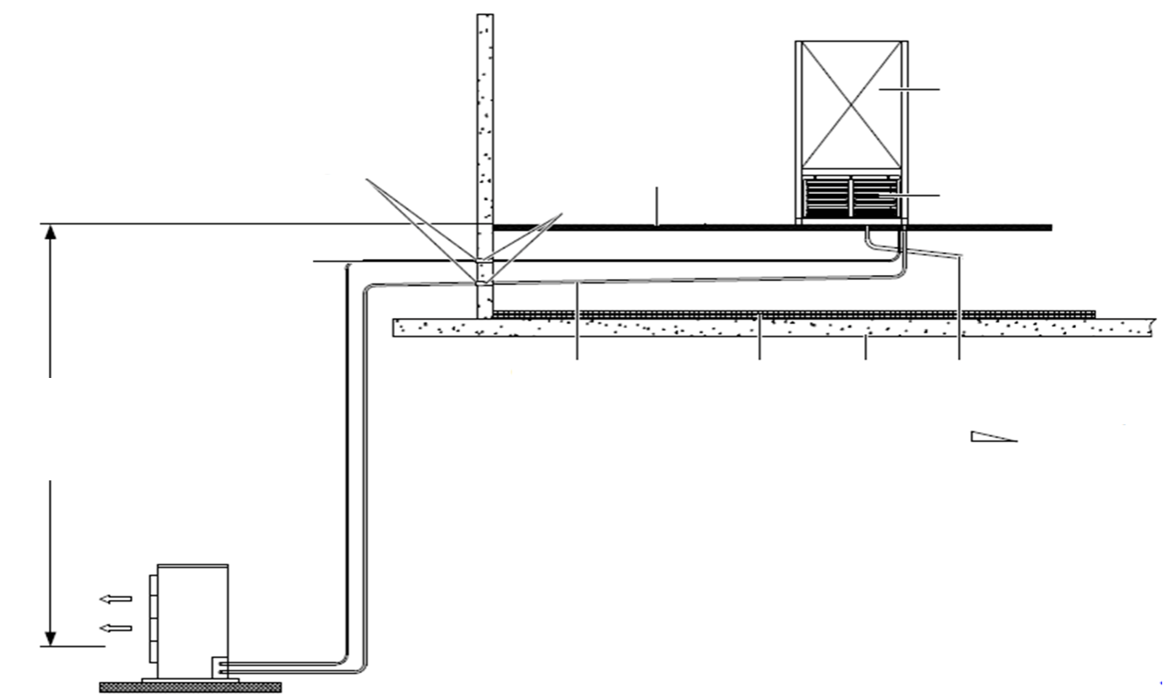
Drain pipe of condensate water (extend to outdoor to drain condensate water)
1:200
Sealing on inlets
Gas side pipe
Heat insulation material
Floor
Liquid side pipe (no direct sunlight)
Isolation floor
Wall bushing
Outdoor unit
Cabinet
Indoor unit
Max
5m
[16.40ft]
Figure 3-12 The Condensing unit is installed lower than the indoor unit

Table 3-5 shows the vertical distance between the indoor and the condensing unit.
Table 3-5 Vertical distance between Indoor unit and Condensing Unit
Relative Position | Value
Condensing unit installed higher than indoor unit | Maximum: 15 m (49.21 ft.)
Condensing unit installed lower than indoor unit | Maximum: 5 m (16.40 ft.)

Following are the steps that need to be observed for the regular installation of the condensing unit:
- Place the condensing unit on the base
- Use expansion bolts to fix the condensing unit on the base.
If there are multiple condensing units, they need to be placed on top of the other. The method to implement placement of the condensing units on top of the other is shown in Figure 3-13.
Following points need to be taken during the installation of the condensing uni.
NOTES:
- The condensing unit must be placed appropriately in a safe place for maintenance. It also should not be installed on the bottom floor of the public site. It should not be kept in a residential area.
- It should not be kept in an environment where noise levels are considered crucial.
- Keep the condensing unit in a clean environment, free of debris, dust foreign matter. This is done to avoid blocking of the heat exchanger and ensure an efficient cooling effect.
- There should be no steam, hot gas exhaust gas near the condensing unit.
- Preferably, keep above 450 mm between the condensing unit and the wall, obstacles, or adjacent devices. For Standard condensing unit, if the condensing unit will be installed in an outdoor environment, the recommended distance of the back side (return air side) from the wall should be 200 mm (7.87 in.). It is a must to provide these clearance distances to ensure appropriate airflow across the condensing unit.
- Avoid keeping the condensing unit in places where snow may accumulate in the air intake side and air outlet side.
- Preparing a base to bear the weight of the condensing unit is important where the base should be at least 50 mm (1.97 in.) higher than the ground and 50 mm (1.97 in.) wider than the condensing unit base.
- The condensing is around 44 kg (97 lbs.); therefore, utmost care must be taken while removing it; any mishandling will result in severe injury and damage to the equipment.
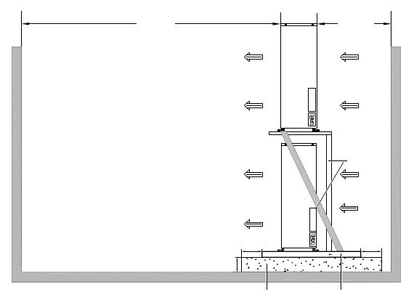
Outdoor unit base
Base
Note:
1. Use 5# angle iron for bracket, when two units are installed with one above the other.
2. Use 6.5# channel steel for bracket, when three units are installed with one above the other.
0.2m
[0.66 ft.]
4m
[13.12 ft.]
Airflow
Out-door unit
Out-door unit
Bracket
50mm [1.97 in.]
50mm [1.97 in.]
Min. 50mm [1.97 in.]
Airflow
Figure 3-13 Installing multiple condensing units one above the other
    - Installing the drain fitting to the indoor unit
Fasten the drain fitting to the drain port of the indoor unit, as shown in Figure 3-14. The drain fitting contains a sealing block, which is used for preventing the water leaking from the drain fitting port. Make sure the sealing block is installed tightly.
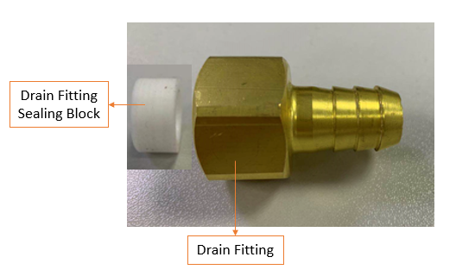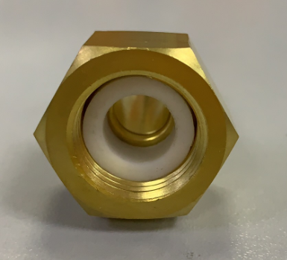
Drain Fitting
Drain Fitting Sealing Block
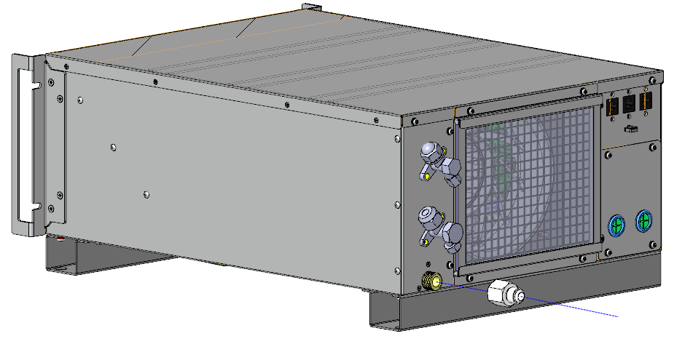
Figure 3-14 Installing the drain fitting
    - Installing the condensate pump
NOTES:
- Please finish the cable connection in chapter 4 first, otherwise it will be difficult to connect the cables.

1. Divide the pump bracket into part 1 and part 2, as shown in Figure 3-15 and Figure 3-16.
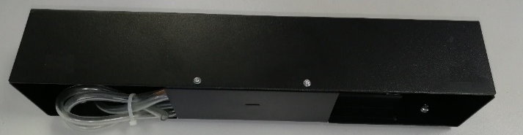
Pump bracket part 1
Pump bracket part 2
Pump bracket part 1
Figure 3-15 Appearance of pump bracket
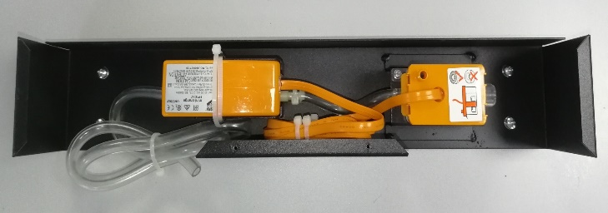
Figure 3-16 Internal structure of water pump bracket
2. Install the power cord and the L-shape pipe, as shown in Figure 3-17.

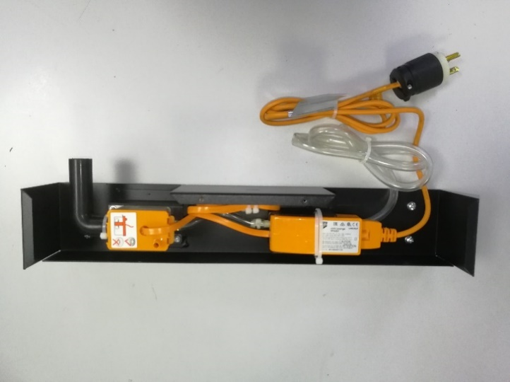
Screws (M5 x12)
L-shape pipe
Power cord
Figure 3-17 Internal structure of water pump bracket
3. Loosen the four screws in Figure 3-17 about 4 turns.
4. Slide the pump bracket part 1 on L-shape mounting rail, as shown in Figure 3-18.
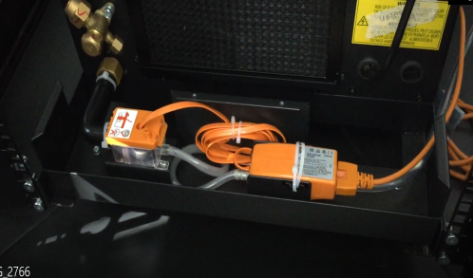
Figure 3-18 Installation of the pump kit
5. Install L-shape pipe to drain fitting, and fix it with a cable tie, as shown in Figure 3-18.
6. Fix the pump bracket part 1 with tightening the 4 screws in Figure 3-17.
7.Install pump bracket part 2 to pump bracket part 1 with tightening the 2 screws in Figure 3-19.
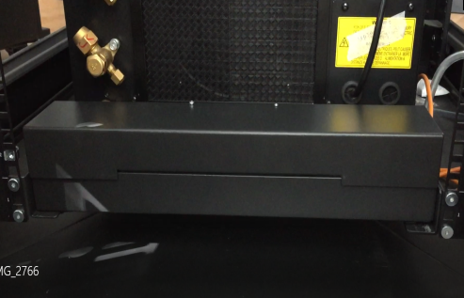
Pump bracket part 2
Figure 3-19 Installation of the pump bracket part 2
There are an anti-Siphoning device and a condensate water pipe in indoor unit package. The anti-Siphoning device is used to prevent siphonage and should be installed vertically on the pipe. The condensate water pipe can be used to extend drainage lines.
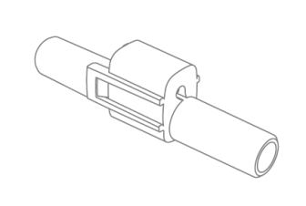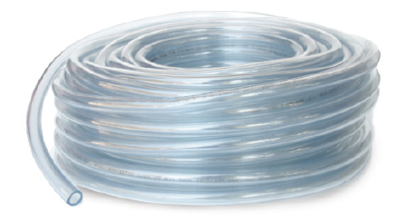
Figure 3-20 Anti-Siphoning device and condensate water pipe
  - Connecting the Copper Pipes to the Unit
For standard condensing unit, before connecting the copper pipes, it is needed to install the air deflector first as shown in Figure 3-21.
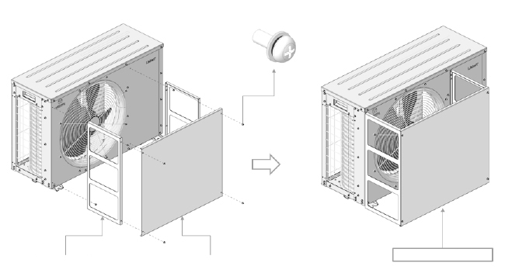
AIR DEFLECTOR
SIDE PANEL *2PCS
FRONT PANEL *1PCS
STAINLESS STEEL PAN HEAD SCREW * 4PCS
Figure 3-21 Air deflector installation for standard condensing unit
In this section, the general principles of connecting copper pipes, installation information about the connectors and the required pipe connections will be explained in detail. Figure 3-22, Figure 3-23 and Figure 3-24 show connectors on both the indoor and the condensing unit.
General Principles
- Copper pipes with quick thread connectors must be used to connect the indoor and condensing unit. If the pipe length exceeds the standard pipe length and a straight copper pipe is used, in that case, piping joints must be brazed.
- Follow standard industry practices in selection and placement of pipes, system evacuation charging with refrigerant (only when the pipeline is long). The standard refrigerant of the unit is R410A. The charging amount for low ambient condensing unit is 4.0kg (8.82 lbs), while other units is 1.3 kg (2.87 lbs).
- Take the pipeline pressure drop and the oil return to the compressor into consideration to avoid oil leakage and clogging in parts of the system. Utmost care while considering these factors minimizes the noise and vibration significantly.
- If an extended piping kit is required or if the equivalent length exceeds 20 m (65.62 ft.), it’s necessary to add a check valve at the liquid pipe outlet of the condensing unit. Also, consult your local Vertiv Sales Office, if the vertical distance between the indoor unit and condensing unit exceeds 15 m (49.21 ft.).

Liquid pipe: 3/8''
Connector: 5/8'' -18UNF
Suction pipe: 1/2''
Connector: 3/4'' -16UNF
Drain pipe: 1/2 NPT
Figure 3-22 Connectors of indoor unit
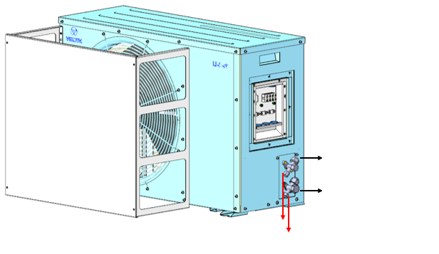
Needle Valves
Liquid pipe: 3/8''
Connector: 5/8'' -18UNF
Suction pipe: 1/2''
Connector: 3/4'' -16UNF
Figure 3-23 Connectors of standard condensing unit
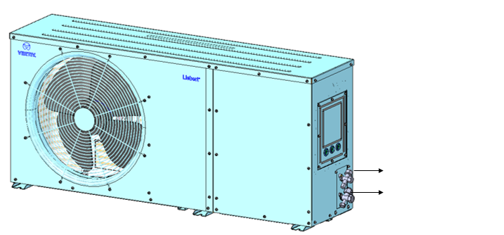
Liquid pipe: 3/8''
Connector: 5/8'' -18UNF
Suction pipe: 1/2''
Connector: 3/4'' -16UNF
Figure 3-24 Connectors of low ambient condensing unit
- Use thermal insulation material to cover quick thread connectors of both indoor and condensing units, after completing the installation and commission, as shown in Figure 3-25.
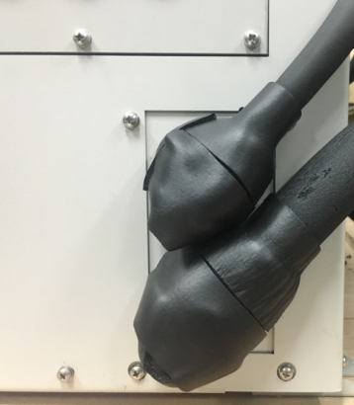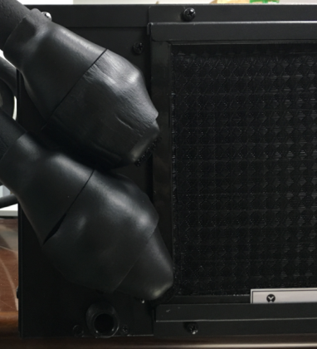
Figure 3-25 Keep copper piping and quick thread connector insulation
Installation Notes of the connector
Both top as well as the bottom piping method are compatible with the unit. The connectors of the unit are located on the indoor unit and condensing unit. Utmost care must be taken while connecting the quick thread connector.
Read the following steps thoroughly before making the connection:
  - Remove the dust-proof caps.
  - Wipe the coupling seats and threaded surface with a clean cloth carefully.
  - Lubricate the male thread with refrigerant oil.
  - Thread the coupling halves together manually (by hand) to ensure that the threads mate properly.
  - Tighten the coupling body’s hexagon nut and union valve until a definite resistance is felt.
  - Use a marker to draw a line lengthwise from the coupling unit to the bulkhead. Tighten the nuts by an additional quarter turn with a wrench (22 mm for liquid pipe, 24 mm for suction pipe). The misalignment of the lines depicts how much the coupling has been tightened. The final quarter turn is essential to ensure that the joint doesn’t leak.

NOTES:
- The maximal equivalent length of piping between the indoor unit and condensing unit is 30 m (98.43 ft.).

The Table 3-6 prescribes the equivalent length of the piping to be considered in the liquid line piping for the bends and the elbows connector devices.
Table 3-6 Equivalent length for bends and valves
Liquid Pipe OD  (mm (inch)) | Equivalent Length (m (ft.))
Liquid Pipe OD  (mm (inch)) | 90° bend | 45°bend | 180° U bend | 90° shut-off valve | Check valve
9.52 (3/8) | 0.44  (1.44) | 0.22  (0.72) | 0.65  (2.13) | 1.8  (5.91) | 1.6  (5.25)
12.7 (1/2) | 0.50  (1.64) | 0.25  (0.82) | 0.75  (2.46) | 2.1  (6.90) | 1.9  (6.23)
The procedure for fitting the connectors of the condensing unit are mentioned in Figure 3-26. The same can be replicated for fitting the connectors of the indoor unit.
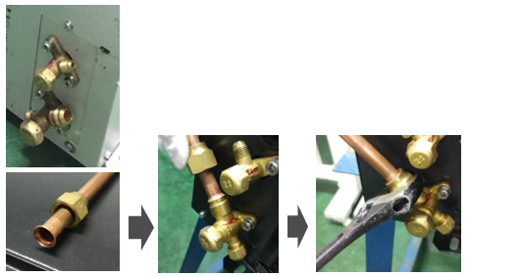
Tighten with a wrench

Torque for gas line, thread 3/4'' -16UNF, 25-32 Nm (18-24 ft.-Ib.)
Torque for liquid line, thread 5/8'' -18UNF, 15-20 Nm (11-15 ft.-Ib.)
Figure 3-26 Tightening the connectors of the condensing unit
The recommended torque values are listed in Table 3-7.
Table 3-7 Torque value for tightening the piping connections
Coupling Size | Torque Value (Nm (ft.-lb.))
3/4” - 16UNF | 25 – 32 (18-24)
5/8” - 18UNF | 15 – 20 (11-15)

Required Pipe Connections
Following steps must be implemented during connection of the refrigerant pipe between the indoor unit and the condensing unit.
- The liquid pipe functions as the refrigerant liquid pipe of the condensing unit outlet. Select an appropriate pipe diameter and length for the pipe to ensure that the pressure drop of the refrigerant liquid through the pipe during the unit operation doesn’t exceed 40kPa (5psi ̴ 6psi).
- Install and remove the pipe with utmost care to prevent it from getting damaged. Use tube benders and ensure that all the bends are made accurately prior to making connections to either end.
- If the jointing mode is required, ensure all the refrigerant piping connections are made with silver blazed joints.
- Check all the piping supports, leakage testing, dehydration of refrigerant pipes evacuation before usage. Use vibration isolation support to isolate the refrigeration pipes from the building.
- Use soft and flexible material for packing around the pipes to protect them from damage caused due to openings in walls and to reduce vibration transmission.
- Use a thermal insulation material to cover the connecting copper piping and the quick thread connectors of the indoor unit and condensing unit to ensure good performance of the unit.
- Connect pipes of the indoor and condensing units based on the labels. The unit adheres to the quick connection mode.
- The unit has been charged with appropriate refrigerant and refrigerant oil (FV50S) before delivery. However, if the connecting pipe between the condensing unit and indoor unit is longer than 10m (32.8 ft.), add the refrigerant and refrigerant oil (FV50S) to the system to ensure normal system operation.
- When installing the condensing unit 7.5m higher than the indoor unit, a trap should be installed on the discharge pipe. This trap will retain refrigerant oil in the off cycle of the compressor. When the compressor starts, oil in the trap will be carried up the vertical riser and return to the compressor immediately.
Refrigerant and refrigerant oil must be added in accordance with the following formula:
Refrigerant and refrigerant oil amount to be added (kg (lbs.)) = Adding refrigerant and refrigerant oil amount per meter of the liquid pipe (kg/m (lbs./ft.)) × total length of the extended liquid pipe (m. (ft.))
Table 3-8 shows the refrigerant and refrigerant oil amount to be added per meter of the liquid pipe.
Total length of the extended liquid pipe (m (.)) = Total length of the liquid pipe (m (ft.)) – 10.0 m (ft. (32.8))
Table 3-8 Additional refrigerant and refrigerant oil
Adding Refrigerant Amount per Meter kg/m  (lbs./ft.) | Adding Refrigerant Oil (FV50S) Amount per Meter ml/m  (ml/ft.)
0.050 (0.034) | 13.0 (4.0)

NOTES:
- Risk of oil contamination with water. Can cause equipment damage. VRC systems require the use of PVE (FV50S) oil. PVE oil absorbs water at a much faster rate when exposed to air than previously used oils. Because water is the enemy of a reliable refrigeration system, extreme care must be used when opening systems during installation or service. If water is absorbed into the PVE oil, it will not be easily removed and will not be removed through the normal evacuation process. If the oil is too wet, it may require an oil change. PVE oils also have a property that makes them act as a solvent in a refrigeration system. Maintaining system cleanliness is extremely important because the oil will tend to bring any foreign matter back to the compressor.
- Risk of improper refrigerant charging. Can cause equipment damage.Refrigerant charge must be weighed into air-cooled compressorized systems before they are started.
  - Refrigerant Charge
The unit is usually pre-charged with the rated amount of refrigerant in factory, and the connectors of the liquid and the suction lines are closed. The suction and liquid pipe should be filled with 27 bar nitrogen at the needle valves on suction and liquid pipe connectors for at least 3 hours to check for any leakage in the piping and connections. If there is no leakage observed, vacuum the liquid and suction lines at the needle valves. Open the connectors of the liquid and the suction lines after evacuation.
If the unit is not pre-charged, it is necessary to add refrigerant, as shown in Table 3-9. Open the connectors of suction and liquid pipe, then the suction and liquid pipe should be filled with 27 bar nitrogen at the needle valves on suction and liquid pipe connectors for at least 3 hours to check for any leakage in the piping and connections. If there is no leakage observed, vacuum the unit at the needle valves. Add refrigerant to air conditioner after evacuation.
For standard unit, position of needle valves for vacuuming and charging the refrigerant is shown Figure 3-27.
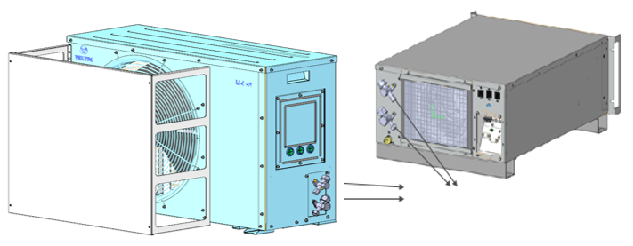
Needle valves for vacuuming and charging
Figure 3-27 Charging the refrigerant gas
For low ambient condensing unit, position of needle valves for vacuuming and charging the refrigerant is shown Figure 3-30. There is a receiver in the low ambient condensing unit. Point 1 and 2 represent the needle valves, point 3 represents a needle valve at the inlet of the receiver depicted in Figure 3-28. When vacuuming or charging the refrigerant, it should be carried out simultaneously from the three points. Especially when vacuuming, it must be vacuumed at point 3, otherwise the vacuum will fail.
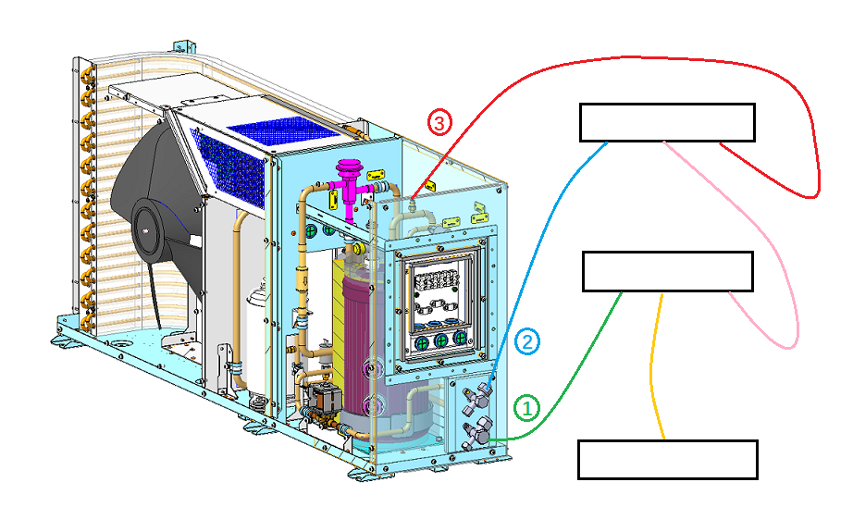
Vacuum or Charge
Pressure Gauge 1
Pressure Gauge 2
Figure 3-28 Vacuuming and charging for low ambient condensing unit
If it is necessary to add more refrigerant and refrigerant oil, please contact Vertiv for technical assistance. For the exact amount of refrigerant and refrigerant oil to be charged in the system, refer to Table 3-8 and Table 3-9.
Table 3-9 Amount of refrigerant to be charged in the system
Unit Type | Refrigerant Type | Refrigerant Charge (kg (lbs.))
VRC200/VRC300 | R410A | 1.30 (2.87)
VRC201/VRC301 | R410A | 1.30 (2.87)
VRC202/VRC302 | R410A | 1.30 (2.87)
VRC200/VRC350 | R410A | 4.00 (8.82)
VRC201/VRC351 | R410A | 4.00 (8.82)
VRC202/VRC352 | R410A | 4.00 (8.82)
  - Installation/Pre- commissioning Check List
After the unit is mounted with the all the necessary mechanical connections done, it is necessary to re-check the installation as per the pre-commissioning checklist per Table 3-10.
Table 3-10 Mechanical Installation Checklist
Items | Results
Sufficient space for maintenance activities at site
Ensure all the fittings are connected firmly.
The placement direction of the indoor unit is correct, pay attention to that the supply air is sent to the cold aisle at the front, the hot air is drawn back to the return air inlet of the unit at the back.
Foreign materials in and around the equipment are removed (such as shipping materials, removed construction materials, tools so on)
The condensate pump and pipes are connected properly
All pipe joints are firmly fixed
All pipe connectors and fasteners are tightly fastened.

After all these items are checked and confirmed, continue with the electrical installation works of the unit.

- Electrical Installation
This chapter describes the electrical installation of unit, including installation noted, cable connection, communication cable connection and installation inspection.
  - Installation Notes
WARNING! Arc flash and electric shock hazard. Open all local and remote electric power-supply disconnect switches, verify with a voltmeter that power is Off and wear appropriate, OSHA-approved personal protective equipment (PPE) per NFPA 70E before working within the electric control enclosure. Failure to comply can cause serious injury or death. Customer must provide earth ground to unit, per NEC, CEC and local codes, as applicable. Before proceeding with installation, read all instructions, verify that all the parts are included and check the nameplate to be sure the voltage matches available utility power. The Liebert® controller does not isolate power from the unit, even in the “Unit Off” mode. Some internal components require and receive power even during the “Unit Off” mode of the controller. The only way to ensure that there is NO voltage inside the unit is to install and open a remote disconnect switch. Refer to unit electrical schematic. Follow all local codes.

WARNING! Risk of electric shock. Can cause equipment damage, injury or death. Open all local and remote electric power supply disconnect switches and verify with a voltmeter that power is off before working within any electric connection enclosures. Service and maintenance work must be performed only by properly trained and qualified personnel and in accordance with applicable regulations and manufacturers’ specifications. Opening or removing the covers to any equipment may expose personnel to lethal voltages within the unit even when it is apparently not operating and the input wiring is disconnected from the electrical source.

WARNING! Risk of electric shock. Can cause injury or death. Open all local and remote electric power-supply disconnect switches and verify that power is Off with a voltmeter before working within the condensate pump electrical connection enclosure. The Liebert® controller does not isolate power from the unit, even in the “Unit Off” mode. Some internal components require and receive power even during the “Unit Off” mode of the Liebert® controller.

WARNING! Do not power on the unit until authorized technical personnel have confirmed that the unit connections are correct.

WARNING! Risk of improper wire sizing/rating and loose electrical connections. Can cause overheated wire and electrical connection terminals resulting in smoke, fire, equipment and building damage, injury or death. Use correctly sized copper wire only and verify that all electrical connections are tight before turning power On. Check all electrical connections periodically and tighten as necessary.

  - Cable Connection
It is required to install circuit breakers between the unit and the power supply. The circuit breakers can be selected based on the FLA of unit that is mentioned in Table 4-1.
The cable connections for the indoor unit are done through the cover panel at the back-side of the unit as shown in Figure 4-1.
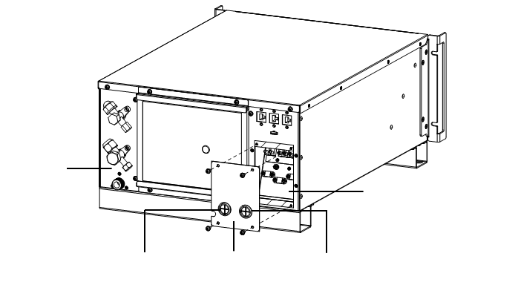
Cover panel
Indoor Cable hole
Outdoor fan hole
Place for Cable connection
Back Plate
Figure 4-1 Cover panel for cabling connections

The power cables can be selected based on the amperage ratings for each component that is mentioned in Table 4-1.
Table 4-1 Current Ratings of Components
Unit Type | Input Voltage | Frequency | FLA of Compressor (A) | FLA of Liquid Line Solenoid Valve (A) | FLA of Outdoor Fan (A) | FLA of Unit (A)
VRC200 | 120 Vac | 60 Hz | - | - | - | 2.1
VRC201 | 208/230 Vac | 60 Hz | - | - | - | 1.7
VRC300 | 208/230 Vac | 60 Hz | 7.2 | - | 0.87 | 7.2
VRC301 | 208/230 Vac | 60 Hz | 7.2 | - | 0.37 | 7.2
VRC202 | 230 Vac | 50/60 Hz | - | - | - | 1.5
VRC302 | 230 Vac | 50/60 Hz | 6.5 | - | 0.37 | 6.5
VRC350 | 208/230 Vac | 60 Hz | 7.2 | 0.13 | 0.87 | 7.2
VRC351 | 208/230 Vac | 60 Hz | 7.2 | 0.08 | 0.37 | 7.2
VRC352 | 230 Vac | 50/60 Hz | 6.5 | 0.08 | 0.37 | 6.5

The cables of the indoor and the condensing units are depicted in Figure 4-2 and Figure 4-3.
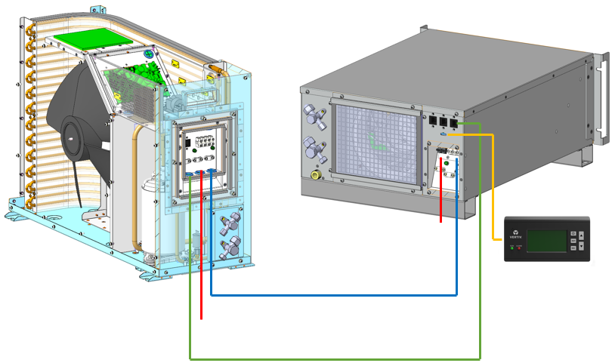
Communication RS485
Outdoor fan control
Outdoor Power
Indoor Power
Display board
Figure 4-2 Overview of the cabling connections (Standard condensing unit)
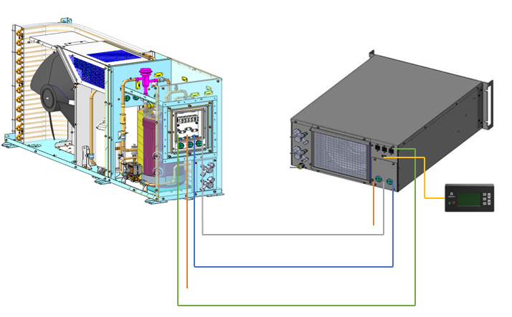
LLSV
Communication RS485
Outdoor fan control
Outdoor Power
Indoor Power
Display board
Figure 4-3 Overview of the cabling connections (Low ambient condensing)
Detailed input cabling connections of the indoor unit power terminal are shown in Figure 4-4.
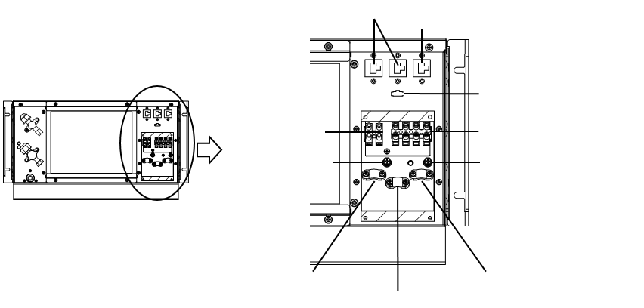
Cable clamp 2
Cable clamp 3
Cable clamp 1
Terminal block for Input Power
Grounding screw 1
Grounding screw 2
Terminal block for LLSV Power and Outdoor Fan Power
Display board plug
Compressor communication line
RJ45-1/RJ45-2
Figure 4-4 Input Cabling connections – Indoor Power terminal
Input cabling connections of the condensing unit power terminal block are shown in Figure 4-5
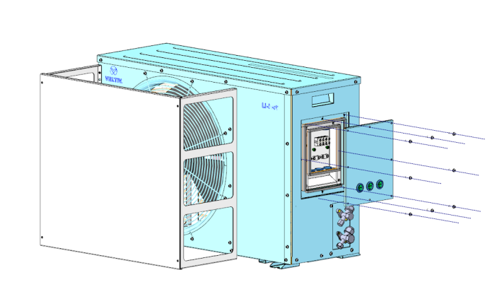
Cross head screw M4*10 × 8PCS
sealing strip
Outdoor fan terminal block
Input power terminal block
Outdoor unit communication terminal block
Cover plate
Figure 4-5 Input Cabling connections – Condensing Power terminal
Detailed input cabling connections of the condensing unit electric box are shown in Figure 4-6 and Figure 4-7.
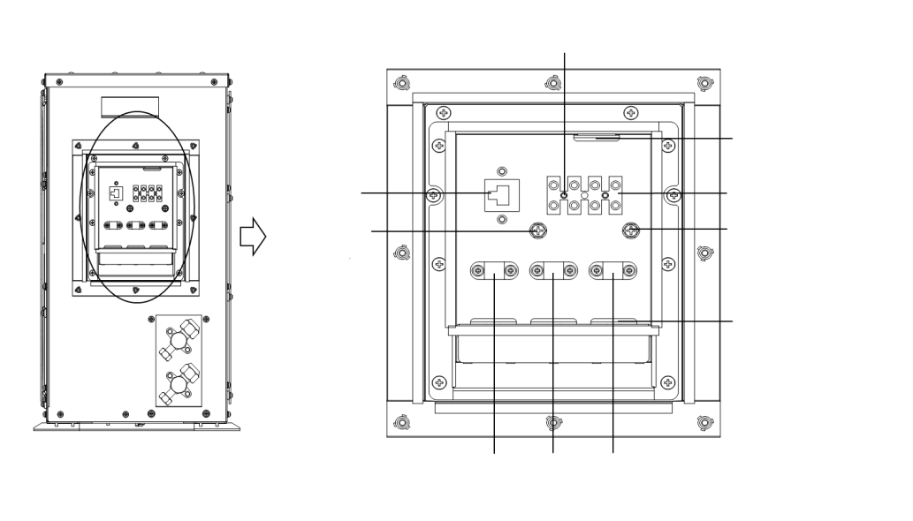
External cable hole
Cable clamp3
Cable clamp2
Cable clamp1
Compressor communication line
Grounding screw1
Grounding screw2
Terminal block for Outdoor Fan Power
Inner cable hole
Terminal block for Input Power
Figure 4-6 Standard condensing unit electric connection illustration

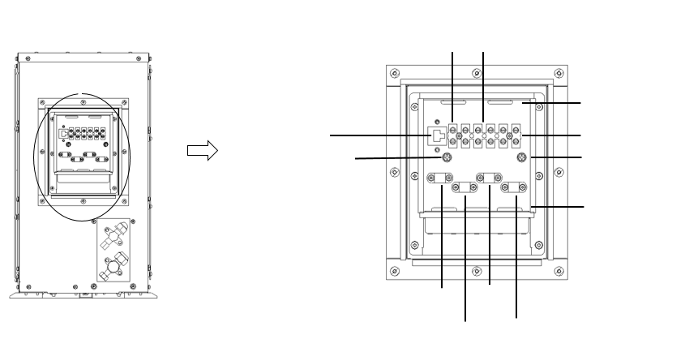
Terminal block for LLSV
Cable clamp 4
External cable hole
Cable clamp 3
Cable clamp 2
Cable clamp 1
Compressor communication line
Grounding screw1
Grounding screw2
Terminal block for Outdoor Fan Power
Inner cable hole
Terminal block for Input Power
Figure 4-7 Low ambient condensing unit electric connection illustration
  - Communication Cable Connecting
    - Display cable connection
Two display cable shall be provided in the accessories kit. Insert one end of the cable into the display board plug, connect the other end of the cable to the display board.
    - Communication connection
The RJ-45 port (RS485-3) for connecting indoor and condensing unit must be provisioned by the customer. The length of the communication line should be prepared according the actual installation distance at site. The position and description of insert plug are shown in Figure 4-6 and Table 4-2.
There are RS485-1 and RS485-2 ports on the unit for communication with third party monitoring systems to enable remote monitoring of the unit. The RS485-1 (with 12 V power supply) could connect with SIC card monitoring kit. The aforementioned connections are shown in Figure 4-8 and Table 4-2. Please refer to RDU-SIC G2 Card Field Installation for details.
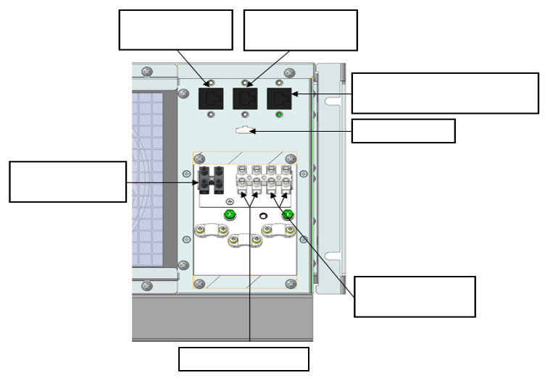
Network port RS485-1
Network port RS485-2
Outdoor Communication RS485-3
Display plug
Input Power Terminal block
LLSV Block
Outdoor fan Terminal block
Figure 4-8 Display, power and monitoring cable connections in the indoor unit

Table 4-2 Communication port description
Port type | RS485-1 | RS485-2 | Compressor Communication RS485-3
1 | 12 V | NC | NC
2 | 12 V | NC | NC
3 | NC | NC | NC
4 | GND | GND | GND
5 | GND | GND | GND
6 | NC | NC | NC
7 | D+ | D+ | D+
8 | D- | D- | D-
  - Installation Inspection
After the electrical installation is completed, it should be confirmed according to Table 4-3 below.

Table 4-3 Installation inspection
Items | Results
The power supply voltage meets the rated voltage on the unit nameplate
The system electric loop has no open circuit or short circuit
There must be no open-circuit or short-circuit in the electrical connections.
The power cable and grounding cable to the air-break switch are connected.
The ratings of the miniature circuit breakers and fuses are correct (Refer to the unit nameplates to select suitable miniature circuit breakers or fuses)
The control cables are connected firmly.
All the cables connections are fastened appropriately, with no loose screws at the connections

After confirming the above points, you can start the commissioning of the unit.
NOTES:
- Do not power on the unit until any Vertiv authorized technical personnel has checked and confirmed the unit.

- Controller Operation Instructions
This chapter gives a detailed description on feature, appearance, LCD screen, control buttons, control interface and menu structure of the air conditioner.
  - LCD Screen
The LCD screen displays English menus with white backlight. Figure 5-1 depicts the image of the controller display.
ESC
ENT
ALARM
RUN
LCD Screen
ON/ OFF Button
Up Arrow Button
ENT Button
Down Arrow Button
Alarm Indicator
Run Indicator
ESC Button
Figure 5-1 Controller Display
  - Control Buttons
The micro-processing controller provides five control buttons, as shown in below Figure 5-2.
ON/ OFF Button
Up Arrow Button
ENT Button
Down Arrow Button
ESC Button
ESC
ENT
Figure 5-2 Control Buttons
The functions of the control buttons are described in Table 5-1.
Table 5-1 Functional description of the controller buttons
Key | Function Description
ON/OFF | Switch on/off the controller by pressing and holding for 3s.
ENT  (Enter button) | Enter the selected menu screen. Validate the parameter setting value.
ESC | Exit the current menu and return to the Normal screen or previous menu screen. Abort parameter change; make the audible alarm scilent.
Up button | Move the cursor up or increase the parameter value. For a toggle selection: scroll through the options. For a multi-screen menu: scroll up the screen.
Down button | Move the cursor down or decrease the parameter value. For a toggle selection: scroll through the options. For a multi-screen menu: scroll down the screen.

  - ON Screen
After the unit is powered on, the LCD screen will display the ON screen, and you can choose English or Chinese on the display board.

  - Normal Screen
After the unit is powered on, the Normal screen will be displayed after 10 seconds, as shown in Figure 5-3. The temperature units of VRC200, VRC201 and VRC202 are Fahrenheit, Fahrenheit and Celsius, respectively. The VRC200 is used as an example.
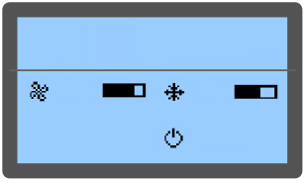
S / ON
63 %
75 %
RET 90 °F
86 °F

SUP -- %
-- %

SUP 68 °F
ACT 70 °F

Figure 5-3 Normal Screen
It displays the settings and actual values in the upper half of the display related to the settings and actual supply air temperature in the first column, humidity in the second column and return air temperature in the third column.
In the lower part of the screen, it displays the unit output status (fan, cooling) and unit operation status (off, running, standby locked).
The icons on the main screen indicate the unit output status, unit property unit operating status. The icons and their definitions are displayed in the Table 5-2.

Table 5-2 Controller display icon details
Icons | Definitions
 | Fan rotating speed. Displaying the percentage of actual fan rotating speed
 | Compressor capacity. Displaying the percentage of actual compressor capacity
 | Unit property/operation status. S: single; ON: running; R-OFF: remote shutdown; L-OFF: local shutdown; M-OFF: monitoring shutdown; MANU: manual mode; BKUP: backup; Lock: lock

  - Unit Working Icons
The icons and their definitions are listed in Table 5-3.

Table 5-3 Description of Icons
Icon | Description
SUP | Supply air temperature setpoint
ACT | Actual air temperature
RET | Specified return temperature
 | Cooling, the output of compressor
 | Rotating speed rate of the fan, ranging from 30% to 100%
 | Unit attribute/running state. S: standalone; RUN: running; OFF: shutdown

  - Menu
Alarm Menu
Select Alarm Menu on Main Menu screen to enter the screen shown in Figure 5-4. Press the Up or Down button to scroll up or down the menu items.

<ALM Status>
<HP Abnormal>
<ALM Set>
Figure 5-4 Alarm Menu
Alarm Status
The alarm status menu is used to monitor the current alarm status of the air conditioner unit. It prompts no alarm or specific alarm information. The specific alarm information includes XX/YY, alarm type alarm generation time, as shown in Figure 5-5. XX indicates the alarm SN YY indicates the total number of reported alarms.
ALM Status 1/1
Hi SupTemp
2018/01/01 12:00
Figure 5-5 Current alarm menu
NOTES:
- The latest alarm SN is the biggest number. Press the Up or Down button to scroll through the alarm status records if more than one alarm is activated.
- The current alarms are automatically cleared upon system power failure.

Alarm Set
On the Alarm Set menu, select to enter the alarm setup screen. Use the Up or Down key to query menu items. The alarm setup menu includes Alarm Setpoint, System Alarms Alarm Handle, as shown in Figure 5-6, Figure 5-7 and Figure 5-8. Parameter settings can be saved permanently.

Hi Sup Temp 80.6 °F
Lo Sup Temp 46.4 °F
Hi Ret Temp 86 °F
Figure 5-6 Items of the alarm value setup menu

Hi Sup Temp ON
Lo Sup Temp ON
Hi Ret Temp ON
Water HL ON
Figure 5-7 Items of the system alarm attribute setup menu

Filt Maint Yes
Clr HP Abnor No
Figure 5-8 Items of alarm handle attribute menu

Temp Set
Select Main Menu -> Temp set enter the screen as shown in Figure 5-9 the Temperature Setting values will be permanently saved.

Ctrl Mode Sup Air
Sup Stpt 60.8 °F
Ret Stpt 82.4 °F
Temp DB 0.9 °F
Cool Prop 9 °F
Figure 5-9 Temp & Hum Set menu
NOTES:
- The specified temperature value is the target temperature for ensuring normal system running. When the control mode is set to return or supply air, the specified temperature is the temperature of the return air or supply air.
- The default control mode of the unit is return air control mode, and the setpoint is 25 °C (77 °F).
- If the indoor unit is used in the open rack, it is recommended to use return air control mode.
- If the indoor unit is used in the closed rack, it is recommended to use supply air control mode.

System Status
Select Main Menu -> System State to enter the System State menu, as shown in Figure 5-10.

<Run Time>
Figure 5-10 System Status

Run Time
You can query the operation time of the device on this menu, as shown in Figure 5-11.

Fan 23 h
Comp 0 h
Figure 5-11 Run time menu

Help Menu
The menu includes Date &Time information. You can view the relevant information, as shown in Figure 5-12.

Date (Y) 2018
Date (M) 1
Date (D) 1
Time (H) 12
Time(M) 20
Time(S) 30
<Date&Time>
Figure 5-12 Date & Time menu

PART III
SYSTEM OPERATION &
GENERAL MAINTENANCE

- Startup Commissioning
This chapter describes the startup commissioning, including specific operations.

  - Preparations Before Commissioning
    - Mechanical Part
- Ensure all valves are open in the refrigerant lines as per their initial valve opening set-points.
- Ensure that the amount of refrigerant charged inside the system is correct.
- Connect the condensate water drain system piping and inspect for any leakages in the connections.
- Ensure that the unit has a heat load of at least 0.9 KW. If not, use other heating devices that compensate for the heat load to ensure necessary amount of heat load for commissioning.
    - Electronic part
- Ensure that the input voltage of the main power supply is within ± 10% of the rated voltage and that the power disconnector is closed.
- Ensure that all electrical or control connections are correct and tighten all electrical and control connectors.
- Ensure that the power cable and low-voltage control cable are separately arranged.
  - Start-up Inspection Checklist
Before powering up the unit, ensure the below mechanical and electrical inspections are properly checked as per the Table 6-1 below.
Table 6-1 Start-up inspection checklist
Inspection | Items | Remarks
Mechanical inspection | Check if the indoor unit and condensing unit have been connected as an entire system.
Mechanical inspection | Check if all valves in system have been opened fully.
Mechanical inspection | Check whether refrigerant and oil were added as instructed.
Mechanical inspection | Check if drainage pipe has been connected properly and tightly.
Mechanical inspection | Check if there is heat load for AC operating, if not, please increase the heat load by some devices, such as heaters.
Electrical inspection | Check, measure confirm if the AC mains voltage and frequency are normal verify if the AC mains correction is correct without any short circuit
Electrical inspection | Check if all electrical or control connections are correct and tight.

  - System Commissioning
The indoor and condensing units have been charged with the rated amount of refrigerant in factory, when the indoor unit and condensing unit have been connected as an entire system at sites, the steps mentioned below should be followed to ensure the normal operation of the unit:

    - Start up the unit
- Close all the circuit breakers of the unit only after a careful inspection of the entire unit installation is done.
- Press and hold the ‘ON’ button on the display board for 3 seconds to power up the unit.
- Pay attention to the controller display to ensure that there are no alarms or warnings displayed.
- Ensure the operating status of compressor, evaporator fan and condenser fan, is smooth and that there are no vibrations or any kind of noise from any of these components.
- Observe and monitor whether the system parameters are within the normal range, such as return air temperature and supply air temperature etc. as per the set operational functionality.
- If any abnormal operation is noticed, stop the unit by pressing the ‘ON/OFF’ button on the display board for 3 seconds disconnect all circuit breakers.
    - Check refrigerant charge capacity of low ambient condensing
The low ambient condensing unit has been charged with refrigerant before delivery. Check whether the refrigerant charge capacity is proper after powering on by using the following method.
There are two sight glasses on the receiver, as shown in Figure 1-6. When the high pressure is not lower than 20.3 bar, the liquid level of the refrigerant will reach the higher sight glass. When the ambient temperature is low and the high pressure cannot meet the requirement, the liquid level of the refrigerant will reach the lower sight glass.
  - Commissioning Complete Inspection
Check according to Table 6-2 after commissioning.
Table 6-2 Checklist after commissioning
Inspection Items | Inspection Results
Check that all outputs are functional.
Check that the temperature settings are correct and are controlled within range
Are there any abnormal alarms or warnings displayed on the controller?
Make sure all the other functions are set correctly.

- System Operation and Maintenance
Periodic system maintenance is crucial to ensure product reliability and validity. This chapter expounds the system maintenance of the air conditioner, including safety instructions, electric inspection, indoor unit maintenance, outdoor unit maintenance, electrical connection maintenance, cooling system maintenance, system diagnosis testing and maintenance inspection checklist.
  - Safety Instructions
Following are the safety instructions that need to be observed during the maintenance process:
WARNING! During the operation of the precision air conditioner, very high voltage may be present in the equipment. Adhere to all of the notes and warnings marked on the equipment or contained in this manual, which may otherwise lead to an injury or fatality.

WARNING! Only qualified maintenance personnel can operate and handle the equipment. All maintenance and operation must follow the local laws, especially the regulations about the electric power, refrigeration, and production.

WARNING! Risk of contact with high-speed rotating fan blades. Can cause serious injury or death. Open all local and remote electric power-supply disconnect switches, verify with a voltmeter that power is off, and verify that all fan blades have stopped rotating before working in the unit cabinet or on the fan assembly.

WARNING! Risk of hair, clothing and jewelry entanglement with high speed rotating fan blades. Can cause equipment damage, serious injury or death. Keep hair, jewelry and loose clothing secured and away from rotating fan blades during unit operation.

WARNING! Risk of contact with extremely hot and/or cold surfaces. Can cause injury. Verify that all components have reached a temperature that is safe for human contact or wear appropriate, OSHA-approved PPE before working within the electric connection enclosures or unit cabinet. Perform maintenance only when the system is de-energized and component temperatures have become safe for human contact.

WARNING! Risk of improper wiring, piping, moving, lifting and handling. Can cause equipment damage, serious injury or death. Installation and service of this equipment should be done only by qualified personnel who have been specially-trained in the installation of air-conditioning equipment and who are wearing appropriate, OSHA-approved PPE.

CAUTION: Comply with the manufacturer’s instructions before and during maintenance. Failure to observe this will result in the warranty becoming void. Adherence to the safety instructions is mandatory to ensure personnel safety and prevent any environmental impact apart from equipment damage. Unsuitable components will impede equipment performance and may cause equipment shutdown. Therefore, Vertiv recommends the use of Vertiv OEM or Vertiv-approved components.
  - Electrical Inspection
Inspect the control board and temperature sensor every 6 months for loose electrical connections and circuit corrosion.
Following are the steps to inspect the boards:
- Firmly tighten all the electrical contacts.
- Clean the electrical and control components with a brush or by using compressed dry air.
  - Indoor Unit Maintenance
    - Evaporator Fan
Since the fan operates 24/7 throughout the year, any unusual airflow obstruction must be cleared in time to avoid damage to the cooling system and other system components caused by reduced air volume. Periodic inspection covers the state of the fan impellers, fastening of fan components, abnormal noise of the fan cable connection of the fan.
Do not operate and maintain the fan in a running condition to avoid any injury to the operator or damage the fan blades.

    - Return Air Filter
The return air filter is mounted on the back side of the indoor unit, as shown in Figure 7-1. To ensure the normal operation of the filter, the filter service alarm logic is provided by the controller. The default fan running time is 2000 hours (settable according to the local running environment), when the time is exceeded, the filter service alarm is triggered. The filter needs to be replaced based on its clogged condition. The filter must be checked for its condition once a month and be replaced as required.
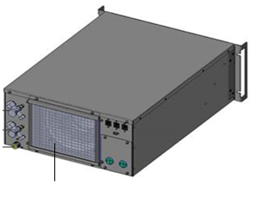
Return air filter
Figure 7-1 Return air filter
    - Drainage Pump
Inspect the drain pipe for normal operation. Ensure no pipe buckling is present. If the pipe buckling happens, the new pipe should be used. Ensure that reservoir, pump filter and inlet tube are free of sludge and debris. If not, please clean it.
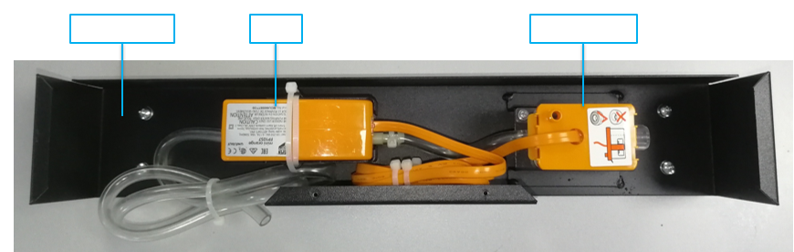
Pump reservoir
Pump
Pump brackets
Figure7-2 Condensate pump kit
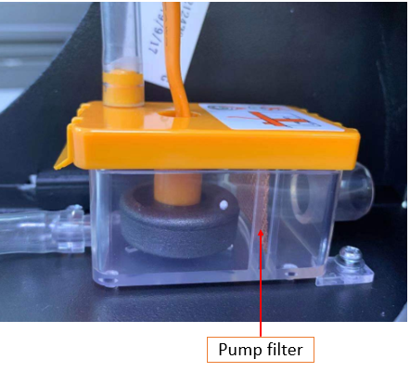
Pump filter
Figure 7-3 Pump filter
  - Condensing Unit Maintenance
    - Condenser
- Sometimes the airflow through the condensing unit is restricted. In such a scenario, use compressed air or a fin cleaner (alkalescency) to clean the dust and debris that inhibits airflow off the condenser. The compressed air should be blown in the reverse airflow direction.
- Check for bent or damaged fins and repair them, if necessary.
- Check the connection refrigerant pipes for signs of oil leakage and rectify it if any leakage is found.
    - Compressor

CAUTION: Avoid touching or having skin contact with the residual gas and oils in the compressor. Wear long rubber gloves to handle contaminated parts. The air conditioning system contains refrigerant. The release of refrigerant is harmful to the environment.

The compressor faults can be categorized into two types:
- Motor faults (such as winding burnout, insulation failure, short circuit between coils, etc.)
- Mechanical faults (such as compressor failure, relief valve faults, etc.)
If the operating pressure is not established, it means that the compressor has failed. Confirm if the suction pressure and discharge pressure are balanced and verify that the motor does not rotate reversely. The controller is streamlined with capabilities like powerful alarm and protection functions to ensure safe operation of the compressor. Periodic checks of high pressure and low pressure along with alarm protection for such pressure-related issues should be carried out by maintenance personnel on a regular basis to rule out discrepancies.
    - Condenser Fan
The monthly inspection items of the fan include: motor operation status, impeller status, fan fixation and clearance between fan and impeller. Inspect the motor bearing and impeller monthly and replace it if any damaged impeller is found. Check that the impeller is tightly mounted on the rotor of the motor and does not rub against its neighboring metal components during rotation. Since the fan kit operates 24 hours every day continuously, any unusual airflow obstruction must be cleared in time to avoid the damage to the cooling system and other system components caused by reduced air volume.
    - Receiver and Heating Belt
Periodically check the liquid level of the refrigerant in fluid reservoir to ensure that no refrigerant leakage happens. For detailed operation, refer to 6.3 Check refrigerant charge capacity of low ambient condensing unit.
Periodically check whether the heating belt works normally. See following for details:
When the system is powered on and standby, and the high pressure is lower than 1.2 MPa, the heating belt preheats the receiver. If the heating does not happen, check whether the heating belt or the pressure switch works normally. After confirming the fault part(s), replace it or them.
NOTES:
- Wear long rubber gloves to handle contaminated parts.
- The air conditioning system contains refrigerant and release of refrigerant to the atmosphere is harmful due to environment.

  - Electrical Connection Maintenance
    - Electrical Maintenance
Check the appearance to the electrical connections and take actions according to the following procedures:
- Conduct overall electrical insulation test: find out the non-insulated contacts and rectify them with proper insulation covering.
- Disconnect all the fuses or MCBs of the control part during the test as the high supply voltage may damage the control components.
- Clean the electrical panel and control panel boards from dust with a brush or by blowing low pressure dry compressed air.
- Properly fasten all the electric connection terminals.
- Check that the sockets and plugs are in good condition. Replace the loose ones with new sockets and plugs
- If the power cables are damaged, the cables must be replaced by professional personnel to avoid any non-standard installation practices.

    - Controller Connections Maintenance
Check the appearance to the control part and take actions according to the following procedures:
- Check the appearance of the power module and measure the output voltage.
- Check whether the surface of the control interface board, control board temperature NTC electronic expansion valve control board shows any signs of aging or wear & tear.
- Clean up dust and dirt from the electrical control components and control board with a brush using an electronic dust cleaning agent.
- Check and fasten the input and output connectors of the control interface boards, including the control board, interface board temperature NTC electronic expansion valve control board.
- Check whether the contact and connection of the fan power cable, signal cable rotating speed feedback signal cable are firmly fixed.
- Check whether the interconnection terminals between the control interface board and the temperature or pressure sensor are firmly fixed. If there is any loose, poor contact, or fault, immediately replace the interconnection terminal.
- Replace the faulty electrical components such as the control fuse (or air breaker) and control board.
- Use the temperature measurement meter with high measurement precision to measure and calibrate the reading of the temperature sensor.
- Adjust the set points. Check the motion of each functional component according to the control logic.
  - Cooling System Maintenance
The components of the cooling system must be inspected for finding any abnormalities in the operation causing abrasions due to continuous operation. As the failure or damage of components is usually accompanied by corresponding faults, regular checking needs to be carried out to prevent most of the system faults.

The surface of the evaporator coil should be kept clean and have no rupture.
The major reasons for electronic expansion valve failure are related to electrical failure and/or mechanical failure. The electrical failure may be attributed to the failure of the power supply of the electronic expansion valve control panel and coil, loosely connected control board wiring pressure and temperature sensor failure. The mechanical failure may be the effect of blockage in the refrigerant flow in an electronic expansion valve. Therefore, when the electronic expansion valve is faulty, pay close attention to the control panel power supply, control board wiring, pressure and temperature sensor wiring or the valve itself.
Refrigerant pipes must be properly fixed and not allowed to vibrate against the wall, floor or the unit frame. Inspect all refrigerant pipes and fixing bracket every six months for signs of wear.
  - Leakage Detection (F-gas)
For countries covered by the F-gas regulation, when the low ambient condensing unit (VRC352) is used, both the indoor unit (VRC202) and the low ambient condensing unit should be checked for leaks once a year according to mandatory rules. There are three holes in the indoor unit for detection, as shown in Figure 7-4 and Figure 7-5.
The following section is a step-by- step illustration of the process of leak detection.
- Remove the 8 screws, grille, water leakage detection board, and 2 rubber bushing in Figure 7-4 one by one.
- Remove the 3 screws and cover plate in Figure 7-5.
- Insert the sniffer into the VRC202 unit to check whether the refrigerant leaks in the areas in Figure 7-6. Check detection area (front) and detection area (rear) from the front and rear of the VRC202 unit, respectively.
- Restore the VRC202 unit to its original state after the check is completed.
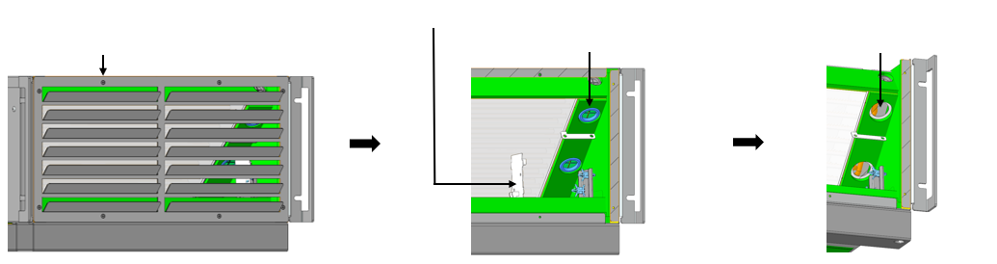
Water leakage detection board
Screw M3×8 * 8pcs
Rubber bushing 2*pcs
Detection hole 2*pcs
Figure 7-4 The detection holes in VRC202 (front)

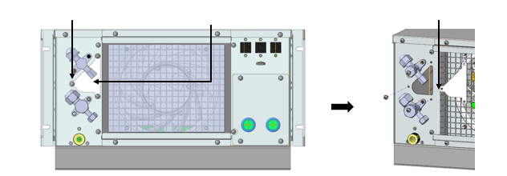
Detection hole 1*pcs
Cover plate 1*pcs
Screw M4×10 * 3pcs
Figure 7-5 The detection holes in VRC202 (rear)
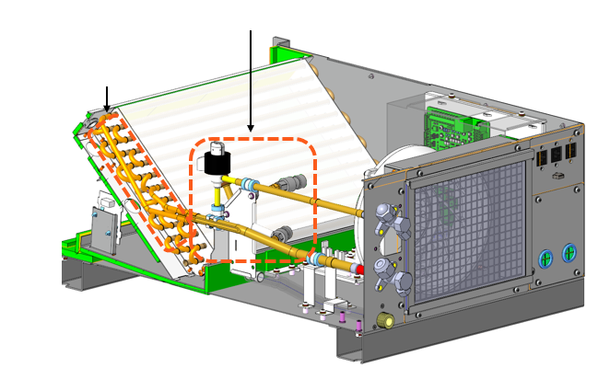
Detection area (front)
Detection area (rear)
Figure 7-6 The detection area in VRC202 (rear)

  - System Diagnosis Testing
The microprocessor controller supports the manual mode and provides diagnostic functions such as manually enabling and disabling parts. Such functions can be used to detect states of the system functional parts.

  - Maintenance Inspection Checklist
The maintenance checklist of the unit is provided in the Table 7-1 below.
Table 7-1 Maintenance Checklist
VRC2/3
Date: |  | Prepared by:
Model: |  | Serial Number:
Type | Maintenance Components: | Item | Result
Monthly: | Return air filter | Check for restricted air flow
Monthly: | Return air filter | Check the filter cleanliness
Monthly: | Return air filter | Clean the filter
Monthly: | Evaporator fan and condenser fan | Check if fan blades are distorted.
Monthly: | Evaporator fan and condenser fan | Check whether the fan generates any noise during operation
Monthly: | Evaporator fan and condenser fan | Check whether the fan has stoped rotating.
Monthly: | Evaporator fan and condenser fan | Check and fasten the circuit connector.
Monthly: | Evaporator fan and condenser fan | The fan base should be firm
Monthly: | Drainage pump | Check whether filter is clogged or damaged
Monthly: | Drainage pump | Clean the filter
Monthly: | Drainage pump | Check whether the pipes are loose.
Monthly: | Drainage pump | Check whether there are impurities and debris in the water tray.
Monthly: | Drainage pump | Check the drain pump connection line for clogging.
Monthly: | Drainage pump | Check whether the cable of the drain pump is loose.
Semi-annually: | Compressor | Signs of oil leakage
Semi-annually: | Compressor | Check if there is abnormal vibration and noise of compressor
Semi-annually: | Condenser | Check the fins cleanness
Semi-annually: | Low ambient kit | Check whether there is leakage
Semi-annually: | Low ambient kit | Check whether heating belt works normally
Semi-annually: | Low ambient kit | Check whether pressure switch works normally
Semi-annually: | Low ambient kit | Check whether the liquid line solenoid valve works normally
Semi-annually: | Cooling system | Suction pressure
Semi-annually: | Cooling system | Discharge pressure
Semi-annually: | Cooling system | Superheat
Semi-annually: | Cooling system | Connection pipe no leakage
Semi-annually: | Cooling system | Charging capacity of refrigerant
Semi-annually: | Electrical control part | Check whether the main circuit breaker and the circuit breaker cable of the power module are tightly connected.
Semi-annually: | Electrical control part | Check and fasten the circuit connector.
Semi-annually: | Electrical control part | Check whether the cables and meter reading of each sensor are within prescribed range.
Semi-annually: | EEV electric board | Check whether the wiring and coil of the electronic expansion valve control board are loose
Semi-annually: | EEV electric board | Check electrical connections
Semi-annually: | EEV electric board | Check the surface for signs of corrosion

- Troubleshooting
This chapter introduces the failure diagnosis and troubleshooting and can be used together with the alarm section in Chapter 5.
CAUTION: Certain circuits carry lethal voltages. Only professional technicians are allowed to maintain the unit. Extra precautions should be taken when troubleshooting a live unit. Be particularly careful troubleshooting with the unit’s power switched on.

CAUTION: If jumpers are used for troubleshooting, make sure to remove the jumpers after troubleshooting. If the connected jumpers are not removed, they may bypass certain control functions causing damage to the equipment.
  - Troubleshooting
Trouble Shooting for the entire unit is mentioned in the below Table 8-1.
Table 8-1 Troubleshooting
Fault Occurrence | Possible Cause | Check or Remedy
High temperature alarm | Unreasonably high temperature alarm setpoint | Check and reset high temperature alarm setpoint
High temperature alarm | Overload condition | Check whether the max. actual heating load is over the rated value
High temperature alarm | Condenser fan does not run normally or is faulty | Check if the fan power cable is disconnected
High temperature alarm | Compressor does not run normally | Check if the compressor power cable is disconnected
Low temperature alarm | Unreasonably low temperature alarm setpoint | Check and reset low temperature alarm setpoint
Low temperature alarm | Evaporator fan does not run normally or is faulty | Check if the fan power cable is disconnected
Low temperature alarm | Compressor does not run normally | Check to see if the compressor power cable is disconnected
High pressure alarm | Condenser fan does not run normally or is faulty | Check if the fan power cable is disconnected
High pressure alarm | High pressure sensor is abnormal | Check if the high-pressure sensor is normal
High pressure alarm | Insufficient condensing airflow | Remove debris from the coil and air inlet
High pressure alarm | Insufficient condensing airflow | Check if the fan speed controller operates normally
Low pressure alarm | Refrigerant leakage | Check for leaking points and re-charge refrigerant
Low pressure alarm | Condenser fan runs at full speed when ambient temperature is too low | Check if wire connection of outdoor fan is reversed
Low pressure alarm | EEV adjusts abnormally or is closed | Check if the EEV coil or EEV cable is loose
Low pressure alarm | Evaporator fan does not run normally or is faulty | Check if the cable of fan is disconnected
Low pressure alarm | Insufficient airflow across evaporator coil | Remove debris from the coil and air inlet
Severe condensation or water leakage | The air humidity is too high | Use other dehumidifier to control the air humidity
Severe condensation or water leakage | EEV adjusts abnormally | Check if the EEV coil or EEV cable is loose
Severe condensation or water leakage | Compressor runs at high speed | Check if the compressor is out of control
Severe condensation or water leakage | The drainage pan or pipe is loose or blocked | Check if drainage pipe is loose or clean the debris in the drainage pan or pipe
Compressor vibration or abnormal noise | The mounting position is not even | Check mounting position state
Compressor vibration or abnormal noise | The fixing parts are loose | Check the fixing nuts of compressor and fasten again
Compressor vibration or abnormal noise | Compressor is faulty | Call the customer service hotline of Vertiv

  - Fan Troubleshooting
The fan troubleshooting is listed in Table 8-2
Table 8-2 Fan fault diagnosis and handling
Symptom | Probable Causes | Check Items and Handling Methods
EC fan can’t be started | The circuit breaker is open | Check if the circuit breaker is closed.
EC fan can’t be started | Fan power module failure | Check the alarm indicator of the fan power module to if the control board fails
EC fan can’t be started | The cable is faulty | Check whether the cable from the main control board, fan fault detection board, or power module to the control terminal bar is firmly fixed.  Check whether the cable from the control terminal bar to the plug wire terminal of the fan is firmly fixed.

  - Fault Diagnosis and Handling of Electronic Expansion Valve
As a key component for refrigerant system and cooling capacity adjustment, the working of the electronic expansion valve is important. Table 8-3 describes the fault diagnosis and handling methods.
Table 8-3 Fault diagnosis and handling methods
Symptom | Probable Causes | Check Items and Handling Methods
The adjustment of the electronic expansion valve is faulty. | The temperature sensor or pressure sensor is faulty. | Check whether the sensor cable is firmly fixed.  Check whether the sensor cable position on the control board is correct.
The adjustment of the electronic expansion valve is faulty. | The control board is powered off. | Check whether the output fuse of the transformer has tripped/broken.  Check whether the input power of the control board of the electronic expansion valve is of 24 V power supply.
The adjustment of the electronic expansion valve is faulty. | The cable connection of the control board is faulty. | Check whether the valve cable connection on the control board of the electronic expansion valve is faulty.  Check whether the communication cable between the electronic expansion valve control board and the main control board is properly connected.

  - Fault Diagnosis and Handling of the Air Conditioning System
When the air conditioning system component is faulty, identify the causes and tackle the problem to ensure normal operation of the unit. Table 8-4 describes the major faults and troubleshooting methods.
Table 8-4 Refrigeration system faults and troubleshooting methods
Symptom | Probable Causes | Check Items and Handling Methods
The surface of the evaporator has serious condensation. | Check whether the surface of the evaporator is filth blocked. | Check the surface of the evaporator. blockage may result in non-smooth discharge of the condensate water.
Air volume decrease | The air filter is blocked. | Periodically check the filter and replace it in a timely manner to avoid air volume attenuation due to filth blockage.
Air volume decrease | The fan is faulty. | Check whether the fan is faulty. Table 8-1 describes the diagnosis and handling methods.
Air volume decrease | Blockage of the evaporator | Check the surface of the micro-channel evaporator and periodically handle the blockage problem.

Appendix I: System Diagram (Standard Unit)
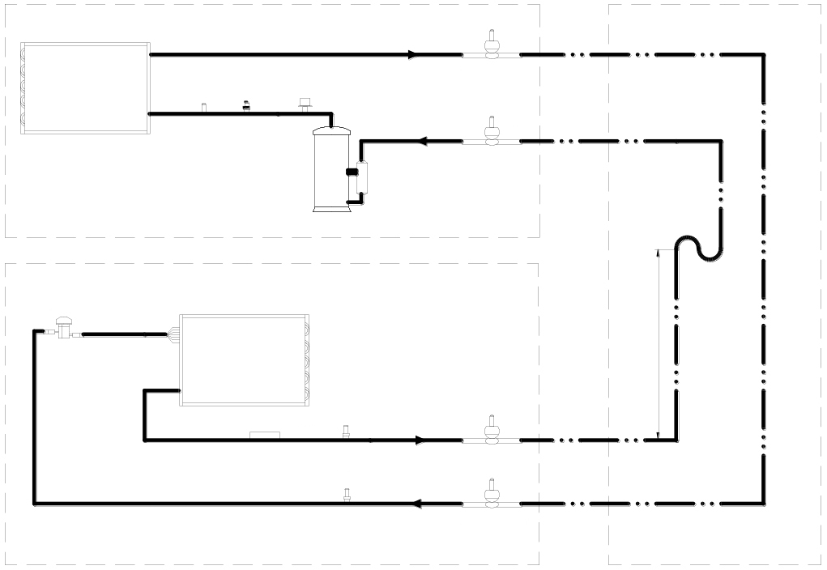
Service Valve
For rising over 7.5 m (24.6 ft), trap every 7.5 m (24.6 ft) or evenly divided.
7.5 m (24.6 ft)
Liquid Line
Gas Line
Trap
Service Valve
Service Valve
Gas Quick Connector
Interconnecting Piping
Liquid Quick Connector
High Pressure Transducer
Low Pressure Transducer
Indoor Unit
Liquid Line
Gas Line
Suction Temperature Sensor
Distributor
Evaporator
Electronic Expansion Valve
Gas Quick Connector
Compressor
Liquid Quick Connector
High Pressure Switch
Service Valve
Service Valve
Discharge Temperature Switch
Outdoor Unit
Condenser

Appendix II: System Diagram (Low Ambient Unit)
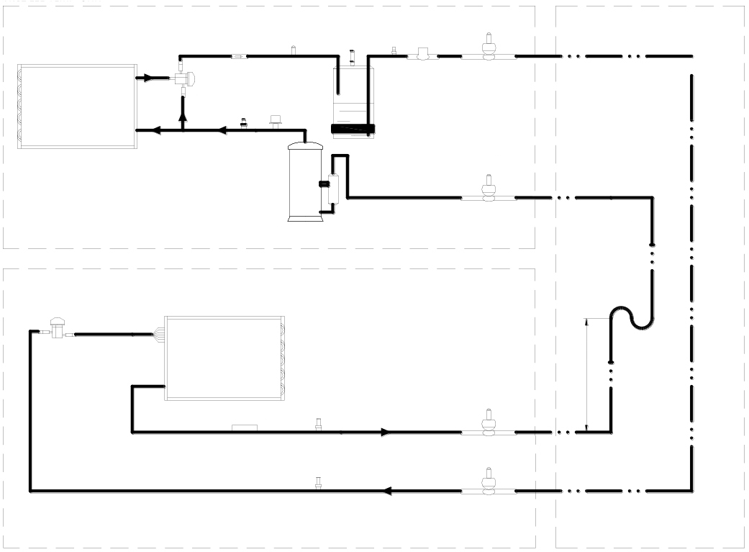
For rising over 7.5 m (24.6 ft), trap every 7.5 m (24.6 ft) or evenly divided.
7.5 m (24.6 ft)
Liquid Line
Gas Line
Trap
Service Valve
Service Valve
Gas Quick Connector
Interconnecting Piping
Liquid Quick Connector
High Pressure Transducer
Low Pressure Transducer
Indoor Unit
Liquid Line
Gas Line
Suction Temperature Sensor
Distributor
Evaporator
Electronic Expansion Valve
Gas Quick Connector
Compressor
Electric Heating Belt
Liquid Quick Connector
Service Valve
Receiver
High Pressure Switch
Service Valve
Solenoid Valve
Pressure Switch
Relief Valve
Service Valve
Discharge Temperature Switch
Head Pressure Valve
Check Valve
Outdoor Unit
Condenser

Appendix III: Wiring Diagram (VRC200/VRC201 Unit)
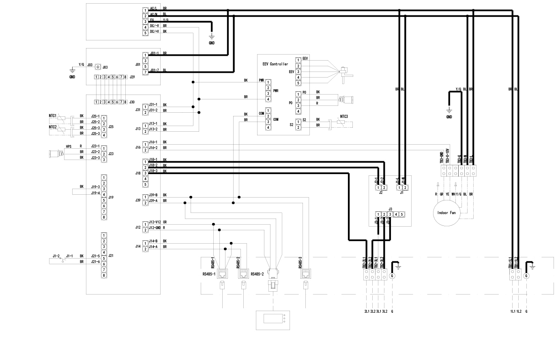
EEV Controller
EEV
RDU-C
RDU-C
RDU-SIC
SEE UNIT NAMEPLATE FOR MAIN SUPPLY WIRE SIZING
LINE VOLTAGE
1 PHASE SUPPLY
EARTH GROUND CONNECTION
CONNECTION PANEL
EARTH GROUND CONNECTION
MBV Outdoor Fan
Display
Compressor Communication
Compressor Communication
Terminal Block
EMI Filter ACM02X2
Suction TEMP. Sensor
Indoor Fan
Low Pressure Sensor LPS
PACC Controller ACM05U1
Water Level Sensor WLS
High Pressure Sensor HPS
Return Air TEMP. Sensor
Supply Air TEMP. Sensor
Power Protector ACM02A1
AC/DC Power Module

Appendix IV:Wiring Diagram (VRC300/VRC301 Unit)
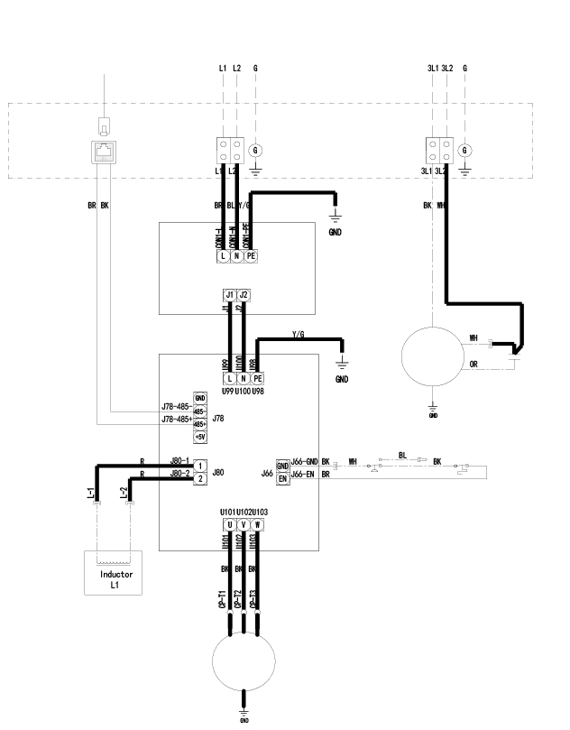
Inductor L1
CON1
LINE VOLTAGE
1 PHASE SUPPLY
SEE UNIT NAMEPLATE FOR MAIN SUPPLY WIRE SIZING
Outdoor Fan
Compressor Communication
Compressor Communication
EARTH GROUND CONNECTION
CONNECTION PANEL
EARTH GROUND CONNECTION
EMI Filter
Outdoor Fan
Capacitor
TEMP. Switch
High Pressure Switch
Compressor
Compressor Inverter

Appendix V:Wiring Diagram (VRC350/VRC351 Unit)
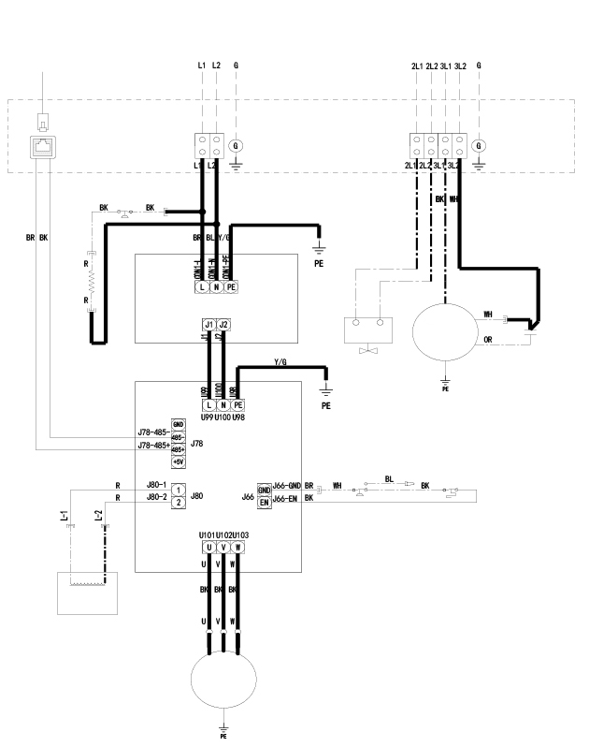
CON1
LINE VOLTAGE
1 PHASE SUPPLY
SEE UNIT NAMEPLATE FOR MAIN SUPPLY WIRE SIZING
LLSV Outdoor Fan
Compressor Communication
Low Pressure Switch
Compressor Communication
EARTH GROUND CONNECTION
CONNECTION PANEL
EARTH GROUND CONNECTION
RHTR
EMI Filter
LLSV
Outdoor Fan
Capacitor
TEMP. Switch
High Pressure Switch
Compressor
Compressor Inverter
Inductor L1

Appendix VI:Wiring Diagram (VRC202 Unit)
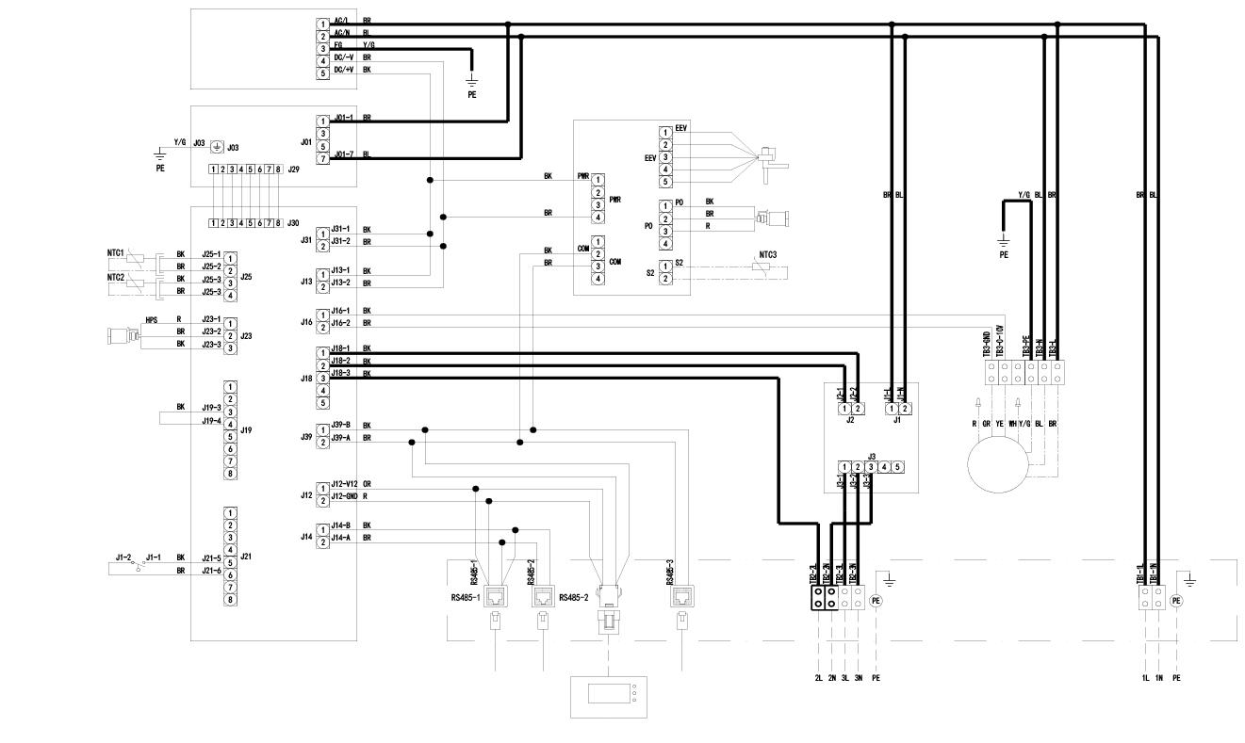
EEV
RDU-C
RDU-C
RDU-SIC
SEE UNIT NAMEPLATE FOR MAIN SUPPLY WIRE SIZING
LINE VOLTAGE
1 PHASE SUPPLY
EARTH GROUND CONNECTION
CONNECTION PANEL
EARTH GROUND CONNECTION
LLSV Outdoor Fan
Display
Compressor Communication
Compressor Communication
Terminal Block
EMI Filter ACM02X2
Suction TEMP. Sensor
Indoor Fan
Low Pressure Sensor LPS
EEV Controller
PACC Controller ACM05U1
Water Level Sensor WLS
High Pressure Sensor HPS
Return Air TEMP. Sensor
Supply Air TEMP. Sensor
Power Protector ACM02A1
AC/DC Power Module

Appendix VII:Wiring Diagram (VRC302 Unit)
SEE UNIT NAMEPLATE FOR MAIN SUPPLY WIRE SIZING
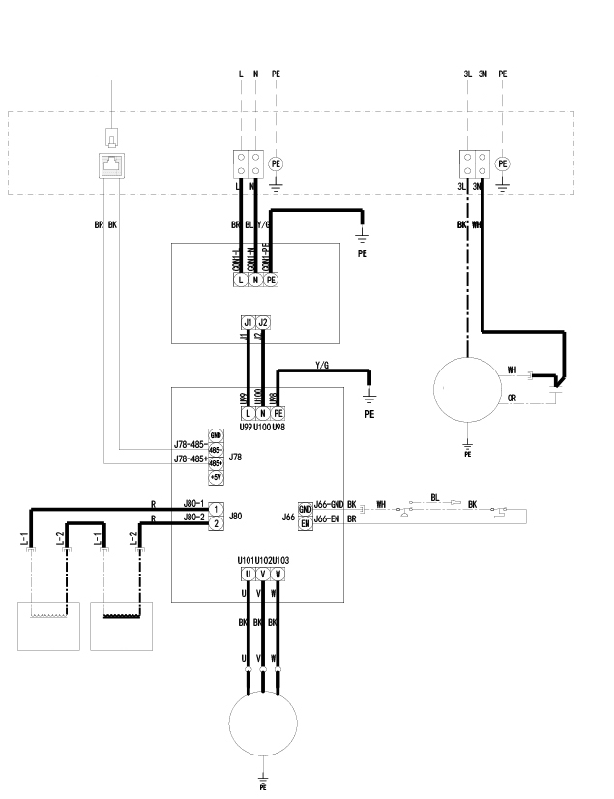
CON1
LINE VOLTAGE
1 PHASE SUPPLY
Outdoor Fan
Compressor Communication
Compressor Communication
EARTH GROUND CONNECTION
CONNECTION PANEL
EARTH GROUND CONNECTION
EMI Filter
Outdoor Fan
Capacitor
TEMP. Switch
High Pressure Switch
Compressor
Compressor Inverter
Inductor L1
Inductor L2

Appendix VIII:Wiring Diagram (VRC352 Unit)
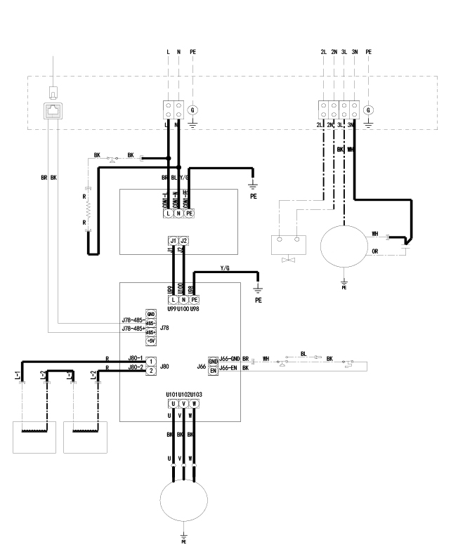
CON1
LINE VOLTAGE
1 PHASE SUPPLY
SEE UNIT NAMEPLATE FOR MAIN SUPPLY WIRE SIZING
LLSV Outdoor Fan
Compressor Communication
Low Pressure Switch
Compressor Communication
EARTH GROUND CONNECTION
CONNECTION PANEL
EARTH GROUND CONNECTION
RHTR
EMI Filter
LLSV
Outdoor Fan
Capacitor
TEMP. Switch
High Pressure Switch
Compressor
Compressor Inverter
Inductor L1
Inductor L2

Suppliers Declaration of Conformity


Unique Identifier: VRC200, VRC201, VRC300, VRC301, VRC350, VRC351

Party Issuing Supplier’s Declaration of Conformity
Vertiv Group Corp.
1050 Dearborn Drive
Columbus, OH 43085
US
Customer service hotline: 614-888-0246

FCC Compliance Statement (for products subject to Part 15)
This device complies with part 15 of the FCC Rules. Operation is subject to the following two conditions: (1) This device may not cause harmful interference (2) this device must accept any interference received, including interference that may cause undesired operation.

Note:
Note: This equipment has been tested and found to comply with the limits for a Class A digital device, pursuant to part 15 of the FCC Rules. These limits are designed to provide reasonable protection against harmful interference when the equipment is operated in a commercial environment. This equipment generates, uses can radiate radio frequency energy and, if not installed and used in accordance with the instruction manual, may cause harmful interference to radio communications. Operation of this equipment in a residential area is likely to cause harmful interference in which case the user will be required to correct the interference at his own expense.



Vertiv.com I 1-4/F, 6-10F, Block B2, Nanshan I Park, No.1001 Xueyuan Road, Nanshan District, 518055 Shenzhen, Guangdong, CHINA
© 2019 Vertiv Group Corp. All rights reserved. Vertiv and the Vertiv logo are trademarks or registered trademarks of Vertiv Group Corp. All other names and logos referred to are trade names, trademarks or registered trademarks of their respective owners. While every precaution has been taken to ensure accuracy and completeness here, Vertiv Group Corp. assumes no responsibility, and disclaims all liability, for damages resulting from use of this information or for any errors or omissions. Specifications are subject to change without notice.
V1.2 / REV 18-03-2020 / Code-31014128

